Season Change in Heaven
Lyrics by Timothy Spearman & Music by James Farganne
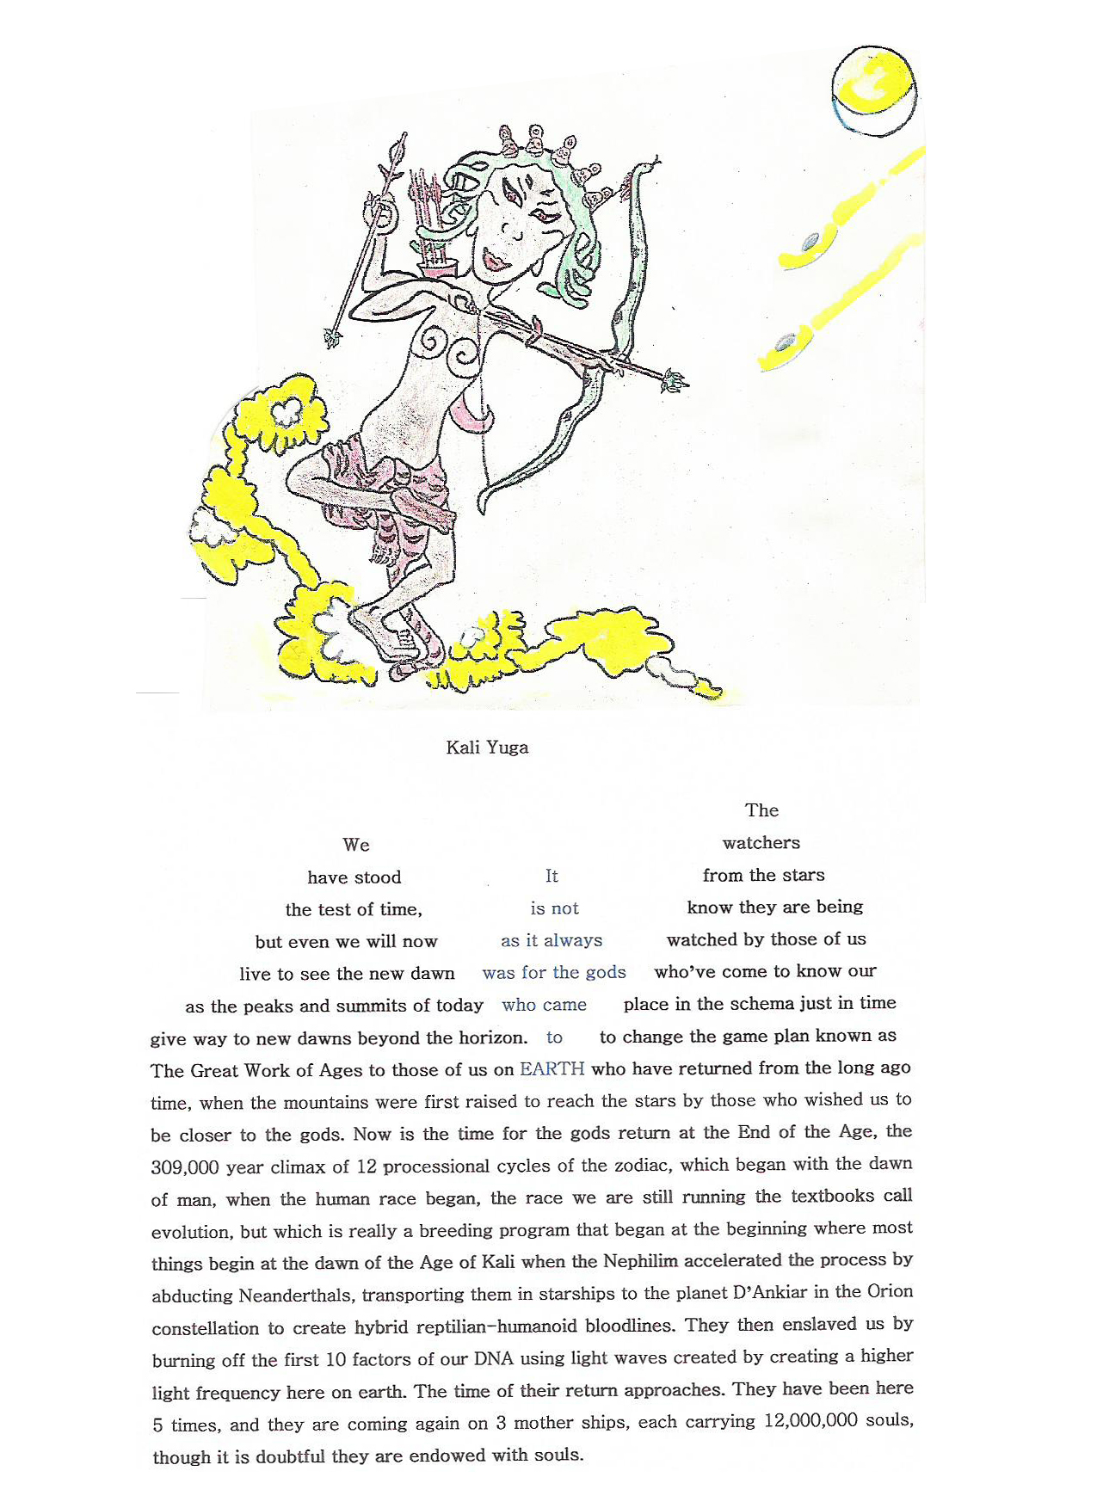

KALI YUGA 7:30

The
We watchers
have stood It from the stars
the test of time, is not know they are being
but even we will now as it always watched by those of us
live to see the new dawn was for the gods who’ve come to know our
as the peaks and summits of today who came place in the schema just in time
give way to new dawns beyond the horizon. to to change the game plan known as
The Great Work of Ages to those of us on EARTH who have returned from the long ago
time, when the mountains were first raised to reach the stars by those who wished us to be closer to the gods. Now is the time for the gods return at the End of the Age, the 309,000 year climax of 12 processional cycles of the zodiac, which began with the dawn of man, when the human race began, the race we are still running the textbooks call evolution, but which is really a breeding program that began at the beginning where most things begin at the dawn of the Age of Kali when the Nephilim accelerated the process by abducting Neanderthals, transporting them in starships to the planet D’Ankiar in the Orion constellation to create hybrid reptilian-humanoid bloodlines. They then enslaved us by burning off the first 10 factors of our DNA using light waves created by creating a higher light frequency here on earth. The time of their return approaches. They have been here 5 times, and they are coming again on 3 mother ships each carrying 12,000,000 souls though it is doubtful they are endowed with souls.

UNINVITED GUESTS

Illustration and song lyrics by Timothy Spearman

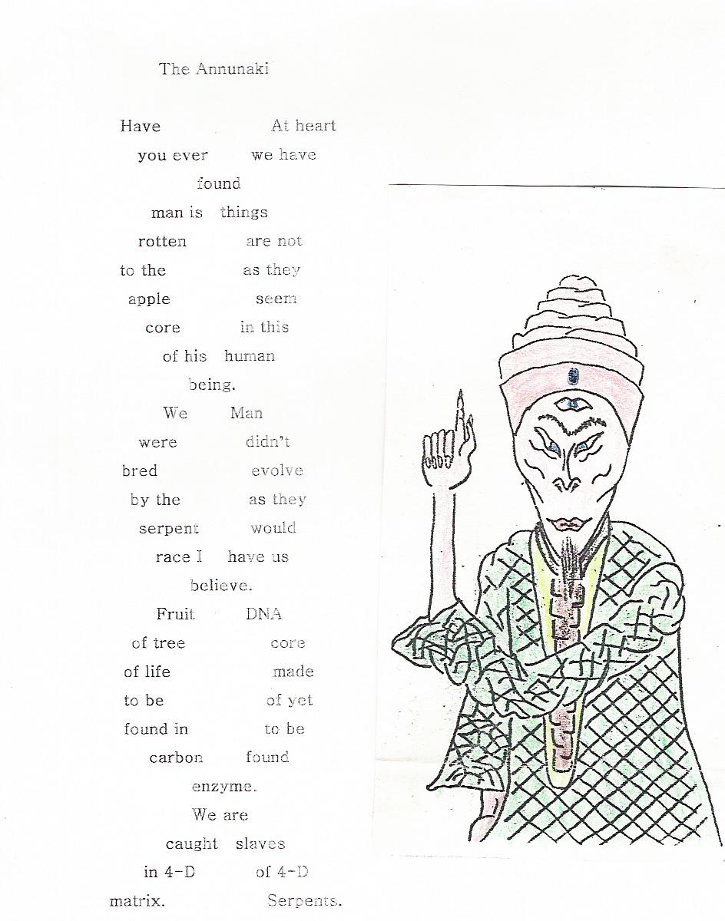

SKULL AND BONES

Lyrics by Timothy Spearman

For
most of us who
read the label on
the products we buy
the skull and bones
logo means poison
but the origin of
the pirate logo
The is very old Such
crossed indeed. advice
bones is given
mean to 3rd
death to Degree
Masons
who then who do
confront not heed
death. warnings.

As for the stern marauders of
the high seas who would have us bow our heads
down to them, don’t believe a word about what the history books say. These pirate ships were the armada of
the Knights Templar, whose organization was driven out of port in La Rochelle by Philip the Fair of France.
Whether or not it was fair has not been established, but for the followers of Templar Jacques de Molay,
King’s edict of Friday, October 13th, 1307 was far from above board, that Black Friday considered a
day of ill-omen ever since. The Templar fleet fled port of La Rochelle before the axe came down
and made their way to Portugal and Scotland to found the respective orders Knights of Malta
and the York Scottish Rite of Freemasonry, which have ruled land and sea ever since.

As who the the it as us
for those hoisted flag up masthead was not they make believe.
It was not the pirate flag as popular lore would have it, but the Knight Templar battle flag. As for the crime syndicate masquerading under the black flag of pirate cutthroats, the Templar-Freemason pirates would exact their revenge against the monarchs of Europe by attacking ships under royal charter. They would then expand their empire, as their banks and corporate syndicates expanded under a host of other brand names.

Statue of Tyranny

Illustrated lyrics by Timothy Spearman

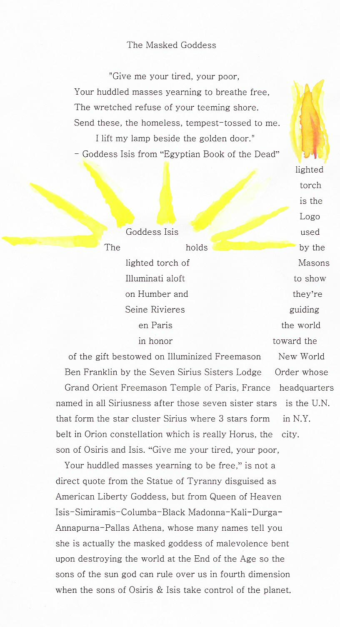

Professor Higgins-style crooning number:

A POUND OF FLESH

Lyrics by Timothy Spearman

There is much wisdom to be found in books. Take The Merchant of Venice for example. In this play, Antonio has taken a loan of 3,000 ducats from Shylock, the moneylender. The loan has been taken out on merchant cargo ships laden with minerals extracted abroad. Let us for our purposes imagine the commodity to be oil. The ships are then lost at sea and Antonio defaults on his loan. As collateral, Shylock has extracted a loan on exactly one pound of Antonio’s flesh.

By analogy, Saddam Hussein also received many usurious gifts from the former U.S. president, George Bush Sr., when he was head of the CIA, including oil kickbacks, which they split to the tune of $250 billion a year each, through the Pennzoil Oil Company, this revealed in the book by former CIA agent, Russell S. Bowen, The Immaculate Deception: Bush Crime Family Revealed. This prefaced the sale on credit of chemical, biological and nuclear agents that could be used in weapons of mass destruction. For this, Shylock has demanded his pound of flesh in bond. Shylock has followed the same tactics with Iran.
In the play, Shylock does not want his loan to be paid in interest even when reparation is offered at three times its value. He prefers to have his pound of flesh. To him, it is justice to have Antonio suffer for the many insults he has received at his hands, but this is justice based on revenge.
Analogously, Bush does not want the sale of arms to be repaid. Iran may present its inventory of weapons three times over and still Shylock will not be discouraged from his course. Iran may open its borders to UN inspectors and turn every missile, warhead, and chemical weapon over and still Shylock will insist upon his pound of flesh.
Now the bond has come to court, Portia presiding not as a young doctor of law, but as the United Nations. She has come to hear the case. At first, she consents to the bond and agrees that Antonio’s chest should be laid bare that Shylock might lay hold of his pound of flesh. But Shylock is in for a surprise as the most learned judge has stipulated that while he is entitled to his bond of one pound of flesh, if even so much as a single drop of blood is allowed to spill, he will be compelled to forfeit all his property.
Let the UN invoke the same wisdom with the United States, consenting to the bond of invasion – since America insists upon having its pound of flesh, so long as not a single drop of blood is spilled in Iran or North Korea – both slated to be the next targets in the war on terrorism – the terms being that the United States be forced to forfeit all its political and diplomatic power by the International Court should it fail to meet these terms.
Next, Portia stipulates that Shylock is to extract the exact sum of one pound of Antonio’s flesh and not a single ounce more or once again his lands and properties will be held forfeit. Shylock has even brought his balancing scales along to weigh the morbid article that is to be cut away. Observe how the weapons inspectors are now weighing the cache of weapons in their scales to determine whether or not there is cause to go to war.
So let Portia, in the guise of the UN, insist that the invading allied force strike only such installations as weapons silos and weapons caches. Should so much as a single tomahawk missile stray from its course and hit a civilian residence, water treatment plant, sewage treatment plant, or telecommunications installation as occurred in the first Gulf War and the Iraq War, the UN must insist that the United States be forced to forfeit its diplomatic and military power through the jurisdiction of the International Court.
Having been forced to capitulate on his bond, Shylock then requests that the debt of 3,000 ducats be paid with interest. Portia refuses to grant his request on the grounds that he had previously refused such an offer, having insisted instead on a pound of flesh without compromise. Instead, he is told that he will receive no collateral whatsoever on his bond.
So let it be said to the American president that his planned pre-emptive strike on Iran is unlawful and hypocritical since he and his father had already formerly employed weapons of mass destruction on Iraq in the form of tomahawk missiles and bombs laced with depleted uranium, 87,000 tons of bombs, equivalent to seven and one half Hiroshimas, according to Ramsay C. Clark, Former Attorney-General of the United States. In addition, 100,000 cluster bombs have been scattered all over the Iraqi and Kuwaiti deserts, undetonated and waiting to go off under the feet of some unsuspecting innocent. The Geneva Convention stipulates that civilians are not to be targeted in war. So why are they? DU represents a covert bioweapon attack upon civilians and is therefore a war crime.
Then Portia invokes Venetian legal precedent in order to exact a penalty on Shylock for deliberately threatening the life of a fellow citizen, for which all his lands are held forfeit, and at the mercy of the plaintiff to dispose of as he sees fit.
So let the International Court insist that the offended party, Iran, be compensated by being permitted to refuse trading relations with the United States, while the International Court demand that the U.S. government forfeit all its political and military power, to be disposed of as the offending party Iran sees fit.
Portia’s justice is not based on revenge or “might is right”, but upon appeal to higher wisdom. Let us be reminded of her words and address them to the U.S. president in the hope that he will heed her words:
The quality of mercy is not strain’d;
It droppeth as the gentle rain from heaven
Upon the place beneath: it is twice blest;
It blesseth him that gives, and him that takes:
’Tis mightiest in the mightiest: it becomes
The throned monarch better than his crown;
His scepter shows the force of temporal power,
The attribute of awe and majesty,
Wherein doth sit the dread and fear of kings;
But mercy is above the sceptred sway;
It is enthroned in the hearts of kings,
It is an attribute to God himself;
And earthly power doth show likest God’s
When mercy seasons justice.

~ The Merchant of Venice

CLEOPATRA’S NEEDLE

Lyrics by Timothy Spearman

A
long
needle
and thread
has been used
to weave the web
of Illuminati control.
It may not be that easy
for a rich man to enter
the kingdom of heaven,
but they’re not worried.
They weave their webs
And extend their Net &
Worldwide Web globally,
extending their influence
peddling around the map
from the poppy fields of
Afghanistan and Burma
to those killing fields of
Cambodia and Rwanda.
Cleopatra threads her
needle, while children
in the poorer countries
try to darn their socks.
As for the camels that
may have some trouble
passing through the eye
of the needle, no worries;
the rich man has no wish
to go to heaven, with a
place staked out in hell.

SHIP OF FOOLS

The Titanic was built by the White Star Line owned by the Jesuits.

The White Star Line built the Titanic and her two sister ships, the Olympic and York.

All three ships would sink.

There was an explosion in the boiler room below the waterline before she set sail.

The iceberg offered perfect cover and plausible deniability.

Robert Ballard’s footage shows the Titanic wreck does not match the blueprints of ship.

Strangely, they match those of her sister ship, the Olympic.

Titanic’s name plate is missing from hulk lying on ocean floor.

The ship’s grave is nowhere near the location of her last distress call.

There were 55 cancellations before she set sail, including Jesuit banker J.P. Morgan.

Several passengers were scheduled to attend a meeting in New York.

The meeting in New York was to plan the world government that became the U.N.

Many of the delegates went down with the ship.

The ship was built by a shipyard owned by York Scottish Rite Freemasons.

The U.N. is not most people’s idea of a proper world government body.

It has failed to secure the peace of the world.

Why?

Perhaps the answers lie in a watery grave.

Titanic was declared unsinkable.

She was swapped.

It’s her sister ship down there - The Olympic.

SHIP OF FOOLS 2:30

Lyrics by Timothy Spearman

The
12th
Ill- Feb 55
fated 1912 did
ship o’ she not
fools went go
doom down with
crew much her
to the chagrin of all who believed in invincibility
of passenger ship and who never dreamed she’d go 55
down on her maiden voyage by striking an iceberg. were
number of cancellations made before she set sail, including Jesuit Order elite banker
J.P. Morgan, who waved cordial goodbye to World Government faction who sought
to replace Round Table with League of Nations that would preserve global order
as opposed to slaughterhouse known as New World Order inaugurated by the
Morgan-Rothschild-Rockefeller faction, which founded UN headquarters on
land formerly occupied by slaughterhouse for cattle, making explicit how
they see us, whom they call the goyim or cattle. Jesuit owned White Star
Line ensured Titanic’s two sister ships the Olympic and the York went
to the same watery grave. Robert Ballard’s photos show Titanic’s hulk
does not match her blueprints, but rather those of sister ship, Olympic.
There was an explosion in boiler room below waterline before she set
sail from port in Southampton bound for seat of world government.

Language Is the Work of the Devil
By Timothy Spearman

They say, “Better the devil you know.” It’s the devil we don’t know that we have to worry about and the devil is often in the details and hidden in the fine print. You could say that language itself is the work of the devil. Witches cast spells and we cast spells with language. “Spell” a word right and you cast the right “spell.” See what I mean? Our language is steeped in witchcraft. We cast spells and dispel spells depending on how we employ language and for what purpose. One way to dispel spells is to expose the spell contained in language through deciphering, decrypting and decoding the occulted language contained within the written or spoken word.

While Arabic remains untrammelled, uncorrupted and pure as the language of the Quran, it is an entirely different story with English. The British Isles unfortunately were settled by Scythians, Phoenicians and other tribes carrying the bloodline of Cain. The English language is infused with Satanic references and codes. This book goes a long way to explaining why.

The Egyptian God SET represents the “Dog Star” Sirius. He also represents Lucifer and Satan. Lucifer means the “Morning Star”. Sirius is the Morning Star. It rises in the morning and it sets in the evening hence “sunSET”, which we mistakenly believe refers to the central sun of our solar system appearing to pass beneath our horizon in the evening.

According to the Egyptian myth, Osiris the sun god was cut to pieces by the Egyptian god Set. This represents the zodiac cycle of precession, in which Sirius, the Dog Star, transits the entire zodiac along the elliptic over a 26,000 year period, transiting all of the zodiac signs within that timeframe. Osiris was then divided into 13 parts, one of which became the occulted sign of the zodiac found between Scorpio and Sagittarius, representing the snake, which is symbolic of Osiris’ missing phallus. Why missing? Because when Isis, the moon goddess, reclaimed his body parts and raised him from the dead in a necromancy ceremony, one of his body parts went missing and was never reclaimed, namely the phallus.

Horus, the son of the sun god, then avenged his father’s death. Strikingly, we see this ancient myth commemorated in so many ways in the Luciferian symbols of our time. The White House of Washington DC and White Hall of London represent Sirius the Dog Star. The White Star shipping line that experienced so many sea-going disasters is also named after Sirius the Dog Star. Federal Triangle in Washington DC represents Osiris and Isis, while the hypotenuse represented by Pennsylvania Ave. symbolizes Horus. The swine flu conference for H1N1 was held on Pennsylvania Ave.

Federal Triangle plays a significant role in the Washington street plan. Let me explain. The Washington street plan, designed by 33 degree Freemason Pierre L’Enfant – named in honour of the infant child of Lucifer, namely the Antichrist – represents the Great Work of Ages. The men who killed Abraham Lincoln lived in Peterson House, located across the street from the Ford Theatre, where President Lincoln was shot by John Wilkes Booth, and where Lincoln was later taken following the shooting. The room boarders in Peterson House were called the 48ers. They were named so because they had been involved a failed rebellion in Bavaria, Germany in 1848. Having failed to successfully foment unrest in that attempted revolution, they were dispatched to Washington DC to create the US Civil War. Their publishing and printing house was found at 1111 Pennsylvania Ave, Horus Ave. in other words, or Antichrist Lane if you prefer. 11 is a satanic number, representing the perversion of the perfect number 10. The Satanic Merovingian knights known as the Knights Templar of the Cainite bloodline was founded as an Order of Knights in the year 1111. The Armistice for World War 1 was signed on the 11th day of the 11th month. Then we have the number 11 formed by the World Trade Center Twin Towers.

The Pinkerton Security company is the oldest contract security company in the world and they have provided contract guards to the US Secret Service since the time of Abraham Lincoln down to the present. Their logo is the All-Seeing Eye of Horus, the sun of the sun god, representing the sun of Lucifer, the Morning Star Sirius, which is the sun they venerate, and from whence Lucifer, the Fallen Angel hails. The Fox is guarding the hen house, therefore, and the Luciferians control the guard detail for the US Secret Service, so that if a US president ever steps out of line and fails to do the bidding of the globalist Satanists who control the international banking industry, they simply initiate stand down orders, and the guards will either abandon their posts leaving the US president open to assassination or they will participate more actively in his murder, as with William Greer, the driver of the presidential limo, who turned around with a nickel-plated .45 and shot JFK in the head, while Gov. Connelly backed away from the line of fire just in time, slumping down on to the bucket seats and rolling onto the floor of the limo with his wife, proving that it was pre-rehearsed and premeditated. This is shown in the film distributed by William Cooper, author of Behold a Pale Horse.

Our language is infused with this satanic non-sense. It’s all a SET up. The stage is SET. Just look at the language we use every day and you will see that the Luciferians/Satanists are trying to curse us with the very language we use. The table is SET, a reference to the Last Supper, since the curse befalling Jesus implies that it was Satan who SET the table for the Last Supper.

Are you all SET for the End Times? Because history is one big SET up by SET, the evil fallen angel Satan/Lucifer. The stage is SET. The SET construction was the work of the SET designer Satan/Set and is known as the Great Work of Ages. It’s all coming down to the End Times crunch now. The stage SET is ready and all the props are in position. Everything’s all SET up. This means that it’s all a SET up and you’ve been SET up. But then I’ve said that all along: All the world’s staged and you and I are merely played.

So adjust your SET and get SET because we’re all SET if you are. And for heaven’s sake, don’t be upSET if I said anything to un-SET-tle you, for that was not my intention. We simply wish to SET the record straight once and for all. So SETtle down and enjoy the ride because it is certain to SET you straight on a number of issues. With any luck you won’t be able to get off the ride till sunSET or sunrise. I couldn’t be more Sirius.

The Shifting Heavens: As Above So Below
The world will soon experience a pole shift, in which the Earth’s polar axis will eventually shift upright in relation to its orbital plane. This means that the seasonal changes that have dominated life on earth for thousands of years would soon be a thing of the past. Every point on the Earth would receive achieve a temperate climate. No region would be in a state of want. Every region would have an abundance of sunlight, vegetative growth, food, and prosperity.
Regional climactic disparities would also be no more, and a temperate climate would prevail across the globe. These changes would not be confined to weather and climate alone. There would be sweeping changes affecting all life on Earth. Among other things, such a pole shift would eradicate regional disparities and class imbalances. Regions of want and regions of plenty would become an alien concept; rich nations and poor nations would be relegated to the pages of history; and class distinctions resulting from climactic imbalance would be a thing of the past.
What evidence is there to support the related prophecies pertaining to the Apocalypse, the New Heaven and the New Earth of St. John and the coming pole shift? And does this have any relation to the East’s teachings on Gae-byuk or “heaven opening, earth opening”? Gregg Braden’s Awakening to Zero Point offers a lot of corroborating support. His background in the Earth sciences has given Braden the tools to make sense of some of these prophecies. Thanks to Braden and other researchers, modern science is confirming the validity of these ancient prophecies and warnings. The Eastern tradition’s references to geological upheaval leading up to a pole shift, followed by a great opening of heaven and earth, appear imminent in light of Braden’s research.
New Age literature describes such phenomena as “Earth changes”. These changes appear to be brought on by dramatic changes in the Earth’s base resonance frequency and an accompanying weakening of the magnetic field. Braden’s work confirms that changes occurring at a planetary level point to a pole shift. Steady declines in the Earth’s rate of spin and the strength of its magnetic field have been recorded. Such changes are known to precede a reversal of the planet’s rotational spin. Thus, Braden and others anticipate an imminent change in the direction of the Earth’s spin rotation. Braden has also recorded an increase in the Earth’s heart rate. This is the base resonance frequency coming from the center of the Earth. The planet’s heartbeat remained constant at 7.8 Hz (cycles per second) for over 80 years until the mid-1980s. After that, the Earth’s heart rate suddenly increased dramatically. In 1996, the Earth’s heartbeat, also known as the Schuman Cavity Frequency, was measured at 8.6. It has been increasing steadily ever since. The data indicates that the Earth is in the midst of a vibratory frequency hike from 7.8 Hz to approximately 13 Hz.
The planet is not the only thing being affected by these so-called Earth changes. Human beings are being affected profoundly whether they are aware of it or not. For example, the brain receives its information signal from the electromagnetic pulse of the heart (EKG). Our heartbeat is directly influenced by the base frequency emitted by the Earth. Keeping the beat as might a metronome, the Earth receives transmitted electromagnetic pulse beats from the sun. The sun’s pulse beat is triggered by that of the great sun at the center of the Milky Way.
It should be clear then that a frequency change would affect how we think, breathe and live. As the human heart rate increases in time with the metronome of the planet’s heartbeat, our brain waves and thinking are affected. In addition, as the Earth changes to zero gravity at higher frequencies, there will be no magnetic field. Our workload will become comparatively light. Travel, industry and productivity will all be affected. Even the time lag affecting thought will be reduced. The time lag between thought and realization will be dramatically shortened. This will lead to a total perceptual and physical change. Along with planetary changes, a change in the planet’s base resonance frequency would initiate changes in our DNA and genetic structure. We would become less dense and more luminous. If the scientists are right, we would experience a complete metamorphosis, our body structure, organs, even our cells undergoing a sea change.

