End Times Art Nouveau: Psychopathic Art
By Timothy Spearman
None could speak of villainy better than the best. And so we may attribute to Iago no better description of the villain than him who beholds him in the mirror. The fool Iago is best positioned to view the acts of fools. Who could better speak of his own acts than the fool who has lived them? And so Iago, the man wise to his folly, speaks best when he says, “There’s none so foul and foolish thereunto,/But does foul pranks which fair and wise ones do.” This could well apply to the prankish actions of an art troupe who staged the greatest hoax the art world has ever known in the World Trade Center one year before 9/11. Jack the Ripper said, “I gave birth to the twentieth century.” Jack sent several pieces of prankish art telegraphing his crimes to Scotland Yard. Analogously, the psychopathic and presumed Mossad agents whose prankish art exhibition was staged on the 91st floor of Building 1 of the World Trade Center and included many sketch and photograph mementos of their exhibition in a book, gave birth to the 21st century, “the project for a new American century,” the secret destiny of America, the New Atlantis, a project that would send America into free fall like the Falling Man mannequin that Gelatin had planted in Building 1, which would be sent into freefall later before the camera lens of Associated Press photo journalist Richard Drew.
The book recording these antics and published in 2001 is called Gelatin: The B-Thing. It was published by Walter Konig in Cologne, Germany in 2001. The book purports to document a March 6, 2000 exhibition by art students staged in a “studiospace provided by the lower Manhattan cultural council on the 91st floor of World Trade Center 1.”
Not all daytime activity is so clean. As a security specialist, the author can attest to the fact that many crimes are committed in the plain light of day and in full public view. The criminal who commits crime in plain sight is audacious and takes advantage of that audaciousness because no one expects it. Most people, even security people, suffer from “change blindness”. We don’t see it because we don’t expect to see it. No one would think of “pretentious” cross-dressing art students as terrorists or covert operatives. Under the cover of an art exhibition, they can walk right past security without a security guard even blinking. It may have been the greatest performance art piece in history to con security staff in this way. Most Americans have no time for art, the blue collar set particularly. Most security guards in the World Trade Center would look away upon seeing this troupe entering the lobby, repulsed by the sight and the thought of art students dressed in drag visiting some studio in the WTC.
Some consider the art exhibition a hoax and claim it never took place. But why would Gelatin host a party afterwards toasting the success of something that never happened and then insist that all attendees turn in all pictures taken at the party celebration? It doesn’t make sense that you would celebrate a non-event anymore than the Israelis found in jubilant celebration in a park in New Jersey were celebrating a non-event. What do both groups have in common? They’re both Israeli. Hmmm. It does rather give one cause for pause and consideration. The claim is that they feared deportation and insisted that attendees of the party turn in photos of the party celebrations. Why would they fear deportation over pictures of a party celebration? Clearly there would be nothing to fear if the exhibition had been a mere hoax and non-event. The hoax is the clever way in which these Israeli Mossad agents have tried to turn this piece of deconstructionism art into a hoax. They are clearly up on their Derrida. They almost paraphrase him when he argued that, “The world is a book written inside and out.” “The amazing thing that happens when you take out a window is that the whole city comes into the building,” Mr. Janka, one of the art troupe was quoted in the New York Times article as saying.
“If you write about the article maybe you can just not write about it too much,” is reported to have asked a reporter after a feature had been written about the art exhibition on the 91st floor of Tower 1. This was the first of several calls protesting the publication of an article written on the World Trade Center art exhibition despite the fact that they had already published their book Gelatin: The B Thing. In the wake of the New York Times article it is odd that no one in eleven years has raised the most pertinent issue. Hoax or not, how could they have chosen the 91st floor of Building 1 for the exhibition and named themselves after an explosive if they had no prior knowledge of the September 11 attacks and had nothing to do with the planting of explosive charges in the Tower? Stick that explosive question in your pipe and smoke it Gelatin.
A description of the exhibition has been posted in a blog describing the installation of a balcony on the 91st floor of Tower 1 for no apparent purpose. The blog entry ends with the assertion that an attorney will be made available to represent Gelatin. The import of Mr. Charles Drago’s statement is provocative. It seems Gelatin is likely to face litigation at some stage because they held an art exhibition in the WTC without notifying security. They also tampered with the structural integrity of the building by removing a window from Tower 1. It is also possible they might at some point be served a subpoena for suspected involvement in acts of terror in New York. One is even tempted to suspect Mr. Drago’s involvement in the operation, since he seems to have intimate knowledge of the troupe and the exhibition they purportedly staged on March 6, 2000. Mr. Drago writes:
“gelatin is on a floor with other artists who are part of this studio program.
gelatin’s space (the window, where the action will happen), is walled in with a
system of cardboard boxes.
other artists sharing the 91st floor do not know what we are planning and doing.
The construction of the balcony and all other preparations are not visible
for them.”
The narrative continues:
“the balcony is a prefabricated construction, made by gelatin.
one person at a time will be able to stand on it.
the balcony will be camouflaged.
it will be built to be as less visible as possible for any passerby on the street.
it will be taken apart the moment after being pulled back in.”
Further:
“one window will be taken out.
the removing of the window is done in a professional and secured action.
no constructive parts of the building will be removed or damaged.
there will not be any visible traces, after the window will have been put
back in.”
Finally:
“nobody but gelatin is officially involved in the project.
there will be an attorney telling gelatin how to behave.
there will be an attorney responsible to handle the case for gelatin.”
One photo shows a makeshift balcony purportedly erected outside Tower 1. These images are grainy and frankly unconvincing, suggesting either real or feigned fakery. Also, there are photos that appear to have been shot from the balcony itself. Moukhtar Kocache, the director of the studio program, said that the photographs taken of the outside balcony were obviously faked, but digital manipulation experts disagree. But George Dash, the co-owner of Nucleus Imaging and his colleague, used magnifying loupes to examine a copy of The B-Thing. Neither of them could detect inconsistencies. “The angles are all to perfect,” says Mr. Grosso. “It looks real to me. Absolutely. I’ve been doing this for 22 years.”
Gelatin: The B Thing is a very disturbing publication. There is no way this can be passed off as just a prankish hoax by some obscure art troupe from Wien, Austria. The fact is that the exhibition, purportedly held over a year prior to the Sept. 11, 2001 attacks on March 6, 2000, shows two interesting numerological signatures pointing to prior knowledge and criminal complicity in 9/11. March 6 carries the Mark of the Beast at the turn of the millennium in a dire Ides of March portent, since the date is the third month and the sixth day, which could suggests 3/6 or three 6s. Secondly, the fact that the exhibition was staged on the 91st floor of Building 1 points to prior knowledge, especially considering that there are 19 floors from floor level 91 to the top floor 110. 119 is the emergency code for the Middle East, while 911is the emergency code for Western countries. The fact that these numerological signatures are implanted in the staging area of the exhibition suggests that the WTC Towers were built with a pre-established agenda in mind. It seems their planners knew what they were being built for before the foundation stone of the building was even laid.
This seems to be another effort to conceal a covert operation behind front men. Under the cover of an art exhibition, it appears that key components of the future terrorist attack may have been installed by covert operatives posing as art students. The fact that the art exhibition itself is being couched as a “hoax” is ludicrous, since the numerological signature of the future event is imbedded in the floor level and building number of the exhibition staging area. Equally revealing is the inclusion of firefighters in the exhibition who would play such a pivotal role on 9/11, as well as the inclusion of mannequins in The B Thing, when the Falling Man photo seems to capture the descent of a mannequin rather than an actual victim. Hoax or not, the documentary evidence proves that the participants or organizers of the exhibition had prior knowledge of the September 11, 2001 attacks and left the signature of the future disaster all over a covert operation staged as an art exhibition. The foreign agents cleverly conceal their covert operation behind an art exhibition hoax. The hoax lies not in the fact that the art exhibition never took place as they would have us believe, but in the fact that it was a genuine art exhibition. The so-called exhibition gave the agents the cover they needed to install the detonation devices for a future controlled demolition of the WTC Towers. Where is the proof? Perhaps the water-boarding techniques promoted by the criminal cabal behind such events should be turned on the perpetrators. Since the covert ops have been clever enough to remove the physical evidence, perhaps a confession from the Israeli-born art students would qualify as documentary evidence. Since they are not Arab Muslims, their attorney will no doubt put forward the argument that they are not terrorists and should not be subjected to torture, since evidence gained under torture is inadmissible in court -- except of course for Arab and other non-Zionist terrorists.

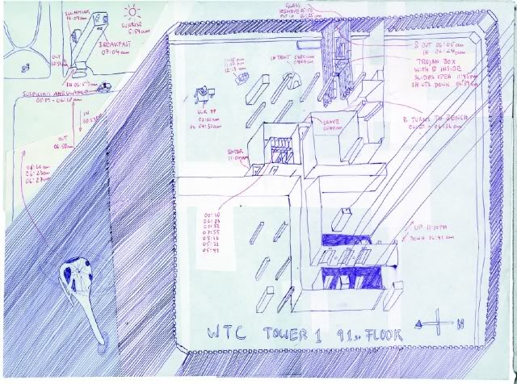
http://www.conspiracy-cafe.com/apps/blog/show/8636674-preparing-the-wtc-for-destruction referenced from http://www.gelitin.net and originally at
http://www.gelitin.net/mambo/index.php?option=com_content&task=view&id=20&Itemid=1 (NA)
My former radio show co-host George Freund of Conspiracy Café radio show on www.thatchannel.com presents a sound argument. Does it seem like a likely coincidence that an Austrian art group was given access to the 91st floor of the North Tower of the World Trade Center to remove windows, erect platforms outside the structure and leave material that could only be viewed by a helicopter upon close approach on a clear day? There are the left-brained and equally left-footed who insist that it is merely a coincidence, but for those in psychological denial they will always require direct rather than indirect evidence because they are incapable of lateral thinking and can’t read directions. Then there is the corroborating coincidence that the “art troupe” just happens to be named after an explosive called gelatin? That is an insulting in your face taunt by foreign terrorists, who like the psychopath John George Haigh are practically making an admission of guilt knowing that there is no hard evidence to convict like Acid Bath Murderer Haigh’s famous no corpus delecti plea. Then there is the fact that the “art troupe” is sponsored by a cultural group whose membership includes an Israeli agent who lived blocks from Mohammed Atta, the terrorist who hated modern art and crashed an aircraft into it. The “art troupe” also happened to live in the same neighbourhood in Wien, Austria that Anders Brevik had stayed in when he was living there. Then there is the likelihood that, if the above sketch showing an aerial view of Tower 1 or the North Tower were found in the hands of a Muslim, they would have a one-way ticket to Guantanimo Bay. And to top it all off the New York Times actually published a full page feature on August 18, 2001, just three weeks before the 9/11 attacks even showing pictures of the artists at work. How audacious is that? And how could the New York Times then overlook the significance of this when the events of 9/11 took place only three weeks afterwards? The fact that the New York Times never published a follow up article suggesting a tie in between the artists and the events of 9/11 or published an editorial from a perceptive reader related to the link speaks volumes about the paper’s management and who they are controlled by. The editorial board of the New York Times in hindsight should be interrogated by Homeland Security if it were the genuine body it claims to be in guarding the homeland. But instead they conduct raids on gun owners trying to protect themselves against the criminal cabal in power in Washington, who have completely shredded the Bill of Rights with the Patriot Act.
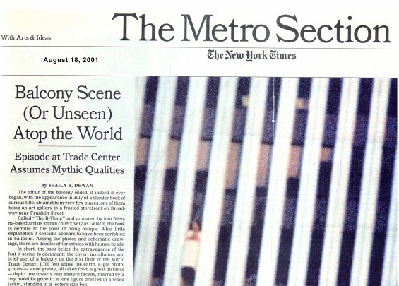
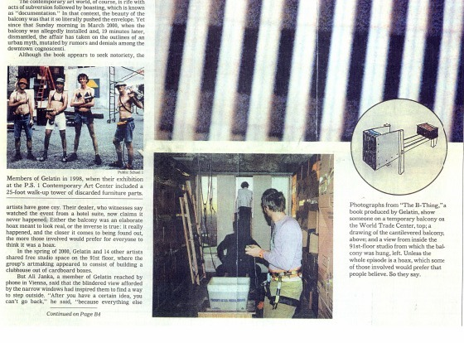
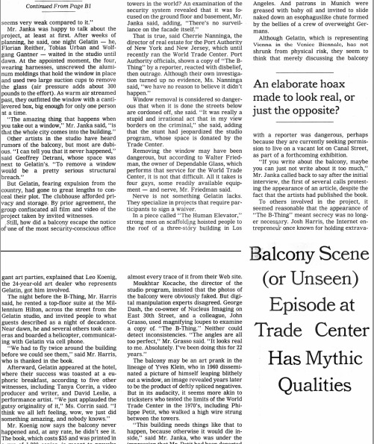
“Balcony scene or (unseen) atop the world,” http://www.nytimes.com/2001/08/18/nyregion/balcony-scene-unseen-atop-world-episode-trade-center-assumes-mythic-qualities.html?pagewanted=all&src=pm and published at http://www.gelitin.net/mambo/files/newspaper_articles/NYT180801.pdf

If this isn’t enough to show a MOSSAD link to 9/11, there is the corroborating evidence of Israeli involvement with the multiple arrests of Israeli nationals following the attacks in New York on Sept. 11. In an article published in the New York Post two days after the attacks, it initially identified the arrested suspects as illegal immigrants from the Middle East. They were apprehended in a white Chevy van near the Meadowlands based on a tip from witnesses who saw them “cheering” and “jumping up and down” in Liberty State Park following the attack. Port Authority police took the three suspects into custody as they drove along Route 3 in East Rutherford in the white van, which had the words “Urban Moving Systems” painted on it. After interrogating the men and searching the van in vain for explosives, the FBI turned the men over to the Immigration and Naturalization Service for deportation.
An article in the New Jersey paper, the Bergen Record, announced on the 12th that, some eight hours after the World Trade Center attacks, police in Bergen County detained five men who were purportedly found carrying maps linking them to the blasts. The five men, who were in a van stopped on Route 3 in East Rutherford around 4:30 p.m., were questioned by police but no charges had been laid. Sources close to the investigation said they found other evidence linking the men to the bombing plot. “There are maps of the city in the car with certain places highlighted,” the source claimed. “It looked like they’re hooked in with this. It looked like they knew what was going to happen when they were at Liberty State Park.” Sources also claimed that bomb-sniffing dogs behaved in a manner consistent with the detection of explosives. The FBI seized the van for further testing, authorities said.
In order to be unbiased and report things from both sides and to make an honest attempt at invoking the dialectic in this discourse, the Israeli papers portrayed the arrests as bungling on the part of the American authorities. According to the Arutz Sheva News Service, the five young Israelis were “on the verge of collapse,” as a result of their incarceration in New York on charges relating to the Bin Laden attacks. It is interesting that the Israeli paper referred to the Sept. 11 events as the “Bin Laden attacks”. Was this a pointed attempt to blame the so-called Muslim terrorist cell al-Qaeda and deflect blame away from Israeli intelligence? According to the Israeli national paper, the suspects were arrested on Sept. 11, only hours after the World Trade Center attack, on charges of “plotting to blow up” a New York bridge. Katie Shmuel of the Galilee town of Yokne’am, purportedly told reporters of the Israeli paper that her son Yaron was in “a very critical psychological situation,” since none of the suspects had been allowed to have visitors and the conditions in which they were being held were difficult. “The Israeli Consul-General in New York was allowed to visit only after asking several times and receiving a special permit,” Katie is reported to have said. “He was allowed to talk to them only in English, and only from behind a glass partition. The Consul told me that the boys are in a bad state and that they are being held under difficult conditions.”
When asked why the five youths, aged 22-26, were being held, Katie replied, “It’s ludicrous. They were on the George Washington Bridge at the time of the bombing, and the FBI had warnings of a terrorist plot, of guys in a white van, to blow up the bridge. So when the FBI saw this van, with my son and his four friends -- one of them had a large sum of money, there were two razor knives in the van, and one of the boys is named Omer, which the FBI guys thought was Omar -- they put one and one together and got three, and immediately arrested them... For the first few days, the boys were held in an FBI dungeon, tied up, with no clothes and no food.” It is interesting that the Israeli paper uses the name Katie instead of the woman’s family name Shmuel. This seems to be aimed at humanizing the story. The fact that the suspects are portrayed as victims being held under duress also wins sympathy points. It is clear that America’s hands are being tied, since Israel is setting the American authorities up for racism and anti-Semitism charges, a ploy used by many nations claiming historical victim status. It is also interesting that “Katie” alleges that the suspects were arrested on the George Washington Bridge, when the American papers reported that the van was stopped on Route 3 in East Rutherford. The Israeli newspaper Ha’retz acknowledged on Sept. 17 that these were the same men who were seen “celebrating” and “making mocking gestures” as the Twin Towers collapsed. The Jerusalem Post reported on October 26 that the Israelis were smiling as they photographed themselves with the collapsed towers in the background.
This was followed by another arrest of Israeli nationals reported in October of 2001. Two men police described as Middle Eastern were detained by federal immigration authorities after being found with detailed video footage of the Sears Tower in Chicago. Plymouth Police encountered the men after an officer responded to a call from Pizzeria Uno on West Ridge Pike at 2:40 p.m. Thursday for a report of illegal dumping. A manager there advised the police officer that a tractor-trailer was discovered by the dumpster at the rear of the restaurant. The manager noticed a freshly dumped pile of furniture adjacent to the Dumpster. The manager then confronted the vehicle’s operator. The man, who later identified himself as Moshe Elmakias, 30, denied that he did anything wrong and fled the scene, heading west on West Ridge Pike... The manager was able to provide township police with the Florida registration number of the tractor-trailer and said that a sign posted on the side of the vehicle read “Moving Systems Incorporated,” the same company name on the van found in New Jersey.
The area was searched by township police, and the vehicle was spotted parked in front of John Kennedy Ford on Ridge Pike. An officer proceeded to make contact with the occupants of the truck. A Middle Eastern man, later identified as Ron Katar, 23, exited the sleeper area of the cab and said that the operator was across the street as he pointed toward the Don Rosen Porsche dealer, reports said. While the Mercury paper avoids identifying the nationals as Israeli, misleadingly portraying them as Middle Eastern, and in the minds of a brainwashed and misled public, probably thought to be Arabs and Muslim. To anyone the least educated, the names of the suspects are clearly Jewish or Israeli names.
Elmakias and a white female, Ayelet Reisler, approached the vehicle from the dealership, when Reisler suddenly began walking in a different direction, acting as if she were not with Elmakias. Reisler was detained and her ID checked. She had a German passport in her name and medication in a different name, according to police. Both her evasive behaviour and use of an alias were obvious red flags. Elmakias allegedly admitted to being behind Pizzeria Uno, although he said that he did not dump furniture, he was only turning around. Elmakias said he was heading back to New York from whence he had come. He said he was in Plymouth because he was supposed to make a pickup in the morning. He then pointed toward the Storage USA facility on Belvoir Road. Elmakias could not, however, provide a name or telephone number of the customer.
Township police then asked for a Motor Carrier Program Inspector. Officer Gerald Schwartz of the Whitpain Police Department responded. Schwartz discovered through his investigation that the operator’s log had been falsified and suspended the vehicle’s license for violations. Inspection of the tractor-trailer’s contents revealed a load containing household items, including furniture and boxes. Among the items retrieved was a Sony video camera. Plymouth Police Officer David McCann reviewed the tape from the camera. Police reported the tape showed footage of Chicago with zoomed-in shots of the Sears Tower. Is it possible that they were taking footage of the Sears Tower as part of a surveillance operation for a future attack?
The Federal Bureau of Investigation was notified and all three subjects were taken to the Plymouth Police station. FBI Agents James Sweeney and Richard Tofani arrived at the station and proceeded to investigate both the subjects and their belongings assisted by Immigration and Naturalization Services. All evidence collected by Plymouth and Whitpain officers was then handed over to federal authorities.
Also in October of 2001 was another worrying report about Israeli nationals caught in highly suspicious circumstances. Six suspects were allegedly stopped by police in the Midwest but released, despite being caught with photos and descriptions of a nuclear power plant in Florida and the Trans-Alaska pipeline.
The Federal Aviation Administration imposed new flight restrictions around nuclear plants nationwide, and the Nuclear Regulatory Commission advised the nation’s 103 nuclear plants to fortify security. The FAA’s flight restrictions and the Nuclear Regulatory Commission’s security recommendations were in response to Ashcroft’s general alert rather than a specific threat. Ashcroft warned that Americans could be struck by another terrorist attack that week.
The incident in the Midwest apparently contributed to the new warning. In addition to the photographs and other suspicious material, they carried “box cutters and other equipment.” They appeared to be from the Middle East and held Israeli passports. Immigration and Naturalization Service released the suspects after determining that their passports were valid.
The FBI declined to comment. An INS spokesman called the report unfounded. “We have absolutely no information at this point in time to substantiate that story,” said the agency’s Russ Bergeron. It could not be learned in what state the six men were stopped or how they aroused suspicion. It was not known whether their true identities matched those on the passports, or why the FBI was not releasing their names or descriptions. This is highly suspect behaviour on the part of the U.S. authorities. It suggests pressure from Washington or Tel Aviv to not hold the suspects and to not release information about the suspects, especially their Israeli identities.
Investigators suspect the men changed cars and fled the jurisdiction, possibly to Canada. Ashcroft and FBI Director Robert Mueller were “furious” that the INS released the suspects without notifying the FBI. Ashcroft and Mueller appeared Monday evening at a news conference to announce that the government had “credible” but vague information that another wave of terrorist attacks could strike Americans within a week.
Spokeswoman Rachel Scott said nuclear plants remained at the highest alert level. “We are in very close communication with all levels of law enforcement, including the FBI, to ensure we have the security measures in place to protect the plants.” The FAA restricted all flights below 18,000 feet and within 10 miles of 86 “sensitive nuclear sites.” Exceptions were allowed for law enforcement, medical and firefighting flights.
Then there is the testimony of the New Jersey police officer responsible who captured the five Israelis who filmed and celebrated while the World Trade Center towers burned. He broke silence when he agreed to a Sept. 16 exclusive interview with American Free Press. The five Israelis he identified as suspects in the Sept. 11 attacks worked under the direction of Urban Moving Systems, a Mossad front company at the center of Israeli involvement in the Sept. 11 attacks. Sgt. Scott DeCarlo has never spoken to the media about the details of that day except for two 30-second cameo appearances in Internet videos from undetermined sources. In fact, DeCarlo confirmed that this is the first and last interview he will ever grant in regard to this subject. DeCarlo revealed to AFP hidden details about the events of 9-11 that mainstream media venues should have uncovered ten years previously, if not for their near-total blackout of meaningful coverage where Israel is concerned. DeCarlo’s direct evidence confirms that Israel dominates foreign and domestic policy initiatives within the United States.
Although not scheduled to work that day, DeCarlo reported in for duty anyway and “was posted on the highway” to prevent traffic from entering New York City. “There was a BOLO, which is a ‘Be On the Look Out’ for a particular van, perhaps loaded with explosives,” explained DeCarlo, “that may have been on its way to destroy the George Washington Bridge.”
DeCarlo explained: “It [the suspicious van] happened to come our way, and I grabbed my sergeant [DeCarlo himself was a patrolman at that time] and said: ‘Hey, man, that’s our van.’ It wasn’t the exact license plate given reported -- it was off by one numeral -- but I said: ‘That’s gotta be it; it’s just too close.’” He continued: “The van was coming off the [N.J.] Turnpike trying to get on Route 3. Traffic was rolling at two miles an hour, so we got in front of the van on foot, weapons drawn, and stopped it.”
All five of the Israeli spies refused to exit their vehicle, so DeCarlo was forced to get physical. “We asked them to get out of the van, but they didn’t listen,” he said. “So, we . . . put them in handcuffs and did it as quickly as possible.” AFP asked DeCarlo why he thought the Israelis refused to follow his orders. DeCarlo was unsure, but asked this writer, “You ever have a gun pointed at your head?” The true answer to the question is that agents involved in covert ops are trained to show dumb obstinacy in situations involving domestic authorities interrogating or arresting them. They are trained not to cooperate and to never answer questions.
DeCarlo then described what happened after the spies were dragged from their van. “When we removed them, one of the guys that was rather chatty said: ‘We’re not your enemy; we’re your friend. Our enemies are your enemies,’” DeCarlo said. “At that point they said they were from Israel. They kept saying, ‘Hey, we’re on your side.’”
“We brought them over to the New Jersey State Police holding cells in the Meadowlands Stadium, and that’s the last I saw of them,” he said. The FBI reportedly took charge of the investigation from there. The five Israelis were held for ten weeks, but were eventually deported to Israel on charges of immigration violations. In November 2001, they appeared on an Israeli TV talk show discussing how they were in the U.S. “to document the event.” The fact that the agents were working for a Mossad front company, whose vans turned up in different states with agents involved in shady activities suspiciously resembling covert ops speaks volumes despite the silence of the deeply corrupt Zionist-controlled mainstream media. Understandably, Sgt. DeCarlo asked AFP to ask interested parties not to contact him. He knew his life was in danger as anyone would be if they were in his shoes. Anyone who doubts this and dismisses it as conspiracy theory is either too sheltered by privilege or is of an opportunistic nature, seeking only career advancement within a fascist corporate culture, where it is considered impolitic to question the government and the fraudulent war on terrorism.
In March 2001, former Operation Gladio agent, Vincenzo Vinciguerra, stated in sworn testimony, “You had to attack civilians, the people, women, children, innocent people, unknown people far removed from any political game. The reason was quite simple: to force … the public to turn to the state to ask for greater security.” For those unfamiliar with Operation Gladio, it was a rogue intelligence network established by NATO that undertook bombings across Europe in the 1960s, ’70s and ’80s. It was Gladio’s specialty to carry out “false flag” operations -- terror attacks blamed largely on communist insurgents, since communism posed the greatest geopolitical threat to Europe at the time.
The former Italian Francesco Cossiga, who confirmed the existence of Operation Gladio, told Italy’s oldest and most widely read newspaper that the 9/11 attacks were a joint operation of the CIA and Mossad, said to be common knowledge among the world’s intelligence services. Cossiga told the newspaper Corriere della Sera: “All the [intelligence services] of America and Europe know well that the disastrous attack has been planned and realized from the Mossad, with the aid of the Zionist world in order to put under accusation the Arabic countries and in order to induce the western powers to take part in Iraq [and] Afghanistan.”
Cossiga first expressed his doubts about 9-11 in 2001, when 9-11 researcher Webster Tarpley quoted him as saying “The mastermind of the attack must have been a sophisticated mind, provided with ample means not only to recruit fanatic kamikazes, but also highly specialized personnel. I add one thing: it could not be accomplished without infiltrations in the radar and flight security personnel.”
A widely respected former head of state, Cossiga is convinced 9/11 was an inside job, which is common knowledge among global intelligence agencies, just one more shocking confirmation ignored by America’s print and TV propaganda machine, where eighty percent of the world’s print publications are located. Despite the corporate media blackout on his startling claim, Cossiga cannot be discounted as a crackpot due to his experience and status in the world.
It was later learned from two El Al sources, who worked for the Israeli airline at New York’s John F. Kennedy airport, that on 9/11 an El Al flight was authorized to take off for Tel Aviv. This was hours after the Federal Aviation Administration (FAA) grounded all civilian domestic and international incoming and outgoing flights to and from the United States. The El Al Boeing 747 was fully loaded with passengers and took off from JFK bound for Tel Aviv’s Ben Gurion International Airport. The two El Al employee sources are not Israeli nationals, but legal immigrants from Ecuador who were working in the United States for the airline.
The flight departed JFK at 4:11 pm and its departure was, according to the El Al sources, authorized by the direct intervention of the U.S. Department of Defense. U.S. military officials were on the scene at JFK and were personally involved with the airport and air traffic control authorities to clear the flight for take-off. This is strong evidence that 9/11 was a combined American and Israeli operation designed to frame Muslims. The intervention by the DoD suggests that the Israeli passengers on board the flight were meant to be spirited out of the country amid great secrecy. The intervention by the DoD suggests DoD complicity and involvement in 9/11, which explains the anomalies reported at the Pentagon, which should have been protected by the surface-to-air missile defence system, which should have shot down anything approaching the Pentagon Building.
According to the 9/11 Commission report, Transportation Secretary Norman Mineta ordered all civilian flights to be grounded at 9:45 am on September 11. The New York Air Traffic control centre’s audio tape of recollections of air traffic controllers made an hour and a half after the 9/11 attacks were destroyed by an air traffic control manager. He apparently did not face criminal charges for destroying physical evidence on the worst terrorist attack in American history. The Transportation Department later claimed the destruction of the tape was the result of “poor judgment”. It is called tampering with evidence and it is a crime. He was probably a dupe instructed to do it to blame an act of wilful negligence on a seeming incompetent.
The El Al flight took off two days before commercial flights were allowed to resume on September 13. September 14 was the date slated for private flights to resume. If this wasn’t enough of a security breach on September 13, a chartered Lear jet flew three Saudis, including a member of the Saudi royal family, from Tampa to Lexington, Kentucky. On September 14, a chartered Northstar Aviation flight flew four Saudis from Providence, Rhode Island to Paris.
On August 22, 2005, WMR reported:

Four Americans flew with ‘Air Bin Laden’ flight transporting Bin Laden family members to Saudi Arabia and Europe nine days after 911. The post-911 domestic flights of Bin Laden family members out of the United States with the sanction of the Bush White House were not the only instances where Americans have flown with the family that spawned “Al Qaeda” leader Osama Bin Laden. WMR has obtained a passenger list from a September 20, 2001 Aero Services private charter flight from Le Bourget Airport, north of Paris, to Geneva, and on to Jeddah, Saudi Arabia (King Abdulaziz International Airport-OEJN). On the list are a number of Bin Ladens, as well as four Americans, including a Los Angeles Police Department officer named Jason Blum who flew to Le Bourget from Los Angeles. A previous list provided to Sen. Frank Lautenberg showed Mr. Blum departing from the Bin Laden party in Boston. The newly obtained list shows he accompanied the Bin Ladens to Paris Le Bourget. The other three Americans on the passenger list are J.P. Buonono, Joseph Allen Wyka and Ricardo V. Pascetta.
Although much has been written about Bin Laden family being spirited out of the country in the days after 9/11, the El Al flight on the afternoon of September 11 is the first instance of Israelis departing the United States while commercial traffic was grounded. There have also been reports that the FBI seized FAA records concerning the events of 9/11 from the New York Air Route Traffic Control Center in Islip, Long Island. The ARTCC holds authority over flights out of JFK. This act points to obstruction of justice by a rogue element within the FBI due to the wrongful confiscation of evidence.
Then we have Osama bin Laden’s denial of involvement. No evidence has ever been produced to implicate bin Laden. What is more interesting than Bin Laden’s denial of involvement is his assertion that the Uncle Sam is pointing one finger at him while three fingers are pointing back at Uncle Sam. “I have already said that I am not involved in the September 11 attacks in the United States. I had no knowledge of these attacks, nor do I consider the killing of innocent women, children, and other humans as an appreciable act. There exists a government within the government of the United States. That secret government must be asked as to who carried out the attacks...The United States should trace the perpetrators of these attacks to those persons who want to make the present century a century of conflict between Islam and Christianity so that their own nation could survive.”

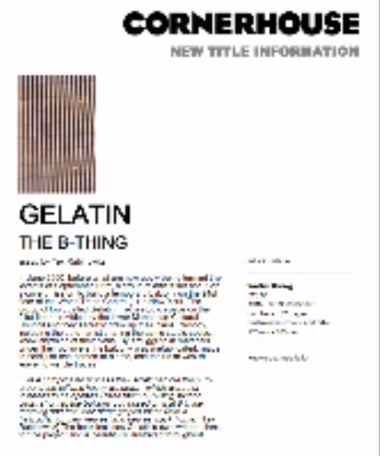
http://www.conspiracy-cafe.com/apps/blog/show/8636674-preparing-the-wtc-for-destruction referenced from http://www.gelitin.net

Gelatin: The B-Thing
Walter König, Cologne, 2001
ISBN: 3-8837-507-9
32 pages, colour throughout, embossed hard covers
Text: Tex Rubinowitz
Photos: Maria Ziegelböck, Thomas Sandbichler, Susanne Wimmer, gelatin
Layout: Johannes Heuer

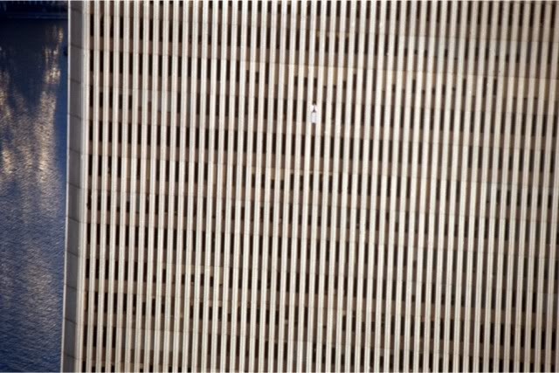
http://www.conspiracy-cafe.com/apps/blog/show/8636674-preparing-the-wtc-for-destruction referenced from http://www.gelitin.net

Though a little hard to see in this photo there does appear to be a platform in an upper floor level of the World Trade Center. Though grainy and not plainly visible to the eye, there does appear to be some kind of structure mounted on the outside of the tower. Is it possible that this installation is a homing beacon of some kind meant to emit a homing signal to an incoming CIA drone plane painted with the colours of a passenger airliner to make it resemble a United Airlines or American Airlines passenger airliner?

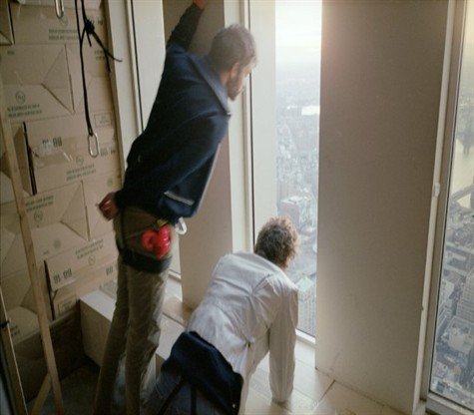
WTC 1 B-Thing Israeli art students ready to remove a window from Gelatin: The B Thing
http://www.conspiracy-cafe.com/apps/blog/show/8636674-preparing-the-wtc-for-destruction referenced from http://www.gelitin.net

Here the Israeli -- and most probably Mossad agents -- lean over to survey the outside of the Tower. They are wearing harnesses and appear to have hooks for abseiling gear. Is it possible that they were able to access other staging areas or floor levels to install explosives or wire the building for controlled demolition on other floor levels of the Tower? There is no question that the hook suspended from the ceiling is installed at that height level in order to permit the agents to abseil down the outside of the Tower. Why else would the line and hook be attached to the ceiling of the 91st floor?
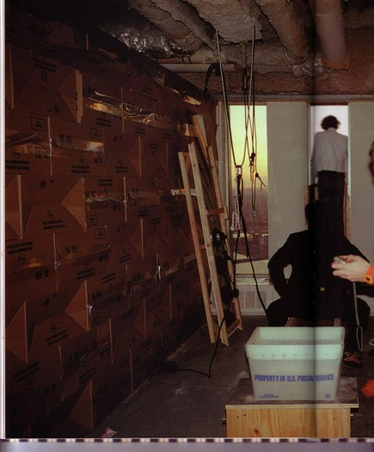
http://www.conspiracy-cafe.com/apps/blog/show/8636674-preparing-the-wtc-for-destruction referenced from http://www.gelitin.net

Gelatin members are shown in their construction rigging and apparatus for the observation deck. What if these boxes are actually explosives? What if other spaces on other floor levels were similarly packed? The agent in the window, posing as a member of the art troupe, is clearly leaning out of the building. It is obvious from his posture, and the fact that his right shoulder is hidden from view on the other side of the window frame, that he is actually leaning out the window. As the article in the Metro section of the New York Times suggested, Gelatin has actually removed a window from the World Trade Center, permitting this agent to tilt his head and lean part of his body outside. From the inclined position of his head, it is clear that he is actually hovering outside of the window frame, allowing him to stare at the New York street scene below. Audacity is one of the mottos of the Illuminati, and any intelligence service like Mossad under their control would be no less audacious. It would be part of their M.O. This brazen group of agents are behaving as though they have complete impunity to do as they wish. We have seen this before. It would only be possible for agents to infiltrate the World Trade Center complex and pull something like this off if there were inside collusion. Someone with authority over the security detail of the building must have allowed these men to circumvent the building’s security. Meanwhile, the behaviour of the agents, both in staging the brazen art exhibition on the 91st floor and doing so openly, shows that they are being protected by very high level officials within the government of Israel and someone on the inside at the highest levels of the U.S. government. There is no other way they could be this openly brazen and audacious. As we can see from the arrests of the various Israelis, who were driving the white vans owned by the Mossad front company Urban Moving Systems, they were immune to prosecution. No matter what the police or FBI had on them, some Illuminati agent high up in the FBI put a stop to the investigation. In each case the Israelis were sent home under the pretext of some kind of immigration irregularity, when they were clearly in the country doing something far more serious than entering or trying to stay in the country illegally. Anyone can see that their behaviour is ludicrously suspicious, and if the shoe were on the other foot, and foreigners had behaved this way in Israel were that nation under attack, the foreigners would be arrested, tried under a kangaroo court and would never see daylight again. These Israelis were taking part in an operation. Anyone can plainly see that. Someone much higher up the pipe, possibly the Director or Deputy Director of the FBI issued stand down orders on this investigation. Perhaps orders were ultimately issued from the White House. Whatever the case may be, orders must have been given. There is no way these Urban Moving Systems agents had not committed any wrongdoing. The very fact that they were caught celebrating the attacks on the World Trade Center is itself an offense that would get you shot in the Middle East. If westerners had behaved that way during an act of terror in any Middle Eastern country, they would have taken a bullet on the spot and questions would have been asked later.

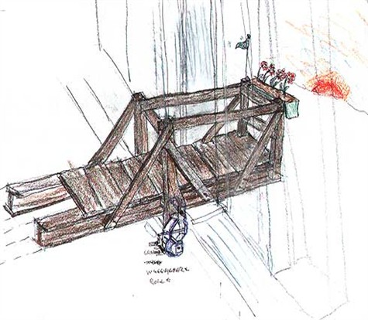
Diagram of observation deck
http://www.conspiracy-cafe.com/apps/blog/show/8636674-preparing-the-wtc-for-destruction referenced from http://www.gelitin.net

The sketch of the observation deck or platform above has a flower pot at one end. It is as if the platform has been disguised to look like something else. It is also made of wood so that it looks more like an outdoor deck or patio meant for leisure and relaxation. There is what looks like a safety harness hanging from it, but which has a strange electronic device at the end. Is this a homing device of some kind to ensure that the CIA jumbo jet painted to look like a passenger airliner can home in on its target? The truth is there were probably no hijackers or passengers on board. The truth is there probably were no passenger airliners, period. If they were planning to do something as audacious back in 1962 as taking a CIA-owned jumbo jet from Langley Air Force Base and painting it to look like a passenger airliner, with plans to shoot it down and blame the attack on Cuba, it stands to reason that they might do something just as audacious or even more so in 2001. As the declassified memorandum known as Operation Northwoods would attest they were even planning to have a fake passenger list on board with fake funerals for the bereaved families.

“Operation Northwoods,” referenced at http://www.gwu.edu/~nsarchiv/news/20010430/northwoods.pdf
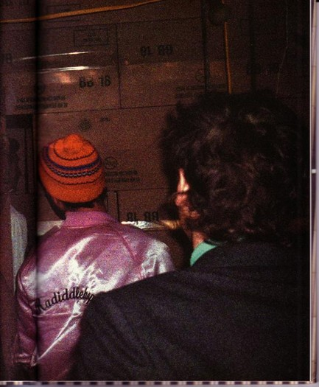
Boxes framing the observation deck area
http://www.conspiracy-cafe.com/apps/blog/show/8636674-preparing-the-wtc-for-destruction referenced from
http://www.gelitin.net

In this sketch from Gelatin: The B Thing, it hardly seems by appearances sake that these men are taking part in an art exhibition. It looks more like they are stealthily creeping around the 91st floor and taking care to ensure the coast is clear. There does not seem to be anything natural about the photo from an artistic standpoint. The agent with the orange ski hat is cocking his head to one side as if to peer around the corner, apparently to see if the coast is clear.
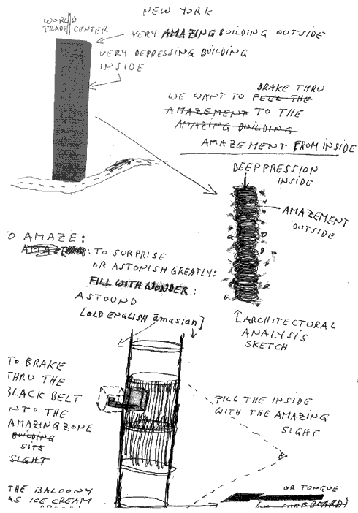

http://www.conspiracy-cafe.com/apps/blog/show/8636674-preparing-the-wtc-for-destruction referenced from http://www.gelitin.net

There can be little mistake that the sketch above is a cleverly disguised installation plan for a controlled demolition under the cover of an art sketch. The fact that there is an arrow pointing from the intact and pristine tower to one that is blowing up speaks volumes. The captions on the intact Tower read “very amazing building outside” and “very depressing building inside”. As for the illustration of the Tower after it has been attacked, an arrow is shown pointing down at the top of the Tower with a caption reading “DEEPPRESSION INSIDE” and another arrow pointing at the Tower from the side with another caption reading “AMAZEMENT OUTSIDE”. There is another sketch of the North Tower at the bottom with a right angle square drawn with a caption reading “FILL THE INSIDE WITH THE AMAZING SIGHT”. This seems to allude to the explosives to be planted on the inside, which once detonated, will create an amazing spectacle, which the 9/11 event most definitely did, a worldwide spectacle such as the world had never before seen televised.
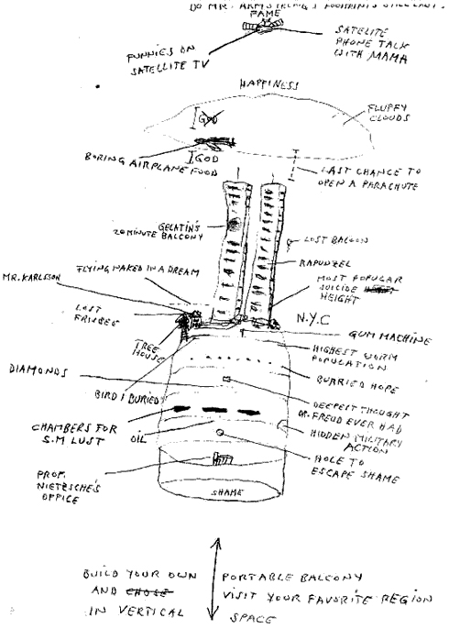

http://www.conspiracy-cafe.com/apps/blog/show/8636674-preparing-the-wtc-for-destruction referenced from http://www.gelitin.net

The sick jokes in the captions in the above sketch show a psychopath’s humour. Not only do the jokes show a complete lack of empathy, the sketch of a fictional installation below the Towers shows a psychopath’s analysis of the human psychology of shame, and how he and his cohorts have completely managed to escape any moral compunction or shame to do with the future event they are planning to stage. There is a suggestion that they reside with Prof. Nietzsche in his office in some fallout shelter beneath the Towers. These agents are protected by the privilege of the military intelligence elect, who have carte blanche authority to commit murder and even mass murder for which they can never be brought to justice because they are protected by the military intelligence and their own government higher-ups along with the American government. How could military intelligence units be granted so much immunity and oversight unless they have actually hijacked and gained control of the governments of Israel and the United States? These Israeli agents provocateur posing as art students are psychopaths and have been handpicked for their psychopathy, since no one else would be able to perform mass murder on this scale without finding “a hole to escape shame” in the subconscious, which appears to be what the underground fallout shelter beneath the Towers shown above represents. In addition, the reference to Nietzsche is most apropos, since it was the German philosopher that created a philosophical endorsement of psychopathy with his prescriptions of going “beyond good and evil” in a no man’s land beyond values, in a twilight realm beyond God and moral valuations.

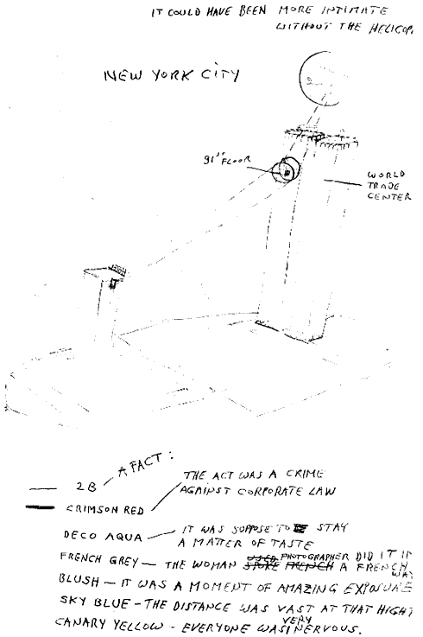
http://www.conspiracy-cafe.com/apps/blog/show/8636674-preparing-the-wtc-for-destruction referenced from http://www.gelitin.net

The circled installation on the 91st floor must surely be a homing beacon meant to be intercepted by a close passing helicopter. The sketch ‘artist’ refers to a helicopter and suggests, “It could have been more intimate without the helicopter.” It seems obvious that the installation represented in the sketch is meant to be a homing beacon for a helicopter. This must all be part of the staging for the future 9/11 terrorist attacks. It is powerful circumstantial evidence in the form of documentary evidence, but in the absence of hard physical evidence, it is unlikely it will ever see its day in court. The government of the United States saw to that. They removed all evidence of the crime with unseemly haste, tampering with the crime scene, a felonious offence for which anyone else would have been indicted. The colour coding above appears to be a disguised reference to the colour coding for security alertness, which is actually as follows:

Condition Blue: Mentally preoccupied, unaware of surroundings, people and possible threats.

Condition Green: Very aware of the surrounding environment, people and/or potential threats.
Condition Yellow: Maintaining a state of suspicious alertness due to perceived potential threats.
Condition Orange: Fully aware of present dangers /threats detected.
Condition Red: Aware of imminent dangers/ threats and prepared to act.
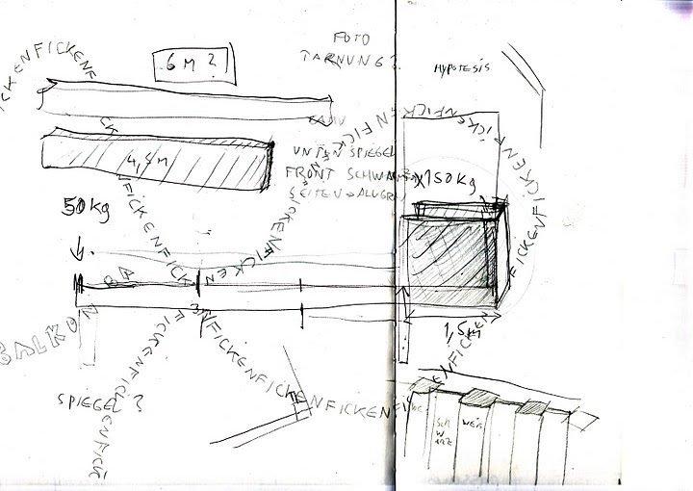
http://www.conspiracy-cafe.com/apps/blog/show/8636674-preparing-the-wtc-for-destruction referenced from http://www.gelitin.net

As for the sketch shown above, unter Spiegel means ‘under mirror’, while Foto Tarnung is German for ‘photo camouflage’. Ficken is German for the ‘f-word’. Seiten means ‘pages’. The word Balkon can also be seen, another reference to the existence of a ‘balcony’. What is the import of all the ejaculations of Ficken? What is implied? It seems obvious that there is an attempt to employ mirrors to conceal the presence of the balcony as a kind of camouflage so that it might not be seen from the ground.

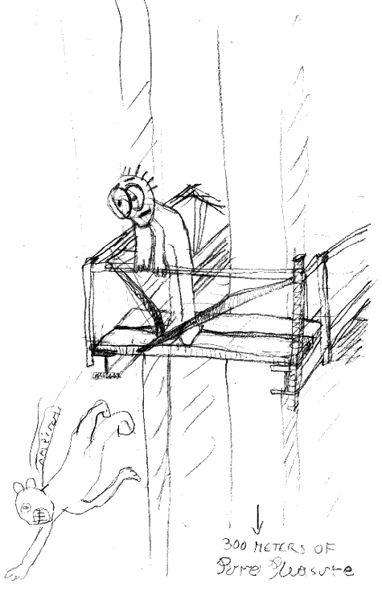
http://www.conspiracy-cafe.com/apps/blog/show/8636674-preparing-the-wtc-for-destruction referenced from http://www.gelitin.net

Here is another piece of psychopathic art from Gelatin: The B Thing. The figure leaning over the platform staring at a falling man appears to be rather bug-eyed and astonished. The falling man is racing through the air toward the street below. The figure is screaming as he falls. The caption displayed is illegible, so it is impossible to guess what he is saying. Many people feel that the falling figures appeared staged, as though they were set up. That is plausible since there is a photo from The B Thing art exhibition showing mannequins. The mannequins also look like they are mounted on some kind of staging platform apparatus. Were these installed on the 91st floor so that they could be seen falling from the Towers at the appointed time?

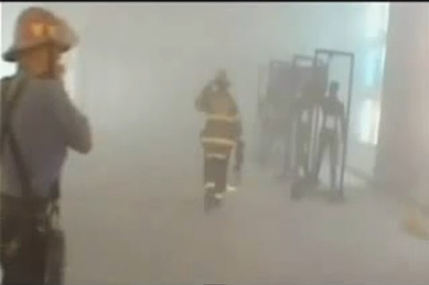
Mannequins used in The B Thing

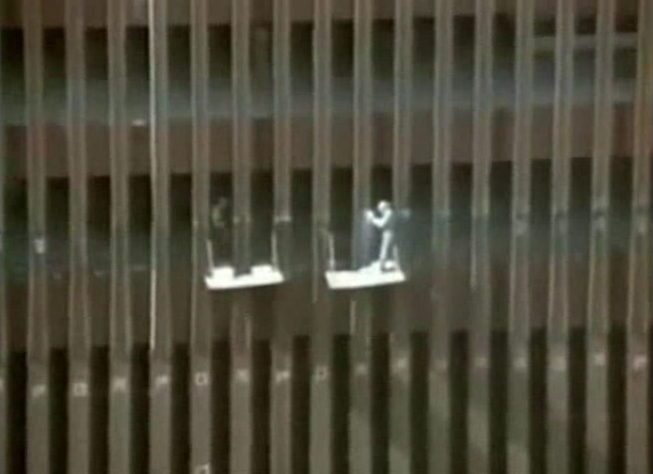
http://www.conspiracy-cafe.com/apps/blog/show/8636674-preparing-the-wtc-for-destruction referenced from http://www.gelitin.net

In the rather grainy photo above from the Gelatin website, workmen can be seen working on an upper floor level of the Tower, presumably the 91st floor. The workman on the left is inside Tower One and in plain view, suggesting that the window pane has been removed so that he can be clearly seen. He is definitely within the window frame of the building and looks to be leaning against the frame. This must be the window pane where the Gelatin member was seen looking out from within the 91st floor level at the street below. The other man is standing outside on what appears to be a platform mounted on the outside wall rather than a scaffold. He appears to be attaching something to the outside wall of the Tower. Could he be installing some kind of homing device so that an aircraft with a guidance system can home in on the Tower as a target?

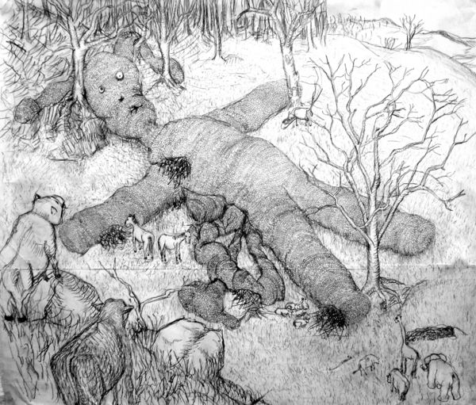
http://www.conspiracy-cafe.com/apps/blog/show/8636674-preparing-the-wtc-for-destruction referenced from http://www.gelitin.net

The above sketch from Gelitin: The B Thing is one of the sickest examples of this psychopathic pseudo-art troupe’s art. The fact that the doll is a rabbit brings such words and expressions to mind as “hop”, “jump”, and “quick like a bunny”. The doll has the stuffing knocked out of it and is lying prostrate as though it has fallen from a great height. Its button eyes also appear cross-eyed, implying a victim that has suffered a concussion-like injury. There is also a broken seam along the doll’s left side and what looks like an intestine spilling out. Animals are gathered near the stricken creature, with two miniature horses seen grazing on the straw falling out of the stuffed doll. To the left are domestic animals that would not look out of place in an illustration from George Orwell’s Animal Farm, perhaps representing the political impact of the future 9/11 event on the developed world, where people will be forced into a feeding frenzy in which the entire social system will be cannibalized to the point of desperation, where people might even be forced to eat each other figuratively or literally. To the right are African wild animals, possibly representing the fallout effects of 9/11 on the people of the developing world. They look to be observing passively from a distance, as though marginalized from the conflict and not directly affected.

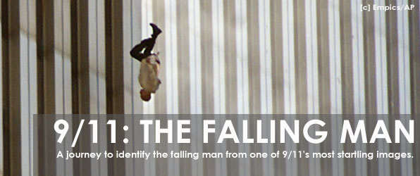
Richard Drew’s AP photo of Falling Man

The above photograph is now iconic. It is so famous it might even be one of the most emblematic images of our time. Richard Drew works as a photo-journalist for the Associated Press. He is most famous for his photo “The Falling Man”, which is the only iconic picture showing a man falling from the World Trade Center towers following the September 11, 2001 attacks. In order to understand the full implications of Drew’s affiliation with the Associated Press, it is necessary to examine what AP is as an entity. First off, it is a not-for-profit cooperative owned by its 1,500 U.S. daily newspaper members. An elected Board of Directors then runs the cooperative on behalf of its affiliate membership. AP has a distribution outreach to half the world’s population, serving 1,700 newspaper and 5,000 radio and TV outlets in the U.S. as well as newspaper, radio and TV subscribers around the world.
The photo-journalist Richard Drew seems to have a penchant for being in the right place at the right time, since he was one of only four press photographers at the scene of Robert F. Kennedy’s assassination. Drew has been an Associated Press photographer for over forty years and lives in New York City.
We are told that the picture of “the Falling Man” was taken at 9:41:15 am EST on September 11, 2001. The man in the photo has supposedly been “positively” identified as Jonathan Briley. How can they be so certain of this based on such visually unclear documentary evidence and dubious testimony by friends and family of the identified man? The picture is far from clear and the man’s face is hidden from view. Given all the other fabrications and cover-ups related to 9/11 is this story any more reliable than the others? Given that Gelatin appears to have used mannequins in its art exhibition, is it inconceivable that Drew was able to get just the “right look”, as he described it, by having a pre-planted and pre-selected mannequin on the scene to photograph, perhaps one left behind by the art troupe Gelatin when it was on site staging its exhibition just months before the 9/11 attacks? A falling victim does not fall in this position. The instinctual reaction is to throw one’s arms out in an attempt to impede and slow one’s fall. Falling straight down with a lifeless looking hooked hand and a lifeless looking arm is a posture more befitting of a falling corpse or mannequin than a falling man.
The identity of the Falling Man was not initially officially confirmed. Because of the number of people, who were purportedly forced out of the towers by the smoke and flames, were blown out, or forced to jump, identifying the man captured in the twelve photos was not an easy task. At least two hundred people purportedly fell to their deaths that morning, according to witnesses at the scene. Initially, the faller was identified by The Globe and Mail reporter Peter Cheney as Norberto Hernandez, but when the family looked at the whole series of pictures, it was clear that it was not Hernandez. Three other families claimed that he was their relative, but after careful analysis of the photo this was disproven.
Finally, the Falling Man was identified by chef Michael Lomonaco as Jonathan Briley, a 43-year-old employee of the Windows on the World restaurant. Briley was a sound engineer who lived in Mount Vernon, New York and worked in the North Tower restaurant. According to the film, the victim was initially identified by his brother, Timothy. Lomonaco claims that he was able to identify Briley by his clothes and body-type. In one of the pictures, the Falling Man’s clothes were blown away, revealing an orange undershirt similar to the shirt that Briley wore to work almost every day. His older sister, Gwendolyn, asserted he was wearing that shirt on the day of the attack. She told reporters of The Sunday Mirror, “When I first looked at the picture...and I saw it was a man -- tall, slim -- I said, If I didn’t know any better, that could be Jonathan.” A charity has been set up for Briley’s family, and many news programs have aired his story as being the one of The Falling Man. Were the charitable donations an incentive for the family to tell their ‘story’ perhaps? Another of Briley’s brothers, Alex, was an original member of the 1970s disco group The Village People.
Falling victims do not fall this way. The instinctive reaction of a falling victim is to throw the arms out laterally in an effort to impede and slow one’s descent. The lifeless hooked hand and lifeless arm suggest either that the victim has already succumbed and is a lifeless corpse or is not a human being at all, but a mannequin. The shape of the head does not look natural. The posture of the legs looks posed as well like that of a mannequin being prefigured into a set pose before being flung from the tower. Was this one of the mannequins included in the art installation on the 91st floor of World Trade Center Tower 1?

Mannequins used in The B Thing

The fact that firefighters are also shown taking part in a photo from “The B Thing” art exhibition suggests all the world’s staged once again. The fact that this exhibition was staged on the 91st floor of Building 1, which displays the signature of the future event, defies coincidence and points to prior planning, premeditated mass murder and conspiracy. The fact that there are 19 floors from the 91st floor to the 110 floor, which is the top floor, provides further evidence for prior planning, since 119 is the emergency code for the Middle East. But even more horrifyingly, it shows that the premeditation goes back even further to the construction of the World Trade Center complex itself. It is not so difficult to imagine, however, when we consider that the Great Work of Ages is encoded in the Washington street plan itself, suggesting that the planning of these events does not occur over days, weeks or months or even years, but over decades, and the evidence would show, even centuries.
Don’t believe it? Then why is the Great Pyramid of Egypt incorporated into the street plan of Washington D.C.? Pyramidologists like Piazzi Smyth have long argued that the Great Pyramid is a prophecy in stone, so wouldn’t the Washington Street Plan also be a prophecy?

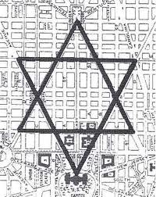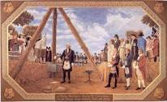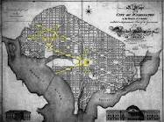

  - 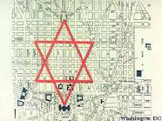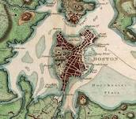
  - 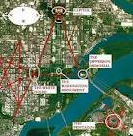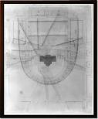

The Great Pyramid in Washington is located at the first point at Independence Ave. and 1st St., where the Cannon House Building is located, draw a straight line across Independence Ave. to Arlington Cemetery, forming the foundation of the Great Pyramid. Going back to Independence Ave. and 1st St., a straight line is drawn through the Capitol Dome, Logan Circle to the apex of the pyramid found at U St. and 16th Ave. Then from the apex, a line is drawn along New Hampshire Ave. through Logan Circle, Washington Circle to Arlington National Cemetery. The passage system of the Great Pyramid is also laid out in the street plan of Washington. The descending passage or well shaft is Maryland Ave. starting at the U.S. Capitol Building and ends at the Jefferson Memorial, which corresponds with the subterranean chamber of the Great Pyramid. The ascending passageway leading to the grand Gallery of the Great Pyramid is Pennsylvania Ave. ending at Freedom Plaza, the Queen’s Chamber passageway is Constitution Ave. The area between the ascending passage (Pennsylvania Ave.) and the Queen’s chamber passageway (Constitution Ave.) is Federal Triangle. The ceiling and the relieving stones in the King’s chamber of the Great Pyramid are composed of I St, K, St, L St, De Salle’s St, and M St. The ceiling of the King’s chamber forms into a pointed roof with Rhode Island Ave. between Connecticut Ave. and Scott Circle and Massachusetts Ave. between Scott Circle and Thomas Circle. The sides of the chamber are framed by 17th St., 15th St., and the meridian of the pyramid drawn through the apex of the King’s Chamber ceiling down to the subterranean chamber formed by the Jefferson Memorial up to the apex of the Great Pyramid, which is formed by 16th Ave, which passes through the Meridian Hill Park. Within this sacred geometry is Station Stone rectangle also found at Stonehenge formed from K St. between Washington Circle and the 13th St., 13th St. between K St. and Logan Circle, P St. between Logan Circle and 23rd St., and 23rd St. P St. and Washington Circle. The perimeter of Station Stone Rectangle in Washington corresponds with the length of one side of the Great Pyramid at Giza, the perimeter also equals the foundation line of the Great Pyramid formed in the street plan of Washington. The Nile River in Egypt forms a delta branching to the left and to the right. The Potomac River also branches to the left and to the right.
Whether elaborate hoax or not, the participants in this art exhibition performance piece must have had prior knowledge of the future 9/11 attacks. Further evidence of this can be found in the photo from Gelatin: The B Thing, in which firefighters are shown in action. How could they have had the foresight to stage the event on the 91st floor of building number 1 and include firefighters in the exhibition when both are key signatures of the future act of terror? The inclusion of mannequins in the exhibition provides additional evidence of prior knowledge, since Richard Drew’s AP photo appears to be black ops propaganda employing a mannequin as opposed to a genuine victim. Is it conceivable that mannequins were left behind in Building 1 so they could be thrown from the WTC Tower on 9/11?
Drew claims he was shooting models the morning of the September 11 attacks at a maternity fashion show in Bryant Park, “because it featured actual pregnant models.” Why say “because it featured actual pregnant models”? Is there some underlying significance to the statement? Is this some kind of occult ritual? The fact that the models are pregnant seems to suggest that they and their progeny represent the promise of the next generation. The fact that they are being photographed in advance of the Falling Man suggests that their future is not so hopeful and that their futures will end like that of the Falling Man in a state of hopelessness and helplessness.
Richard Drew claimed that, in the middle of the show, a CNN cameraman wearing an earpiece purportedly announced that a plane had crashed into the North Tower. Drew claimed that his editor then rang his cell phone. He added that he packed up his equipment and “gambled” on taking the subway downtown. The operation of the subway system was suspended due to the emergency, but he said he was able to catch the last subway train running, claiming that he was the only one on board. He added that he arrived just in time to see the jumper leap to his death as the South Tower imploded virtually simultaneously. Regarding the photo of the Falling Man, he commented, “You learn in photo editing to look for the frame. You have to recognize it. That picture just jumped off the screen because of its verticality and symmetry. It just had that look.” He ignored all the other photos in the sequence, which suggests that there was a preordained “look” he was hunting for. This suggests that he had “professional obligations” to fulfill. In other words, he had been given an assignment to photograph the “Falling Man” according to preordained specifications. Witnesses on the scene claim that there were as many as two hundred jumpers, but only one iconic image was chosen for international syndication. Why?

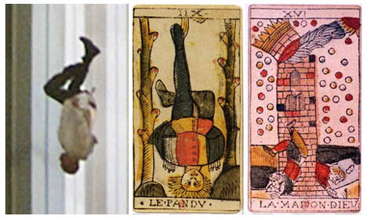
The Falling Man is based on Tarot Cards The Hanged Man and The Tower
http://occultview.com/2011/09/06/the-911-falling-man-in-the-tarot/

Compare the Falling Man with the Tarot’s Hanged Man. The Falling Man with his crossed legs and arms to his side suggests the Hanged Man. Even the names are similar. The Hanged Man is suspended between twin pillars. Analogously, the Falling Man is suspended between Twin Towers. Coincidence? Only to those in a state of complete psychological denial. The Tarot image is framed by the pillars, inside a square, as in the image of the Falling Man. The iconography is so similar the concordances are inescapable.
There is also a Tarot card called The Tower. In this card, a force from the heavens strikes a tower at the upper storey levels. Analogously, the so-called passenger airliners or military jets that were painted to look like airliners struck the Twin Towers. Debris is seen falling from the tower depicted in the Tower card amid people falling to their deaths. These are Falling Men.
This accords with one of the sketches from the Gelatin: The B Thing exhibition, depicting swirling debris surrounding one of the World Trade Center Towers.
Why was it so important that this iconic photograph have the “right look”, consisting of the right “verticality and symmetry” as Drew described? First, it had to conform to the global agenda of the elite, who often employ occult symbolism as part of the major world disasters and events they plan. On the significance of the Falling Man iconography at the dawn of a new century, Mark D. Thompson of Moore Theological College wrote that, “Perhaps the most powerful image of despair at the beginning of the 21st century is not found in art or literature or even popular music. It is in a single photograph.”
Eliphaz Levi offers an explanation of the significance of the Hanged Man in Dogme at Rituel de la Haute Magie. He describes the Hanged Man as a symbol of Prometheus, whose feet are planted in heaven and whose head just manages to touch the earth, “the free and immolated adept, the revealer menaced with death.” The Hanged Man is the twelfth card of the Tarot, suggesting that the consequence of the day’s events may not be felt till the following day, if indeed it is possible to impute any numerological significance to the card. P.D. Ouspensky waxes lyrical and prophetic on the subject of the Hanged Man in his book A New Model of the Universe: “And I heard a voice which spoke to me: Behold, this is the man who has seen the Truth. New suffering such as no earthly misfortune can ever cause...” Ouspensky’s explanation of the Hanged Man alludes to St. John’s Revelations and the angels of the Apocalypse. He suggests that it is a metaphysical agent that is the cause of suffering rather than an earthly agent. In The White Goddess, Graves mentions that the Tarot pack is derived from the twenty-two letters of the full tree alphabet. He associates the Hanged Man with the seventh letter, D for Duir, which represents the oak. Graves mentions that the word Duir means ‘door’. The word for ‘oak’ in many European languages means ‘door’. The gibbet the hanged man swings from certainly does resemble a door. Given that the two targets of September 11 were the Twin Towers, which resembles a gate, and the Pentagon, which is a disguised pentacle star, taken together the targets seem to allude to a “Stargate”. Considering that Revelations 9:11 alludes to Apollyon, the demon who leads the demons who have been released from their dimensional lair, the allusion is striking.
According to an article by Lauren Johnson, Richard Drew was only twenty-one when he took the iconic photograph of a dying Robert F. Kennedy the night he was shot on June 5, 1968. He claims that due to severe thirst, he excused himself from the stage apparently to fetch some water from the kitchen of the Ambassador Hotel in Los Angeles. Claiming that this was his first real newspaper assignment, Drew was there to cover Robert F. Kennedy’s win over Eugene McCarthy in the California presidential primary. Instead, he became one of just four photographers to document the shooting of Robert F. Kennedy.
Drew would have us believe that as an aspiring journalist on his first major assignment, he was too parched and dry to wait for Robert F. Kennedy to finish his historic speech. He asks us to believe that it was more important that he relieve his dry throat than sit through the rest of the speech, when he was on assignment to cover the historic speech. This is what we call plausible deniability. He has to hatch a cover story to explain why he just happened to be in the kitchen right on cue to see the famous politician gunned down. The fact that he should then jump up on a counter inside the kitchen to take multiple snaps of the dying politician in defiance of the dying politician’s wife Ethyl Kennedy’s desperate pleas that the photo-journalists not take pictures is totally contradictory to his previous claim. Instead of heading the woman’s wishes, Drew jumped up on a kitchen table and snapped photos of the dying man’s ebbing eyes. The same man who ran off a roll of film photographing a dying political legend couldn’t wait an additional minute to hear the end of the man’s speech on the stage of the auditorium? This is inconsistent with the opportunist who would not heed the desperate appeals of the dying politician’s wife to not take pictures. The two portraits of the photo-journalist do not match. The story about Drew being too parched and dry to wait for the end of the historic speech is nothing but a cover story to grant him plausible deniability for being right on cue to photograph the dying politician.

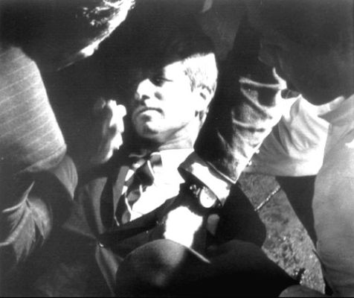

http://dailyentertainmentpics.com/2011/08/31/bobby-kennedy%E2%80%99s-bloody-dying-breaths-photos/
“I remember it like it was yesterday,” Drew informed Lauren Johnson. He was sixty-one when he gave the interview. “I saw this gun pointing at me,” said Drew, who was walking behind Kennedy just before he was shot. Instinctively, Drew hit the floor. Instinctively or had the action been rehearsed in advance and did he know the event was coming? It’s hauntingly reminiscent of the assassination of John F. Kennedy, where if you watch the film given to William Cooper by a CIA agent, you see Governor Connelly ducking out of the way of driver William Greer’s line of fire as he turns around to shoot the president. More probably Drew was prepped on what to do and how to behave in advance. He was most likely told to hit the deck as soon as the assassin’s weapon appeared in the crowd. It is also rather telling that he was able to spot it. One would have to be pretty alert amid the hubbub to be able to spot a gunman holding a gun if you were not trained – as a security specialist would be – to look for such a thing. His behaviour is reminiscent of that of Gov. Connelly, who ducked out of the way of Secret Service gunman William Greer, the driver of the Lincoln Ford limousine, as Greer turned around with the nickel-plated .45 to shoot President Kennedy in the head. The Texas governor must have been in on the planning of the Texan coup d'état orchestrated by such Texans as Skull and Bonesman and CIA man George H.W. Bush, etc.
“Drew hadn’t been assigned to cover the primaries that night,” Lauren Johnson’s informs us at the beginning of her article. “But always wanting to be in the thick of things, he showed up anyway. He was in the habit of photographing the candidates who passed through town.” There is something deeply suspicious about a photo journalist photographing candidates who passed through town. Was Drew working for military intelligence? Was he a CIA man? Was he fulfilling professional obligations to the “Agency” by photographing political candidates passing through town so their movements could be monitored? Was his job to monitor all the politicians who could have posed a threat so the “Agency” would have up-to-date reports and recent pictures to help them identify those who posed a threat to the interests of the New World Order and needed to be eliminated? There is a major contradiction in Lauren Johnson’s article on this point, since she began her article by informing us, “Only 21 and working his first real newspaper job, Drew was there to cover Robert F. Kennedy’s win over Eugene McCarthy in the California presidential primary. Instead, he became one of just four photographers to document the shooting that killed Kennedy.” Johnson tells us in one breath that he is on assignment to cover Kennedy’s win in the primary and in the next breath denies that Drew was on assignment, but was merely there to take in the event. Which story are we supposed to believe? He was on assignment alright. He was there to monitor the man and very likely the content of his speech. He was also there to “shoot” RFK with his camera, while another agent “shot” him with a gun. The Illuminati like to document their murders. It is a perverse psychopathic art form to these Satanists.
Drew tells Johnson that he was working as a photographer for the Pasadena Independent-Star News at the time. He claimed to have found a spot onstage as Robert Kennedy delivered his victory speech to a packed house in the ballroom. “But it was hot,” Johnson writes, “so with the speech nearly over, Drew headed off stage to the kitchen for a glass of water. Moments later, he was standing atop a stainless steel cooking table snapping photographs as Kennedy lay bleeding on the floor after being shot four times with a .22 calibre revolver by assassin Sirhan Sirhan.” Johnson is unequivocal on the point that the speech was nearly over, when Drew headed off stage to the kitchen for a glass of water. The cover story does not pass the smell test. The kitchen is for hotel staff. A journalist’s credentials do not give one the run of the place. It’s rather presumptuous of him to assume that he could just march right into the kitchen and help himself to a glass of water. It seems more fitting to summon a waiter and ask him to get a glass of water for him. The story is unconvincing. It seems like a cover story to explain how Drew managed to get from the stage to the kitchen in time to witness and photograph the historic assassination. “The resulting image is haunting: a grainy black-and-white shot looking down at Kennedy as he lay dying on the floor surrounded by campaign supporters and kitchen staff,” writes Johnson. One wonders if it had the “right look”. Was it intended to look grainy? The fact that they chose an amateur photographer to take the photo was probably part of the plan so that the photo op did not look too staged, premeditated and pre-planned.
“It’s not the only iconic photograph of Drew’s career,” Johnson recounts. “He later shot what became one of the most controversial images taken during the World Trade Center attack: a lone man falling headfirst from one of the towers.” It’s interesting that Johnson refers to the photo of the “falling man” as controversial. It should become a lot more controversial after people read this! One cannot easily stage qualities of the “iconic” picture with the typical obfuscation and denials. Drew’s affiliations are going to have to be looked into. Someone in the FBI is going to have to do a background check on him to see if he’s a Company man. And unlike previous investigations, orders from a Masonic Bureau chief are not going to be able to put a nix on the background check. There will be justice this time. We the people have had quite enough of the obscene nonsense. And no, polite gentlemanly discourse is not going to cut it. When you smell something that doesn’t pass the smell test, you have to call it what it is -- total bullshit.
Johnson continues, “The shadow shrouding the Kennedy image may reflect the symbolic darkness of that moment in our nation’s history, but journalistically, it’s a regret for Drew. I regret I didn’t have a flash, he said.” The cynical nature of that undignified admission of guilt speaks volumes about the career opportunist beyond the iconic photograph. The comment reflects the fact that the man is an unscrupulous career opportunist, who has no true feeling for the tragedy of that night in the Ambassador Hotel or the fact that America lost one of its greatest heroes on that occasion. This award-winning intellectual prostitute wouldn’t know greatness or goodness of character if he tripped over it and would value it even less. Let’s just say he wouldn’t pass Dr. Hare’s psychopath test. Drew would seem to be a ruthless career opportunist, whose sole motivation would appear to be the quest for fame and fortune afforded him by selling out to powerful interests.

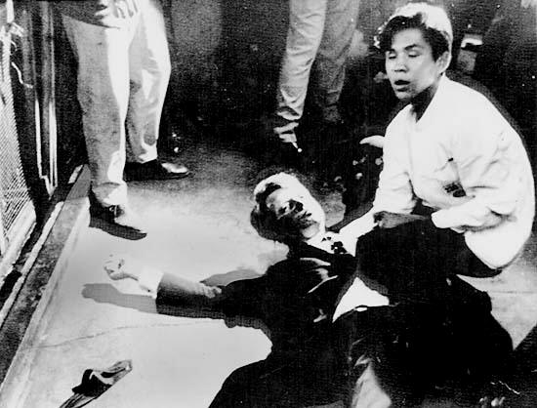
http://dailyentertainmentpics.com/2011/08/31/bobby-kennedy%E2%80%99s-bloody-dying-breaths-photos/

The fact that art was used as the cover for a covert operation is not confined to Gelatin and its “B-Thing” exhibition. The arts have been used as a cover for telegraphing the 9/11 operation in advance. The audaciousness of the hidden in plain sight artistic imagery has shown up prior to the 9/11 attacks in such films as Hollywood films like Diehard II and Fight Club and in post-9/11 films such as Pearl Harbor. There are numerous examples of art showing prior knowledge of 9/11 throughout popular art media. Even various American banknotes, when folded, appear to telegraph stages of the WTC Twin Tower bombing.

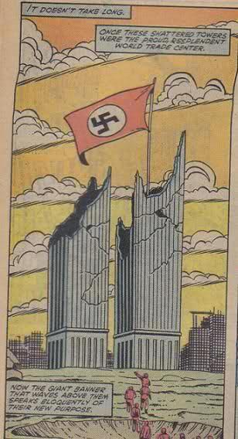
1983 marvel comic book #100

Given that Prescott Bush, George Bush Sr., and George W. Bush were all members of the Bavarian Illuminati creation known as the Skull and Bones Society of Yale University. And given that the Great Seal of the United States found on the back of the American one dollar bill is also the Great Seal of the Bavarian Illuminati. And given that the Bavarian Illuminati was founded by Adam Weishaupt in 1776. And given that Prescott Bush and J.D. Rockefeller ran the parent company Standard Oil of New York that controlled the German subsidiary I.G. Farben, the chemical and industrial giant that built Nazi Germany. And given that Prescott Bush was nearly indicted during World War II for trading with the enemy. And given that JFK was killed in Texas by Texas oil billionaires, I would say that we have a problem Houston.


http://theguardpost.typepad.com/my_weblog/2009/04/preseptember-11th-2001-attack-coincidences-in-the-media-sample-1.html#more

This is a NEW YORK magazine front cover issued on March 12, 2001 depicting a frightened woman peering between the clawed fingers of her left hand with one eye, symbolizing the All-Seeing Eye of the Egyptian god Horus, which the Illuminati make much of in their occult religion. Just one more piece of evidence that the corporate media is under the control of the Satanic cabal ruling the world known as the Illuminati. The March 2001 edition poses the question, “IS THERE LIFE BEYOND THE BOOM?” This is a double entendre, since the boom refers to both a collapsing economy and a building collapse resulting from a loud boom caused by an explosion. Notice the look of terror on the face of the woman depicted on the cover. She is clearly covering her face in obvious apprehension of something terrible that is about to happen. And what do we see directly in front of her hand but the Manhattan skyline with the Twin Towers in stark relief.

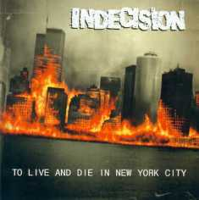
This above album cover by Indecision was released July 22, 2000. It is very interesting not only because of the events that took place on September 11, 2001. It is another example of the predictive programming we have seen so many examples of in the corporate media.

GT

Here is another interesting pre-911 image to ponder. The General Electric advertisement displays their new line for 2000. It is rather audacious of General Electric given their WWII history. The fact that the ad displays a fridge door with the poster of a plane flying in to the twin towers is rather apparently alluding to the future events of 9/11. Given their role in bringing America into the war after the first Pearl Harbor, it seems G.E. is intent on bringing America into the War on Terror with equal vigour. There is a lot of money to be made for corporate interests tied up in the military industrial complex.
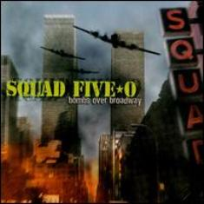
“Bombs over Broadway” is an album cover from August 15th, 2000. The airplanes seen flying in the face of the World Trade Center in the foreground resemble Japanese zeros reminiscent of Pearl Harbor. This suggests a Pearl Harbor-style attack in New York. Given that Paul Wolfowitz authored a document called Project for a New American Century, published one year before the Sept. 11 attacks, in which the opening paragraph reads, “America needs a catalyzing event like a new Pearl Harbor in order to launch the project for a new American century.” The album cover suggests in hindsight that the album cover’s designers were privy to the Neo-Cons agenda one year ahead of the planned attacks.

Band Inner City Hustlers
The above album cover for the band Inner City Hustlers from July 10th 2001 is titled “TIME TO EXPLODE”. It features the World Trade Center Twin Towers in the background exploding in fire. The name of the band seems to appropriately allude to the “inner city hustlers” complicit in the attacks, hustlers like Rudolph Guliani, who supervised an anti-terrorist bombing drill one day before the Sept. 11 attacks called Tripod-II. This operation granted FEMA full access to the Twin Towers the day before the attacks. Site personnel were denied access during the course of the drill. Hustler Larry Silverstein would also fit the bill of an “inner city hustler” since he and his Zionist colleague Frank Lowy purchased the World Trade Center complex from the Port Authority of New York a few months before the attacks, insuring the property against damage, including terrorist attacks, through the same insurance company that insured United Airlines and American Airlines.


In the above album cover of Party Music, “Coup” appears on the top left next to red pentagram. The red pentagram is a satanic symbol. The two musicians appear at the bottom of the cover. One is holding the drumsticks in the shape of the Masonic compass and the other makes the sign of the square with his thumb and index finger. Taken together the two musicians’ hand positions suggest the Masonic Square and Compass. The explosions emanating from what looks like the Twin Towers of the World Trade Center strongly resemble the plumes of smoke seen erupting from the towers on September 11. The artwork for the album cover was completed in June of 2001.
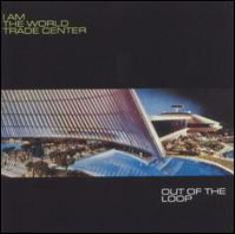
The album cover above is titled “I am the World Trade Center” and down in the bottom corner appears Out of the Loop. It was not just the World Trade Center that was caught “out of the loop” on September 11, but New York and the country as a whole. The surprise attacks were only a surprise for the citizenry of the United States. They were not as a surprise to top government officials. Rudolph Gulliani, the Mayor of New York, was not out of the loop, nor was the White House staff, since despite the denials by White House brass, they were not caught unaware. They had planned and coordinated a war game exercise for over a year involving precisely the scenario that unfolded on September 11. What happened that day was no surprise whatsoever. An emergency drill involving the simulated hijackings of some twenty passenger airliners had been carried out over the course of the entire previous week. The only people caught out of the loop were New Yorkers and the American people.

Everything about 9/11 is a lie. There is a mountain of circumstantial evidence to show that the government’s conspiracy theory is a patent lie. The fact that these psychopaths have the audacity to pull these stunts right in our face, knowing they have more immunity than diplomats is revealing in itself. The fact is though that Gelatin has been too cocky. John George Haigh also believed he was immune to prosecution because he got rid of the hard physical evidence -- the corpus delecti -- and in the absence of a body believed he could never be indicted for murder, but was eventually convicted on the weight of circumstantial evidence. Similarly, if enough people get behind this and expose this story, the Israeli government will be forced to turn these suspects over to the United States so they can be tried for these crimes against humanity. Gelatin appears to be running scared now. They have pulled all this documentary evidence off their website now. That is tantamount to an admission of guilt. They now have to hide the evidence so that there is nothing to overtly link them to these crimes. Too late gents. The gig is up. The world’s citizens are coming after you. We are going to hunt you down. You will be found and you will be made to stand trial. Lucky for you, you will not be water-boarded to extract confessions from you. Instead, you will be subjected to psychological torture by being constantly stalked by the fear of being caught. How does it feel to have the shoe on the other foot and to be hunted as war criminals as your government once hunted Nazi war criminals that once terrorized your people? Looks like things have come full circle now. Your government seems to feel that, due to what was once done to your people, you have the carte blanche authority to go ahead and do what was done to you to others. That is a logical fallacy my friends. It’s called “two wrongs make a right”. No they don’t. They never did. As you will soon see.

Bibliography:
Drago, Charles. Blog on Gelatin, http://educationforum.ipbhost.com/index.php?showtopic=10987.
Dewan, Sheila K. “Balcony scene or (unseen) atop the world,” New York Times, August 18, 2001, http://www.nytimes.com/2001/08/18/nyregion/balcony-scene-unseen-atop-world-episode-trade-center-assumes-mythic-qualities.html?pagewanted=all&src=pm.
Freund, George. Conspiracy Café at thatchannel.com. http://www.conspiracy-cafe.com/apps/blog/show/8636674-preparing-the-wtc-for-destruction referenced from http://www.gelitin.net.

“Full El Al flight took off on 9/11 from JFK to Tel Aviv,” Wayne Madsen Report, March 16, 2010, HTTP://citizensinquest.ca/?p=272.

Gahary, Dave. “9-11 Cop Breaks Silence,” September 23, 2011, http://americanfreepress.net/?p=693#more-693.
Genatin, “Gelatin: The B Thing,” http://www.gelitin.net/mambo/index.php?option=com_content&task=view&id=20&Itemid=1.
Al Guart, Isrealis arrested on Suspicion of 9-11 Involvement, New York Post, Sept. 13, 2001, www.nypost.com/news/regionalnews.

“Italian Who Revealed Gladio Says 9-11 Solved,” American Free Press (Issue #52, December 24, 2007), http://www.conspiracyplanet.com/channel.cfm?ChannelID=79.

Joint Chiefs of Staff, “Operation Northwoods,” March 13, 1962, http://www.gwu.edu/~nsarchiv/news/20010430/northwoods.pdf.

Johnson, Lauren. RFK assassination ‘like yesterday’ for photographer Richard Drew published: June 3, 2008 10:38 AM, http://www.newsday.com/long-island/rfk-assassination-like-yesterday-for-photographer-richard-drew-1.881337.

Lima, Paula, Five Men Detained as Suspected conspirators, Bergen Record, Sept. 12, 2001, www.bergen.com/news/2bombvan200109125.htm.
“Osama Bin Laden Claims He’s Being Framed,” Source: BBC referenced at http://guardian.150m.com/september-eleven/osama-denies.htm.
Merzer, Martin, Curtis Morgan, and Lenny Savino, Wanted by FBI: Still More Suspicious Men with Israeli Passports, Box-cutters, Oil Pipeline and Nuclear Power Plant Plans, Oct. 3, 2001,
www.miami.com/herald/special/news/terrorism/digdocs/088964.htm.
Mowad, Michelle, More Suspicious Israeli “Movers” detained with detailed video of Sears Tower, Pottstown, Pennsylvania, The Mercury, Oct. 17, 2001, www.zwire.com/site/mercury_101801.html.

“9-11 and the Tarot Connection,” http://www.youtube.com/watch?v=2PMoIsSRpxs, referenced at http://www.conspiracy-cafe.com/apps/blog/show/8739547-9-11-photographer-shot-bobby-kennedy-too-

“9/11 lie exposed by astrology: 9/11 mastermind ‘confesses’ in Guantanamo,” http://www.astrologyweekly.com/astrology-articles/911-lie-exposed.php.

“The Falling Man,” http://en.wikipedia.org/wiki/The_Falling_Man.
Travis, Greg. The Guardian Post, April 14, 2009, Pre-September 11th 2001 Attack ‘Coincidences’ in the Media,
http://theguardpost.typepad.com/my_weblog/2009/04/preseptember-11th-2001-attack-coincidences-in-the-media-sample-1.html#more.

Wilson, Colin. The Occult: A History, Borgo Press, 2007, p.112.

“Balcony scene or (unseen) atop the world,” New York Times, August 18, 2001, http://www.nytimes.com/2001/08/18/nyregion/balcony-scene-unseen-atop-world-episode-trade-center-assumes-mythic-qualities.html?pagewanted=all&src=pm
Ibid.
Charles Drago, http://educationforum.ipbhost.com/index.php?showtopic=10987
“Balcony scene or (unseen) atop the world,” New York Times, August 18, 2001, http://www.nytimes.com/2001/08/18/nyregion/balcony-scene-unseen-atop-world-episode-trade-center-assumes-mythic-qualities.html?pagewanted=all&src=pm.
Al Guart, Isrealis arrested on Suspicion of 9-11 Involvement, New York Post, Sept. 13, 2001, www.nypost.com/news/regionalnews.
Paula Lima, Five Men Detained as Suspected conspirators, Bergen Record, Sept. 12, 2001, www.bergen.com/news/2bombvan200109125.htm.
Michelle Mowad, More Suspicious Israeli “Movers” detained with detailed video of Sears Tower, Pottstown, Pennsylvania, The Mercury, Oct. 17, 2001, www.zwire.com/site/mercury_101801.html.
Martin Merzer, Curtis Morgan, and Lenny Savino, Wanted by FBI: Still More Suspicious Men with Israeli Passports, Box-cutters, Oil Pipeline and Nuclear Power Plant Plans, Oct. 3, 2001, www.miami.com/herald/special/news/terrorism/digdocs/088964.htm.
Dave Gahary, “9-11 Cop Breaks Silence,” September 23, 2011, http://americanfreepress.net/?p=693#more-693.
“Italian Who Revealed Gladio Says 9-11 Solved,” American Free Press (Issue #52, December 24, 2007), http://www.conspiracyplanet.com/channel.cfm?ChannelID=79.
“Full El Al flight took off on 9/11 from JFK to Tel Aviv,” Wayne Madsen Report, March 16, 2010, HTTP://citizensinquest.ca/?p=272.
Ibid.
“Osama Bin Laden Claims He’s Being Framed,” Source: BBC referenced at http://guardian.150m.com/september-eleven/osama-denies.htm.
“Gelatin” The B Thing,” http://www.gelitin.net/mambo/index.php?option=com_content&task=view&id=20&Itemid=1.
Joint Chiefs of Staff, “Operation Northwoods,” March 13, 1962, http://www.gwu.edu/~nsarchiv/news/20010430/northwoods.pdf.
“9-11 and the Tarot Connection,” http://www.youtube.com/watch?v=2PMoIsSRpxs, referenced at http://www.conspiracy-cafe.com/apps/blog/show/8739547-9-11-photographer-shot-bobby-kennedy-too-.
“The Falling Man,” http://en.wikipedia.org/wiki/The_Falling_Man.
“DC Street Sorcery”, http://archives.sfaw.org/video-03-2009.asp.
“9-11 and the Tarot Connection,” http://www.youtube.com/watch?v=2PMoIsSRpxs.
Ibid.
Colin Wilson, The Occult: A History, Borgo Press, 2007, p.112.
Ibid.
Lauren Johnson, RFK assassination ‘like yesterday’ for photographer Richard Drew published: June 3, 2008 10:38 AM, http://www.newsday.com/long-island/rfk-assassination-like-yesterday-for-photographer-richard-drew-1.881337.
Ibid.
Ibid.
Ibid.
Ibid.
Greg Travis, The Guardian Post, April 14, 2009, Pre-September 11th 2001 Attack ‘Coincidences’ in the Media - Sample #1, http://theguardpost.typepad.com/my_weblog/2009/04/preseptember-11th-2001-attack-coincidences-in-the-media-sample-1.html#more.
Greg Travis, “Pre-September 11th 2001 Attack ‘Coincidences’ in the Media - Sample #2”, April 14, 2009, http://theguardpost.typepad.com/my_weblog/2009/06/preseptember-11th-2001-attack-coincidences-in-the-media-sample-2.html#more.
“Pre-September 11th 2001 Attack “Coincidences” in the Media - Sample #3,” Greg Travis, June 5, 2009, http://theguardpost.typepad.com/my_weblog/2009/06/preseptember-11th-2001-attack-coincidences-in-the-media-sample-3.html#more.
Greg Travis, “Pre-September 11th 2001 Attack ‘Coincidences’ in the Media - Sample #4,” June 5, 2009, http://theguardpost.typepad.com/my_weblog/2009/06/preseptember-11th-2001-attack-coincidences-in-the-media-sample-4.html#more
Greg Travis, “Pre-September 11th 2001 Attack Coincidences in the Media - Sample #5,” June 6, 2009, http://theguardpost.typepad.com/my_weblog/2009/06/preseptember-11th-2001-attack-coincidences-in-the-media-sample-5.html#more.
“Pre-September 11th 2001 Attack ‘Coincidences’ in the Media - Sample #6,” http://theguardpost.typepad.com/my_weblog/2009/06/preseptember-11th-2001-attack-coincidences-in-the-media-sample-7.html#more.
Pre-September 11th 2001 Attack “Coincidences” in the Media - Sample #7, http://theguardpost.typepad.com/my_weblog/2009/04/preseptember-11th-2001-attack-coincidences-in-the-media-sample-7.html#more.

