Jack the Ripper: Politically Motivated Masonic Ritual Sayings
“Jack the Ripper” is a misnomer. Like so many murders and assassinations sponsored by a Masonic elite, the “Jack the Ripper” murders were sensationalized as the work of a lone crazed killer, when the reality is that “Jack” was a trio, inspired by the Masonic ritual of the Third Degree, in which the perpetrators symbolically represent the “three unworthy craftsmen.” The trio consisted of two killers and one accomplice. The lone killer misconception is the reason the case remained insoluble for so long. As with the Shakespeare authorship controversy, where each Shakespeare scholar argued for his favored candidate for ‘bardship’, so each Ripperologist argued for his favored suspect, but invariably became tied up in logical inconsistencies or contradictions by trying to pin the crimes on a lone suspect, when there was actually a team of three operating together.
As for how many slayings there actually were, most Ripperologists agree with Sir Melville Macnaughten, who joined Scotland Yard as an assistant chief constable with the Criminal Investigation Department in 1889. Mcnaughten’s official notes list the five “Ripper” victims as follows:
- 31st Aug. ’88. Mary Ann Nichols—at Bucks Row—who was found with her throat cut & with slight stomach mutilation.
- 8th Sept. ’88. Annie Chapman—Hanbury St.:—throat cut—stomach and private parts badly mutilated & some of the entrails placed around the neck.
- 30th Sept. ’88. Elizabeth Stride— Berner Street: throat cut, but nothing in shape of mutilation attempted, & on same date Catherine Endowes—Mitre Square, throat cut & very bad condition, both of face and stomach.
- 9th November. Mary Jane Kelly—Millers Court, throat cut and the whole of the body mutilated in the most ghastly manner.
By comparing the M.O. involved in the murders, of these women, Annie Chapman in particular, one can see a similarity to the “three Juwes” or “unworthy craftsmen” associated with the 3° rites.
'Jubela, Jubelo, Jubelum'

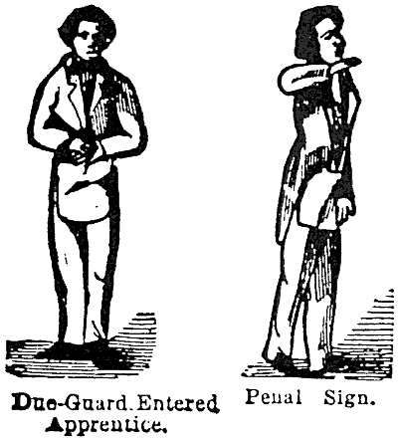
First, Jubela—"O that my throat had been cut across, my tongue torn out, and my body buried in the rough sands of the sea, at low water mark, where the tide ebbs and flows twice in twenty-four hours, ere I had been accessory to the death of so good a man as our Grand Master, Hiram Abiff!"
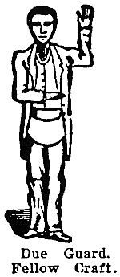
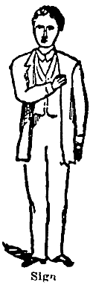
The second, Jubelo—"O that my left breast had been torn open and my heart and vitals taken from thence and thrown over my left shoulder, carried into the valley of Jehosaphat, and there to become a prey to the wild beasts of the field and vultures of the air, ere I had conspired the death of so good a man as our Grand Master, Hiram Abiff!"
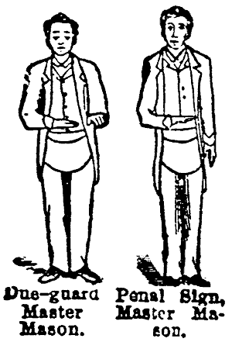
The third, Jubelum—"O that my body had been severed in two in the midst, and divided to the north and south, my bowels burnt to ashes in the center, and the ashes scattered by the four winds of heaven, that there might not the least track or remembrance remain among men, or Masons, of so vile and perjured a wretch as I am; ah, Jubela and Jubelo, it was I that struck him harder than you both. It was I that gave him the fatal blow; it was I that killed him outright;"
'The Legend of the Three Ruffians'
The 'Blood Oaths' for the 1st°, 2nd°, and 3rd°...
https://freemasonrywatch.org/jacktheripper.html
Knight credits Macnaughten with an accurate Ripper victim count in identifying these five victims as those of the Ripper, but how can we be sure that all five women are “Ripper” victims? Elizabeth Stride, for instance, has been put forward as a Ripper victim based on the most tenuous evidence—in particular, the fact that she was killed on the same night as an established victim, and her throat was cut, which was a common M.O. linking the five victims. Stride was not mutilated like many of the other victims, and many Ripperologists allege that her throat was not cut from left to right like other victims, but in the opposite direction. However, the fact that Stride’s murder was part of the same serial killing spree is supported by new evidence, derived from secret government and police papers and from a postmortem report that was suppressed, even at the Ripper inquest. The latter report shows that Liz Stride’s throat was cut in precisely the same left-to-right fashion as the other canonical murder victims.
New concrete evidence has emerged confirming that four of the five women knew each other. These were not random killings perpetrated by a crazed sexual deviant, but the systematic elimination of specified targets—murder by numbers. As with the other four victims, Mary (Marie) Kelly was not just some luckless whore who just happened to run into “Jack” instead of an ordinary john. She was the intended final victim. As we shall see, in her previously obscure history lies the keystone to the case.
All Leads Point to Dorset Street and Mary Kelly
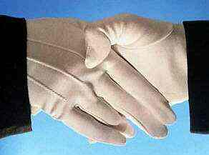
The following are known facts which point to an organized planned conspiracy as opposed to the “lone nut” theories being propagated by “academic” Ripperologists, some of whom are known to be actively involved in Freemasonry or royal circles themselves.
1. There were between 80,000 and 100,000 prostitutes in London at the time of the “Jack the Ripper” killings, yet four of the five canonized victims personally knew and associated with each other, including routinely socializing with each other at the same pub. secret masonic handshake
2. The victims’ bodies were found miles apart from each other, yet lived within the same or adjoining flop house on Dorset Street, a short one block street.
3. The last two victims used the identical name, Mary Kelly. The first “Mary Kelly” was the street name or alias used by the victim, the second the actual name of the victim. Both victims were the only two to have their faces mutilated. The inference is that the first “Mary Kelly” (Catherine Eddowes) was killed in error, the error was discovered, and then the second real “Mary Kelly” was killed. The significance of this is that the murderer did not randomly kill for deranged pleasure but had a specific motive—the elimination of Mary Kelly and those in close contact with her.
The “Jack the Ripper” saga had its origins on Cleveland Street, which at the time was the artistic center of London, where the local artist Walter Richard Sickert had his studio. Sickert’s son Joseph learned all about the Ripper case and what led to the murders of the five indiscreet prostitutes from his father Walter.
At No. 22 Cleveland St., there was a confectioner’s and tobacconist’s shop, where Annie Elizabeth Crook worked. Mary (Marie) Kelly had been her co-worker in the shop, the same girl who was the Ripper’s last tragic victim. It was here that Prince Eddy, Duke of Clarence, had met Annie on one of her secretive visits to the area. A wedding had taken place at St. Saviour’s Chapel, but there was only one relevant witness, Mary (Marie) Kelly. In 1888, there had been a police raid on certain premises on Cleveland St. and two people were apprehended and taken away—the Duke of Clarence and Annie E. Crook, the latter being confined to various institutions until her death in 1920, completely insane. Mary (Marie) Kelly had seen what had happened and also took charge of the couple’s child, Annie Margaret. Mary (Marie) fled to the East End and hid in a convent, and the next time she was heard from was the day of her death, November 9, 1888.
According to Walter Sickert’s account, as told to his son, Joseph, who in turn, related it to author Stephen Knight, Prince Albert Victor ( Eddy) had been accustomed to visiting the artist Walter Sickert on Cleveland Street whenever he could escape the stifling scholastic life of Oxford. Sickert introduced the prince to the shop girl Annie E. Crook under a fake identity and alias, as Walter’s younger brother, but people soon guessed at the prince’s true identity, and the story of the affair and the child gradually made it to the upper echelons of Whitehall. Queen Victoria became alarmed and ordered then Prime Minister Salisbury to take action to contain the scandal.
It was immediately after this that police were sent to Cleveland Street to arrest the lovers. After Prince Eddy and Annie Elizabeth were taken into custody, the prince was returned to court and placed under “strict supervision” amounting to “house arrest,” while Annie was confined for 165 days at Guy’s Hospital, and later at various workhouses and hospitals. Annie died tragically 32 years later, insane, probably as the result of a lobotomy operation Gull had performed to ‘silence’ her.
Walter Sickert believed that Annie Crook underwent “some kind of operation designed to destroy her memory of events on Cleveland St.,” since on the one or two occasions he saw her after that, she was a completely different person who did not seem to know him. Sickert believed William Gull had performed the operation himself, which not only robbed her of memory, but made her epileptic. Epilepsy is known to be associated with the temporal lobe region of the brain. Had Annie been lobotomized, this would account for her epileptic seizures. After Guy’s Hospital, she spent months confined in various workhouses, which were not required to keep records of patients or have inspections by authorities to monitor patient treatment. Eventually, it became apparent that Annie no longer possessed any ‘dangerous’ knowledge, whereupon she was released—a hopeless wreck of a human being, broken in body, mind, and spirit, abandoned on the very streets from which she had been snatched by the heartless establishment figures who had sabotaged her life. Unable to support herself, she was unable to survive on her own. After drifting in and out of workhouses for a few more months, she was apprehended and confined for the rest of her miserable life in prisons, workhouses, and hospitals.
An important point should be made at this juncture. The Freemasons founded all of our social institutions, including the medical profession. We can see their influence even in the anatomical terms for parts of the body. The “temples” found on either side of the skull in the frontal region, housing the frontal cerebral cortex, gets its name from the 3rd° of Freemasonry, where Hiram Abif was attacked in the Temple of Solomon. The first two ruffians then delivered blows to his “temples,” which gets their name from the Temple complex where the attack took place. When a mental patient is given a frontal lobotomy operation, the operation targets the two temples, as a medical reenactment of the 3rd°. When a person is lobotomized, they are rendered a senseless idiot, and are therefore ‘silenced’, as no one will pay any attention to the blithering ‘idiot’ talking nonsense ever again. If such a fate befell Annie Elizabeth Crook, as depicted in a nightmarish scene in the film “From Hell,” then this is how the British establishment effectively silenced the illiterate young newlywed bride of Prince Eddy. The lobotomy operation is often used to silence a black sheep member of an establishment family or someone who imprudently whistle-blows about a subject the establishment wishes to be hushed up. Medically, it is a lobotomy, but Masonically, it is a 3rd° ritual punishment, after which the ‘invalid’ is permanently silenced, as it is the operation itself that has rendered them an ‘invalid’.
Author Stephen Knight makes a compelling case in Jack the Ripper: The Final Solution, for how Britain’s entire political system at the end of the 19th century was threatened by the hidden facts—Prince Albert Victor (“Eddy”) was not only bisexual, but had married a Roman Catholic girl and fathered a child with her. Such “debaucheries” were so scandalous that the ruling class could not abide even the slightest hint of such a revelation. And the reason for this is that the British establishment had created the illusion of such an ultra-conservative and respectable upper class that its very survival depended on maintaining the false façade of respectability.
The painter Walter Sickert is Knight’s source, indirectly through his son Joseph, for much of the information related to the scandal that erupted on Cleveland Street that led to the Ripper murders. Walter Sickert’s son, Joseph, had stated that Annie Elizabeth Crook was the occupant of No.6 Cleveland St. The author Knight then investigated the artist’s stories to see if they checked out. In nearly every case, the information provided by the artist was validated. For instance, Annie Crook’s existence was confirmed when another document was cross-referenced—the birth certificate of Annie Crook’s daughter. The certificate was obtained from Somerset House to verify Sickert’s basic claims, which were as follows:
- Annie Elizabeth Crook was a tobacconist’s assistant on Cleveland St. in the 1880s.
- In April 1885, she gave birth to an illegitimate child.
- The birth took place at Marylebone Workhouse.
- The father of the child was Prince Eddy.
- The child’s name was Alice Margaret Crook.
The birth certificate confirms four of these five points. It is dated April 18, 1885 and it records:

SEX: Girl

NAME: Alice Margaret Crook

PLACE OF BIRTH: Marylebone Workhouse
confectionary
assistant from Cleveland St.
NAME OF FATHER: blank
OCCUPATION OF FATHER: blank
The birth certificate is marked by a cross next to which is written—The mark of Annie Elizabeth Crook, Mother, 6 Cleveland Street, Fitzroy Square.
The cross confirms another aspect of Sickert’s story—that Annie was illiterate.
Knight’s theory, which in post-Diana Buckingham Palace now seems quite plausible, is that a group of White Chapel District prostitutes—namely Annie Chapman, Mary (Marie) Kelly, Elizabeth Stride, and Mary Nichols (the other victim Catherine Eddowes was killed in a case of mistaken identity and was unknown to the other women)—planned to blackmail the royals, prompting Queen Victoria to appeal to the then reigning prime minister, the Marquess of Salisbury, to contain both the problem and the fallout. Lord Salisbury accordingly placed Sir William Gull, physician and abortionist to the Royal Family, in charge of the operation to stifle the whistle in the whistle-blowers’ mouths.

Knight argues convincingly that Freemasonry was the power behind the government and it was the unseen influence of the Masonic elders which dictated major policies as opposed to the façade of debates in the houses of parliament. Freemasonry is and has been since the time of its inception a shadow government of the state—part of the Deep State—operating behind the scenes to ensure that the marionettes and puppets on the political stage danced to their tune and paid the piper. This is as true today as it was in the day of Victoria and her “Ripper”. Of course much of the skullduggery of Freemasonry is now subcontracted out to affiliate Freemason-spawned organizations so that mainstream Freemasonry can escape blame and pin such crimes and misdemeanors on splinter affiliates such as The Order of the Black Hand, to which the assassin of Archduke Ferdinand belonged, or the Muslim Brotherhood, or the Confederate Lodge of Freemasonry to which Timothy McVeigh belonged, or the P2 Freemason Lodge which Operation Gladio gladiator Lucia Gelli headed while fellow Lodge member Roberto Calvi, God’s Banker, did his bidding. Now Freemasonry has even spawned organizations outside its rubric like the intelligence services all over the world and they, in turn, now subcontract their skullduggery out to organizations such as the CIA’s Wackenhut Corp., BCCI or the CIA’s Scientology founded by CIA-operative, L. Ron Hubbard.

The brutal slayings of the five White Chapel prostitutes were carried out according to Masonic ritual. The ritual murder and disembowelment “met with such ghastly success because of the audacity with which they were executed,” said Sickert, Knight’s informant, whose father Walter Richard Sickert was a prominent local artist in the district, who had intimate knowledge of the Cleveland Street scandal and the related Whitechapel murders. This so-called “audacity” is a trademark of Masonic “mischief-making.”

The Masonic conspiracy theory, most-developed and expanded upon by author Stephen Knight, rests on the testimony of Joseph Sickert, son of painter Walter Sickert who was allegedly involved in the conspiracy along with the Queen’s personal physician, Sir William Gull (aged 72), police commissioner Sir Charles Warren, and other high-level freemasons. In Sickert’s tale, Queen Victoria’s grandson and heir apparent Prince Eddy, Duke of Clarence had married and fathered a child with a common Irish Catholic shop clerk from London’s East End named Annie E. Crook. With the monarchy in an already fragile state and a Catholic ‘bastard’ now standing in line for the throne, Freemason-affiliated establishment figures were charged with cleaning up the mess and eliminating all witnesses. Sickert had the role of playing the Duke’s brother on his outings and suspiciously was not himself a target of the Masonic hit squad, leading some to believe that Walter Sickert himself might be “Jack the Ripper” or at the very least, an accomplice.

The words “The Juwes are the men that will not be blamed for nothing.” (see the Goulston Street Graffito) were found scribbled in chalk near the double-murder scenes of victims Stride and Eddowes.

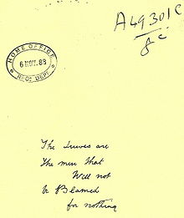
Copy of graffito in Goulston Street,
attached to Metropolitan Police Commissioner
Sir Charles Warren's report to Home Office
on the Whitechapel murders.

Sir Charles Warren, head of the London Police and the Most Worshipful Master of the Quator Coronati Masonic Lodge erased the reference to “Juwes” left behind as a clue by “Jack the Ripper,” ostensibly so as to avoid a backlash against the local Jewish population. Researchers of the “Jack the Ripper” conspiracy point out that the unusual spelling of “Juwes” is a reference to the Masonic murder of Hiram Abiff by the three ruffians Jubela, Jubelo and Jubelum.

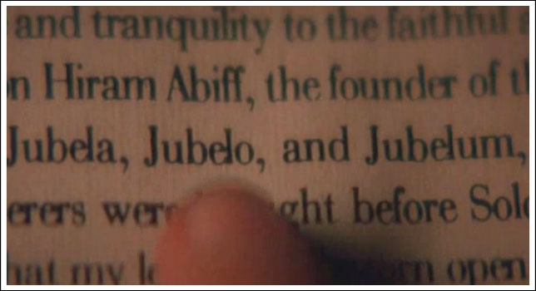
Insp. Abberdine (Johnny Depp) points his finger at the names of the three ruffians known as the 3 Juwes in still shot from movie “From Hell“
Parallels between the Ripper murders and Masonic Oaths:
All of the “Canonical 5 Ripper victims” had their throat cut from left to right (See Entered Apprentice Oath below to understand the parallel). The last victim’s heart was taken (See Fellowcraft Oath below to grasp the parallel). Four of the victims’ abdomen were slashed, with Kelly’s completely emptied (See Master Mason Oath below to fully grasp the parallel). Stephen Knight rightly claims that Jack the Ripper’s murders paralleled Masonic blood oaths shown below:

Entered Apprentice:
All this I most solemnly, sincerely promise and swear, with a firm and steadfast resolution to perform the same, without any mental reservation or secret evasion of mind whatever, binding myself under no less penalty than that of having my throat cut across, my tongue torn out by its roots, and my body buried in the rough sands of the sea, at low-water mark, where the tide ebbs and flows twice in twenty-four hours, should I ever knowingly violate this my Entered Apprentice obligation. So help me God, and keep me steadfast in the due performance of the same.

Fellowcraft
All this I most solemnly promise and swear with a firm and steadfast resolution to perform the same, without any hesitation, mental reservation, or self-evasion of mind whatever, binding myself under no less penalty than of having my breast torn open my heart plucked out, and placed on the highest pinnacle of the temple, there to be devoured by the vultures of the air, should I ever knowingly violate the Fellow Craft obligation. So help me God, and keep me steadfast in the due performance of the same.
(some say, My heart and vitals taken from thence, and thrown over my left shoulder, and carried into the valley of Jehoshaphat…)

Master Mason
“All this I most solemnly, sincerely promise and swear, with a firm and steady resolution to perform the same, without any hesitation, mental reservation, or secret evasion of mind what-ever, binding myself, under no less penalty than that of having my body severed in two, my bowels taken from thence and burned to ashes, the ashes scattered before the four winds of heaven, that no more remembrance might be had of so vile and wicked a wretch as I would be, should I ever, knowingly, violate this my Master Mason’s obligation. So help me God, and keep me steadfast in the due performance of the same.”

As we shall see, local artist Walter Sickert’s intimate knowledge of the Cleveland Street murders stemmed from indirect involvement. He appears to have tagged along as an artist accomplice to paint or sketch the victims and the crime scenes. Forensic scientist and crime novel author Patricia Cornwell has exposed Sickert’s involvement in the Whitechapel murders in her book, Portrait of as Killer: Jack the Ripper Case Closed. In fact, Cornwell misguidedly assumes Sickert to be the killer, though he very possibly was an accomplice and had a penchant for “sick art”—the universe apparently endowing him with an apropos family name.

Walter Sickert had a penchant for prying into other people’s lives. “write, write, write!” he would beg his friends ”Tell me in detail all sorts of things, things that have amused you and how and when and where, and all sorts of gossip about everyone.” Sickert despised the upper class, but was like a star stalker himself. He somehow managed to ingratiate himself upon and hobnob with the major celebrities of his day: Henry Irving and Ellen Terry, Aubrey Beardsley, Henry James, Max Beerbohm, Oscar Wilde, Monet, Renoir, Pissaro, Rodin, Andre Gide, Proust, Prince Eddy, some well-known MPs, and some prominent Freemasons.

Patricia Cornwell is basically a criminologist by trade. She notes that you can tell a lot about a person by what makes them angry. A review of the Ripper letters reveals that “Jack the Ripper”
is intellectually arrogant. Even when he disguised his writing to come across as ignorant, illiterate, or just plain crazy, he did not like to hear those things said about him. He couldn’t help reminding people he was literate by sending the occasional Ripper letter with perfect spelling, neat or beautiful script, and eloquent vocabulary. As the Ripper protested more than once in communication, “I ain’t a maniac, as you say. I am to dam [sic] clever for you” and “Do you think I am mad? What a mistake you make.” How many of the Ripper letters were actually penned by Sickert is unknown, but his artfulness seems to have been called upon in the operation to give it a ‘craft’ component, as Masons are wont to do.

It is unlikely an illiterate Cockney would use the word ‘conundrum’ or sign the letter “Mathematician”. It is equally unlikely that an ignorant brute would refer to the people he had murdered as ‘victims’, or describe the mutilation of a woman as giving her a ‘Caesarian’. The Ripper also used vulgarities such as ‘;cunt’, and tried hard to misspell, mangle, or write in snarls. Then he mailed the trashy letters from Whitechapel, as if to create the impression that “Jack the Ripper” was a pauper from the slums. Few Whitechapel paupers could read or write. In fact, a large percentage were foreign and could not even speak English. Most people misspell phonetically and do so consistently. but the Ripper misspells words several different ways.

One of Walter Sickert’s favorite insults was to call people “fools”. The Ripper shows a fondness for this word in his letters. For “Jack the Ripper” everyone was a fool except ‘him’. Psychopaths tend to think they are more cunning and intelligent than everybody else. Psychopaths tend to think they can outsmart those out to get them. Sickert probably composed some of the letters, including some of the sketches and caricatures included in the letters. Sickert was not the killer, but his voyeuristic and curious ways made him a willing participant. He was probably coopted into the conspiracy in order to add a level of mystery, artfulness, and ‘craft’ to the operation. While he was not the killer, chances are good that he acted as an accomplice in writing many of the Ripper letters and in producing art based on some of the Ripper crime scenes. The scenes depicted in such art are too close to the actual crime scenes for him to have drawn them from imagination or from secondhand account. He had to have been there as a witness, and that makes him an accomplice. The fact that he participated in the act of writing letters to propagate the “lone nut” theory makes him an accomplice after the fact, engaged in an effort to obstruct justice. Participating in a capital crime of this nature makes him an accomplice to murder, but not a murderer per se. It certainly makes him an unsavory character and one his son Joseph would not be proud of if he were ever to have heard this side of the story. While it is unknown whether Sickert was a Mason, or a fellow Lodge member of the Lodge Salisbury and Anderson belonged to, it is likely that he was a Mason, and probably coopted into the operation and sworn to secrecy on this basis. Sickert had the opportunist, social-climbing traits exhibited by many Masons and Mason wannabes. He would have probably joined for the social connections, opportunities, and status it would have afforded him. He was the type to sell his soul in exchange for some modicum of success and notoriety.

Forensic scientists assisting Patricia Cornwell in her investigation of the cold case of the Ripper murders hoped to find reliable DNA evidence linking a key suspect to the Ripper letters. However, it took nearly a year, and more than a hundred tests before they could begin to see results—most of it inconclusive—from the 75- to 114-year-old genetic evidence from Walter Sickert and “Jack the Ripper” when they touched and licked postage stamps and envelope flaps. If it is true that Sickert and the Ripper left the DNA sequences Cornwell’s team found, it was from cells inside their mouths that sloughed off into their saliva and were sealed in adhesive until DNA scientists recovered the genetic markers with tweezers, sterile water, and cotton swabs. The best result came from a Ripper letter that produced a single donor mitochondrial DNA sequence specific enough to eliminate 99% of the population as the person who licked and touched the adhesive backing of that stamp. All the mark components found in the single-donor profile were also present in components found in another Ripper letter and two Walter Sickert letters…The DNA evidence is the oldest ever tested in a criminal case and is far from conclusive. Cornwell’s team couldn’t prove the source of any of the DNA because they didn’t have the mitochondrial DNA profiles of any of the individuals involved when the tests were conducted, probably due to the fact that such technology was not relied upon back in the 1880s…

By comparison, it is interesting to note that Cornwell’s team isolated a single-donor mitochondrial DNA sequence from a letter written by Ripper suspect Montague John Druitt. The mitochondrial DNA sequence recovered from the stamp and envelope flap swabbed on a letter he wrote from Oxford University in 1876 shares no significant markers with the single-donor profile from the Openshaw letter penned by “Jack the Ripper.” This evidence proves only that Druitt did not pen the Openshaw Ripper letter. To disqualify him altogether as a suspect, would require a comparison to be made between Druitt’s single-donor mitochondrial DNA sequence drawn from his letter penned at Oxford and the DNA evidence recovered from all the Ripper letters, not just one.

What is noteworthy, however, is the fact that the Openshaw letter was written on stationary that exhibits the same watermark as one of the many types of stationary used by Sickert. In fact, forensic scientists, as well as art, paper, and lettering experts, have found the following: a Ripper letter written on artists’ paper; numerous watermarks on paper used in Ripper letters match watermarks on paper used by Walter Sickert; numerous Ripper letters were written with a waxy lithographic crayon; letters with paint or ink were applied with a paintbrush. In addition, microscopic and ultraviolet examinations revealed that swabs of what appeared to be “dried blood” on Ripper letters turn out to be a mixture of white wax. oil, and resin—or etching ground—used by fine-art printmakers to prepare copper etching plates for printing. According to forensic paper expert and paper historian Peter Brown, etching ground was usually mixed in Art studios. Sickert apprenticed under James McNeill Whistler, and Bowers claims it was not unusual for artists to develop slightly different recipes over time from those of their teachers. Art experts say that sketches in Ripper letters are professional and are a good match for Walter Sickert’s art works and technique. Distinctive handwriting quirks and the position of the Ripper’s hand when he wrote his taunting, malevolent letters lurk in other Ripper letters beneath a disguise. These same quirks and hand positions lurk in Sickert’s erratic handwriting as well. In addition, paper used in letters the Ripper sent to the Metropolitan Police precisely match paper used by Sickert in his own letters—in spite of differences in handwriting. It is evident that Sickert is right-handed, but video footage taken of him in his seventies shows he was quite skilled at using his left hand as well. Lettering expert Sally Bower claims that, in some Ripper letters, the writing was disguised by a right-handed person writing with his left hand.

A parallel can be drawn between Sickert’s Riper letters and Francis Bacon’s pseudonymous writing. Bacon worked diligently at creating different writing voices and styles to conform to that of any of the pseudonymous authors he pretended to be, whether it be John Lily, Thomas Nash or some other pseudonym he would use to disguise himself. Similarly, Sickert’s Ripper letters would be written in different voices and handwriting styles, perhaps in an attempt to represent “the three Juwes,” the “three unworthy craftsmen” of Masonic legend, who are symbolically represented by the three assassins in the Whitechapel murders.

All of the foregoing evidence linking Sickert to the Ripper letters does not prove he was the killer, despite Cornwell’s convictions and assertions. The impression Cornwell gives is that she has a personal dislike for Walter Sickert and is driven by a vendetta to see him implicated in the crimes. Perhaps she had a past acquaintance or even a boyfriend she later took a dislike to of whom Sickert reminds her. It would not be the first time this would drive someone to have it out for someone. As a researcher on the same case, the author of Shakespeare’s Codex does not care for Sickert much either, but Gull, Netley and other conspirators in the Ripper case are far less savory or likeable. Sickert had a perverse sense of humor and fun. It seems clear that he had no empathy for the victims and might have been something of a misogynist. How many of the Ripper letters he actually penned himself is unknown, but regardless, although the Ripper letters penned by him do implicate him in the murder conspiracy, they do not tie him directly to the murders themselves and prove him the murderer. He may have even turned one of his studios over to the Masonic operators so that different conspirators could pen different Ripper letters, some by Gull perhaps, others by Netley perhaps, and some by Sickert himself as part of a sick prank or joke.

Having researched several crimes the Freemasons have had a hand in historically, it does not take researchers long to discern a pattern. A common characteristic is the crafty or artful design of their crimes. Masonry is nicknamed the “Craft” for good reason. The Masons value art and try to execute their operations with an artful design and craft component.

“Freemasons applaud violence, terror and crime, provided it is carried out in a crafty manner,” writes Knight. “Humor is all important and the most appalling crimes may be committed under its cloak.” An example would be the humor associated with George W. Bush playing father of the nation in a scheduled visit to a kindergarten in Florida as the World Trade Center in New York was under attack on 9/11. To add to the sick and perverted Masonic humor, Bush was seen apparently reading along, with the storybook upside down, as the school children read about a pet goat. The Satanic signature here is obvious to anyone familiar with the Goat of Mendes and the long Templar-Masonic tradition associated with Baphomet and the veneration of the goat-headed demon god. The goat and goat head are apropos as symbols, given that they are cloven-hoofed beasts, symbolic of Satan who is represented as cloven-hoofed and horned in most iconography. A prominent Satanic M.O. is reverse imaging and lettering and wording as the inversion and perversion of all things in Creation is the Satanic agenda. Thus, Bush is seen reading the book about pet goats upside down.

To return to the Ripper case, it will be recalled that a group of working girls led by Mary (Marie) Kelly decided to blackmail the royals, requiring the Marquess of Salisbury, then Prime Minister, under orders from no less a personage than Queen Victoria, to silence the Whitechapel whores. He entrusted Sir William Gull, physician and abortionist to the Royal Family, to undertake the mission. One of the country’s most prominent Freemasons, Gull, understood that “Freemasonry was the power behind the government and it was the unseen influence of the Masonic elders which dictated major policies, not the pleasing façade of House of Commons debate.”

When Mary (Marie) Kelly fell in with some prostitutes with whom she shared her story, she would find some support for her plan, devising an ambitious blackmail scheme, which as we now know was a death sentence for Kelly and her morally compromised associates. Salisbury was now faced with not only hushing up Prince Eddy’s indiscretions, but also the horrific treatment and institutionalizing of his bride.
The man entrusted to take care of the sordid affair was Sir William Gull, Physician in Ordinary to Queen Victoria, a man who had proved himself to be a loyal servant by performing several discreet abortions in the bedchambers of Windsor Palace. The troublesome had also been rendered harmless by Gull certifying them as insane. He had signed just such a bogus certificate in the case of poor Annie. He may even have performed the lobotomy on the poor dear—depicted in the film “From Hell”—to both silence her as well as certify the fact that she had been certified insane. Her muffled protestations that she was Prince Eddy’s wife and that she had had his child would from thenceforth be dismissed as the ravings of a lunatic.

Gull was also a higher degree Freemason, who had gone through all the degree rites of the Order and knew what the oaths meant and how to carry them out. It was purportedly neither the royal family of the government that was behind the effort to silence Kelly and her companions, but Freemasonry. It is doubtful Lord Salisbury would have ever ordered anyone murdered nor ever would have imagined that Gull would invent “Jack the Ripper.” It was more likely that intense pressure was being applied from above by none other than Queen Victoria and that the culmination of that pressure was serial killings and murder most foul.

Fellow Freemason Lodge member Salisbury determined that Gull was the one most qualified to contain Prince Eddy’s scandal and silence the witnesses. First, there was the fact he was one of the nation’s foremost Freemasons, and had played a lead role in the highly secretive and exclusive Masonic Lodge meetings convened to decide on a proper solution to the Cleveland St. debacle. Gull’s higher degree Freemason status explains how he was promoted over the head of Sir William Jenner, the greatest physician in England. He had already institutionalized Annie Crook with a bogus certificate of insanity. Salisbury might have counted on him to do the same in the case of Kelly and her associates. What Salisbury failed to consider was Gull’s highly developed sense of the bizarre and his obdurate determination to proceed on a course of action in his own way. Gull decided that capturing the whores and institutionalizing them could prove as imprudent as allowing them to remain free. His reasoning was this: someone overhearing one certified lunatic claiming to be the prince’s bride and mother of his child could easily be dismissed, but hearing the story of the prince’s scandalous affair with an illiterate Catholic shop girl on Cleveland St. from five different women, certified lunatics or not, was a pattern that could pique someone’s curiosity. Since institutionalizing or incarcerating them was out of the question, Gull reasoned, silencing them permanently through death was the only alternative, a conclusion he arrived at quite callously due to the heartless individual that he was.

He proceeded to eliminate the women strictly according to Masonic rites, and nothing could dissuade him from his course. He was driven into the East End on several reconnaissance trips by cabby John Netley, who was chosen because he was already deeply involved in the affair, as he was the one who had chauffered Prince Eddy to and from Cleveland St. for his secretive visits to Sickert or Annie Crook. Inquiries in advance by Netley determined the whereabouts of four of the female targets, while Kelly herself was identified with the aid of a picture. The third member of the “Ripper” team was purportedly the Assistant Commissioner of the Metropolitan Police, who conveniently was another high-ranking Freemason who just happened to belong to the same Lodge as Salisbury and Gull, Sir Robert Anderson.

Gull had planned for the whole operation to be completed within a month. Within that timeframe, he planned to take out the four women—Nichols, Chapman, Stride, and Kelly. In keeping with a Masonic tactic of spreading fear and terror to leave the population awestruck in the face of the power unleashed, he planned to bring the series to a frightening climax with the final and most gruesome murder of all. However, something went wrong and Catherine Eddowes was mistaken for Kelly and murdered in her place, but the mistake was soon corrected by the murder of the final most wanted victim, Kelly.

Prior to the “Ripper” murders, William Gull had suffered an illness that had resulted in slight paralysis, not considered serious in the normal sense of a stroke. It was described as being of so minor a nature, it might not have affected his life much at all. Some writers have exonerated him as a suspect on this basis, but his stroke has been described as being of the mildest form it is possible to have and unlikely to have caused serious impairment or disability.

However, the image of Guill skulking through the streets of Whitechapel, butchering his female victims alone and then skulking off to avoid capture is hard to envision for a man of his age, particularly when he had suffered a stroke the previous year. However, according to Sickert’s son Joseph, that’s not how it happened anyway. Sickert said the murders, excepting those of Stride and Kelly, were committed in a moving carriage. Thus, Gull would not have to exert himself much in performing his part in the slayings. The reason is this—Gull first induced unconsciousness in the victims by feeding them black grapes that had been injected with poison beforehand. Then, as the victim lay motionless in the carriage, he would surgically inflict the Masonic mutilations with the help of Anderson. John Netley would then undertake the strenuous job of carrying and laying the corpse out in the street. On some occasions, Netley was assisted by Anderson, while Gull remained safely ensconced within the carriage. Hence, the physical exertions required of Gull were minimal. This goes some way to explaining how Masonic audacity allowed the killers to perform the macabre exercise in frequently patrolled police beat locations without much apprehension about being caught. Typically, like most crimes involving the elite, the low man on the totem pole would end up being the one caught holding the bag. If apprehended, Netley would be the one caught in the act and held suspect. While the more respectable-looking and posh gentleman in the carriage would get off Scot-free, asked at best to be a witness rather than go to the police station to be interrogated. The fact that Anderson would be in the carriage with Gull would probably exonerate him anyway, due to Anderson being a high-ranking police officer. Uncomfortable questions like ‘What are you two gentlemen doing her? Are you aware a murder’s been committed in the vicinity?’ could be met with a dismissive respoinse like, ‘Yes, of course, we were following the suspect.’

During the murders, Netley drove the party around the East End in his coach. As he drove, the two Masonic murderers carried out their ghastly work within the dark confines of the vehicle.
In the case of Nichols, Chapman, and Eddowes, Netley placed the bodies where they were discovered. Liz Stride was actually killed where her body was found, while Kelly was murdered in her room. The coachman Netley also made two attempts on the life of Alice Margaret, daughter of Prince Eddy and Annie. At the height of the Ripper murders, Alice was knocked down by Netley’s coach on Fleet Street or the Strand. She was nearly killed, but recovered after some months in Bartholemew Hospital.

There are more people than Sickert who accuse Gull of the unspeakable crimes. For instance, in the Chicago Times-Herald of April 28, 1895, there appeared a story titled “Capture of Jack the Ripper.” It recounted a story told by a well-known London physician named Dr. Howard. Howard, who claimed he was one of twelve London physicians who had sat as a court of medical inquiry and as a commission of lunacy upon a brother physician, who had been responsible for the “Jack the Ripper” murders. It said:

Jack the Ripper was no less a person than a physician in high standing and in fact was a man enjoying the patronage of the best society in the West End of London.
When it was absolutely beyond peradventure that the physician was the murderer, and his insanity fully established by a committee de lunatico inquirendo, all parties were sworn to secrecy. Up to the time of Howard’s disclosure this oath has been rigidly adhered to
He was a physician of good standing, with an extensive practice. He had been ever since he was a student of Guy’s Hospital, an ardent and enthusiastic vivisectionist.

The report goes on to say that after the inquiry, the unnamed physician was at once removed to a private asylum in Islington.

And he is now the most intractable and dangerous madman confined to that establishment. In order to account for the disappearance of the doctor from society a sham death and burial was gone through.

In American journalese, the report concludes with:

None of the keepers know that the desperate maniac, who flings himself from side to side in his padded cell and makes the long watches of the night hideous with his piercing cries is the famous Jack the Ripper. To them, and to the visiting inspectors he is simply known as Thomas Mason, alias number 124.

Despite the yellow journalism sensationalism, there was a basic core of truth to the story. For instance, there was an asylum in Islington called St. Mary’s, but of course its records have been destroyed. And in 1896 an Islington pauper named Thomas Mason died at exactly the same age as Gull had he lived.

Another important consideration is the fact that “Jack the Ripper” was described by Howard as a West End physician. There was a sizeable list of West End physicians in in 1888. However, of these only one disappeared—ostensibly through death—shortly after the year of the Ripper. This is Sir William Gull. This fact comes to light through the writing of a man, who was ironically trying to prove the opposite—that the killer was not a West End doctor in his book, Jack the Ripper: A New Theory by William Stewart, who wrote:

I have made a complete list from the Medical Register of the practitioners residing in the West End prior to August 1988, and defined the West End as a square.
At the top left-hand corner, I placed Harlesdon, at the top right-hand corner Camden Town, at the bottom left-hand corner Hammersmith. In the list of practitioners in the area, I included all those who were employed in hospitals. In comparing this list with the obituary of practitioners for the year subsequent to November 1888, I discovered that no West End doctor was missing. In other words, all the medical doctors in the West End who were practicing before the murders were alive and practicing for at least a year or two afterwards.

Stewart’s final statement is incorrect, however. Sir William Gull is supposed to have died in January 1890, just 14 months after the last murder, so he would not be thought to be alive and practicing for a year or two after the murders. There are two possible explanations for Stewart’s mistake. The first is that he was careless and made an error, the second, that for some reason he did not include Gull on the first list. The second explanation is more likely, as his exhaustive survey shows that, except for the error concerning Gull, he was correct in his statement. No other eminent physician died in the two years after the Whitechapel murders. As a result, Stewart actually strengthens the evidence implicating Gull.

The reason Stewart excluded Gull from the original list is because, though he was trying to prove that no West End physician was “Jack the Ripper,” he did not in fact check every doctor, but only the practitioners. As Gull had retired in 1887, he could not be classified as a practitioner. This is the reason Stewart omitted Gull from the first list. For this reason, when he saw Gull’s obituary notification, he dismissed it as irrelevant. But even though Gull had retired, he remained a resident of Brook St., and could still be accurately referred to as a West End doctor, which was the description used by Howard. Thus, Stewart exonerated all West End doctors through his painstaking research, leaving just a handful of doctors as suspects, including Gull. A more thorough check of the obituaries in addition to a complete check of the Medical Register and Medical Directory, shows that of the handful of suspects, only Gull died in the period immediately after the murders. Along with the fact that all the details of Howard’s story fit him, they show that Gull was certainly the doctor described in the Chicago news story as Jack the Ripper. Even more importantly, they show that, if the Ripper was a doctor, and a physician from the West End, Gull is the only possible suspect.

Of all the papers contained in the secret files of the Home Office and Scotland Yard only one file is incomplete. This is Home Office file A49301, in which it is noted that 33 out of 51 items were destroyed or missing when the file was assembled in 1893. Can it be coincidence that this is the file that just happens to contain accusations against doctors and police? Two points make the circumstances surrounding Gull’s death suspicious, which become understandable when they are applied to a man who was secretly committed to an asylum when the world had believed him dead.

- In his final years, Gull was attended to by three doctors— Dr. Herman Weber, Dr. Charles Hood, and his sin-in-law Theodore Dyke Achand. While there is no law on the books forbidding a doctor from certifying the death of a relative, it is generally frowned upon. This is especially true where the patient is under the care of several doctors, only one of whom is a relation, as was the case with Gull. Proper practice requires that the death certificate be signed by a doctor not related to the deceased. This is because it could later be suggested that the patient did not die from the cause given by the doctor. Relatives are considered more likely to have a motive for falsifying a death certificate than non-relatives. In the case of Sir William Gull, the death certificate was signed by his son-in-law in contravention of proper practice. The allegations that Gull did not die in 1890, but was placed in an asylum would account for the unusual departure from convention.
- It was not until 1888—shortly after the last Ripper murder—that Gull disappeared from public life. This contradicts the established myth that he was too ill to take part in public life from October 1887 onward, placing his retirement from society close to the time when the police were led to the “Ripper”. The reason normally given for his withdrawal from public life during 1889 is that he suffered further strokes that year. That propagated myth is a patent lie. His death certificate verifies that he had no apoplectic attacks whatsoever between the first in 1887 and the last occurring two days before his death:

Cerebral
Haemorrhage
Hemiplegin
1st attack Oct 1887
2nd do Jan 27, 1890
Certified by
Theodore Dyke Achand
MD

The known facts do not agree with Gull being a broken man after 1887. He was still active for more than a year after that date. Then for no apparent reason—certainly nothing related to physical illness—he suddenly dropped out of society, and his death was announced in January 1890. However, the facts are consistent with him being placed under restraint following the last Whitechapel murder. It would obviously have been too risky for Gull’s death to be announced immediately following the murder of Mary Kelly. The coincidence would have been so blatant, it would have attracted notice and unwanted attention. A reasonable time lapse had to be given lest suspicion be directed against Gull, and by association, his Masonic colleagues. However, his sudden withdrawal from public life following the Kelly murder had to be accounted for. The reason put forward was that Gull had suffered further strokes, a statement which his death certificate shows was a complete fabrication.

Mitre Square was chosen as the site of the murders due to its Masonic history and significance. After all, the ‘mitre’ and ‘square’ are Masonic tools and therefore of significant symbolic import for Masons. Mitre Square was an odd place for Catherine Eddowes to end up the night of her murder. She was headed in the wrong direction home after being released from Bishopsgate Police Station following her arrest for drunk and disorderly conduct. Her only reasonable destination at the time of night was her lodgings at Spittalsfield, where she could crash and sleep off her hangover. That she had planned to go home to Spittalsfield is confirmed by her last words upon leaving the police station. At the inquest, jailer George Hutt told City Police solicitor Crawford that, as Eddowes left, she said, “I shall get a damned fine hiding when I get home.” The fact that she ended up in the opposite direction from the route she would have normally taken to Spittalsfield strongly suggests she was led or lured to Mitre Square by someone. Could it be that Netley had stopped the carriage to offer her a lift? Once she agreed, she might have been enticed inside the carriage by Gull, who would offer some grapes, which she would have relished as a treat. Once inside, she would not be long for this world, and oblivious to the fact she was headed in the wrong direction.

Mitre Square had the following entrances: one from Mitre St. and passages from Duke St. and St. James Place. On two sides of the square, there were warehouses, belonging to Kentley and Tonga, with a watchman on night duty. On the third side, opposite where the body was found, were two old houses, one abandoned and the other the residence of a policeman. On the fourth side were three empty houses. Every quarter hour during the night, the square was patrolled by a London bobby: at 1:00am, the square had been empty when the bobby strolled through; at 1:45am, he found a body. The Times described the situation thus: “The assassin, if not suffering from insanity, appears to be free from any fear of interruption when on his dreadful work.” Despite the fact the murder did not take place in the open, but inside the carriage, Mitre Square still posed an enormous risk, during the few brief minutes it took for Netley to deposit the body. Why was the chosen location for the body to be laid to rest so important that the Masonically symbolic players, the “three unworthy craftsman,” took such a risk? The answer may lie in the fact that they thought Eddowes, in a classic case of mistaken identity, was Mary Kelly, and therefore believed this was the last murder. So from a Masonic symbolism point of view, the body was laid to rest where it could be inscribed within the mitre and square.

There are two other important connections linking Mitre Square with Freemasonry. It had been the scene of a murder in 1530 that in many respects paralleled the mythical Masonic murder of Hiram Abiff, Solomon’s Temple architect that is the cornerstone of so much Masonic allegory. As with the murder of Hiram, the slaying took place in a sacred place, for in the 16th century, Mitre Square was the site of the Priory of the Holy Trinity. A woman was in the priory praying at the high altar, just like Hiram Abiff in Soloman’s Temple before the murder, when she was suddenly attacked by a mad monk. He killed the poor dear and then killed himself. The scene of the murder, the victim at prayer and the subsequent violent death of the killer corresponded to the killing of Hiram Abiff, which is at the heart of Freemasonic tradition.

Mitre Square is also highly venerated by Masons for other historical reasons. Mitre Square became the meeting-place of Mason’s belonging to Hiram’s Lodge. In fact, so strong were its links to Freemasonry that it continued as a center of an expanding Masonic society into the 19th century. The Mitre Tavern at the entrance to the square also became the meeting place of two other Lodges, the Union Lodge and the Lodge of Joppa.

The Ripper victims were killed in each case according to Freemasonic ritual. In the case of the Nichols’ murder, it was not realized that she had been disembowelled until her body reached the mortuary. It appeared on the surface that she had not been as badly mutilated as the subsequent victims, but just because her vitals had not been thrown over her shoulder did not mean that she had not suffered mutilation like the others in true Masonic style. According to Dr. Llewellyn, when she was found in Bucks Row, her legs had bothj been extended, as if she had been formally laid out.

The one inconsistency is that Masonic ritual specifies “the left shoulder,” while in the case of Eddowes’ murder, her intestines were slung over her right shoulder. The discrepancy might be explained by the fact that the Eddowes’ murder occurred in Mitre Square, the most vulnerable of all the murder sites, chosen because it was sacrosanct to Masons, and she was believed to be Mary Kelly at the time—the planned final victim. She was mutilated more elaborately than any of the other victims except Kelly, because she was believed to be Kelly in a case of mistaken identity. Time was short in this murder attempt because police constables conducted patrols every quarter of an hour in Mitre Square, so not a second could be lost in laying out the body where it was found. In the haste to arrange the body in Masonic style, it is possible that a mistake was made concerning the entrails being slung over the wrong shoulder according to the proper Masonic rites. This is especially likely, because, according to Sickert, Gull and Anderson remained in the carriage, and the ritualistic arrangement of the corpse on the ground was performed by the Masonically ‘profane’ Netley, meaning novice.

According to Dr. Brown, who testified at the Eddowes’ inquest, another deliberate mutilation had been performed on her body. “A triangular flap of skin had been reflected from each cheek…” he testified. These two triangles have a special Masonic significance. The sacred sign of Masons is two triangles, which represent the altar top of the Royal Arch Degree.

In the case of Mary Kelly, the killers really went to town on the Masonic ritual mutilations. The parallels with an actual Masonic ritual murder are striking, as an engraving by the artist William Hogarth illustrates. The Reward of Cruelty, the final stage of Hogarth’s Four Stages of Cruelty series. Hogarth was a Mason and one of the first whistle-blowers to expose the fraternity. There is Masonic symbolism in many of his engravings, but this is his most audacious and frank. Comparing Kelly’s injuries, as described in The Times with the fate of Hogarth’s victim makes the parallels between Masonic ritual and the Ripper’s mutilations of Kelly’s shockingly clear:

The poor woman lay on her back entirely naked…

Hogarth’s victim lies on his back entirely naked as well.

Her throat had been cut from ear to ear, right back to the spinal column…

Hogarth’s victim has a Masonic ‘cable tow’ around his neck, which is defined in Masonic ritual as representing the cutting of the throat.

Her ears and nose had been cut off, and the face otherwise slashed until its features were completely obliterated…

Hogarth’s victim is in the process of being facially mutilated. One of the three Masonic killers in the picture is cutting at the eye with a surgeon’s knife, which happens to match the Eddowes’ murder, where the eyelids were slit.

The stomach and abdomen had been ripped open…

The same mutilation was depicted in Hogarth’s engraving.

The lower portion of the body, including the uterus, had been cut out…

The detail of the engraving is insufficient to determine whether any internal organs are missing, but the lower portion of the body has certainly been cut out.

Kelly’s heart was also cut out—as the First Degree ritual punishment requires. Hogarth’s victim is shown in his engraving series to have suffered the same fate. Finally, in one version of the engraving, the left hand of the victim lies across the left breast, in the very same position as Kelly’s. The left arm of Annie Chapman, the only other murder in which the killers had time to arrange the corpse as they pleased, lay in the same position. Liz Stride’s arm lay across her breast. One final parallel between the Masonic murder depicted by Hogarth and the mutilations of Kelly is that the final Ripper victim had her legs and feet skinned. One of the killers in the Hogarth engraving is skinning the foot with a sharp scalpel.

Sickert claimed the murders were performed by three killers. Hogarth depicts three Masonic killers in his engraving. Masonic murders are traditionally carried out by three Masons, in memory of the Masonic myth of the three Juwes—Jubelo, Jubela, and Jubelum. Three years after Kelly’s death in 1891, the Clarence and Avondale Lodge, named after Prince Eddy, was established at the Masonic Hall at Leytonstone near to Kelly’s burial site.

There is one curious detail about the murder of Annie Chapman that only Stephen Knight has properly examined. There were two brass rings, two newly minted farthings, and a few coins laid out in a neat arrangement at the feet of Annie Chapman’s corpse. The arrangement of these items was more Masonic ritual. Brass is the sacred metal of the Masons because their martyred hero Hiram Abiff was a worker in brass. He supervised the building of the two enormous hollow brass pillars that stood at the entrance of Solomon’s Temple, which have become such prominent symbols of Freemasonry. The two brass rings placed together strongly resemble two hollow brass pillars in cross-section. The other obvious Masonic symbolism of the coins alludes to the fact that, before a Mason is initiated to any new degree, he is divested of all metals such as coins and rings.

There was another cover-up concerning this M.O. related to brass rings and coins. The rings were removed shortly after Chapman’s body was found. And Coroner Whynne Baxter was told they had been stolen by the killer. This point was never paid much attention to by Ripperologist writers before Knight. The first journalist at the scene of the Chapman murder, Oswald Allen, wrote in the Pall Mall Gazette:

A curious feature of this crime is the murderer had pulled off some brass rings which the victim had been wearing, and these, together with some trumpery articles which had been taken from her pockets, were placed carefully at the victim’s feet.

How can the later disappearance of these items be accounted for? Anyone familiar with Masonic ritual and history might easily deduce a Masonic ritual significance the ring and coin arrangement at the victim’s feet. Once the ritual had been performed, any Mason at the crime scene might have thought to remove the items to avoid any uncomfortable questions being brought up at the inquest about the significance of such evidence. The first person at the scene after the police and journalists was Dr. Philips, who has been implicated in being part of the cover-up by withholding evidence at the inquest. He was eager at the Chapman inquest to conceal the Masonic nature of her injuries. He is the most likely suspect to have removed the evidence of the brass rings from the crime scene.

Hours after the Chapman murder, rumors about a leather apron began circulating in London. The garment so important to Masons is actually made od lambskin, but Masons refer to it as the “leather apron.” The Masonic connection to the Whitechapel murders takes us back to the crime scene of Catherine Eddowes in Mitre Square. The apron holds significance in this murder as well, as a portion of her apron was cut off by one of the killers. It was not torn off in some violent frenzy, but removed with a clean cut, calmly, probably after Eddowes has stopped struggling or succumbed, quite possibly by Netley when he placed the body on the ground. Why? If the sole purpose was to wipe blood from the Ripper’s hands or knife, why waste precious time cutting off a section of leather? Other clothing would have presented an easier and quicker way of cleaning off the blood. Once again, the practical explanation makes no sense. The apron was not cut for any practical reason as with the cutting of Nichols’ throat after death. Dr. Llewellyn, who examined Nichols’ body, determined her throat had been cut after the mutilations in the abdomen had been performed. If the throat had not been cut to sever the carotid artery to cause death, but cut after death, then it was obviously done with some ritualistic purpose in mind.

In keeping with the double-headed phoenix motif, Prince Eddy had a doppelganger that could be regarded as a spitting image, Montague John Druitt, who Walter Sickert said had been scapegoated from the very beginning, though he never revealed how Druitt had been selected or how the secretive arrangements had been made. Sickert stuck to his story that Druitt had been a scapegoat, and accused Melville Macnaughten, who was under Freemason influence, of manufacturing a case against him. Along with being a look-alike of Prince Eddy, he also happened to share his penchant for liking men. On this basis, one wonders if Druitt was not also being set up for being impacted in the male brothel scandal on Cleveland Street as well, perhaps with him being chosen as the “fall guy” in the scandal for Eddy.

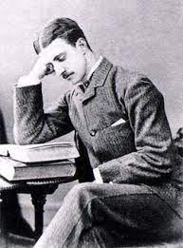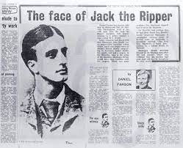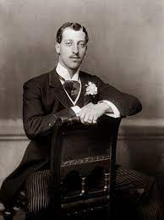
Photo of Montague John Druitt Prince Eddy, Duke of Clarence

There is such a strong resemblance between the two men that they could both easily pass for one another in public. Was it intended that, through his spy training at the Inner Temple, Druitt would be able to impersonate Prince Eddy and even take his place in certain social settings? The fact that there is no known association of Druitt with Cleveland Street could be explained by the fact that he was passing himself off as Prince Albert Victor (Eddy) at the time of his visits. The fact that the Prince Eddy faced a potential scandal in being associated with the male brothel on Cleveland Street could have been because his double was also frequenting the brothel more frequently. Some men at the male brothel may have mistaken Druitt for Eddy and rumors involving Eddy might have spread as a consequence. However, the intention may have been to set Druitt up as the scapegoat so that the prince would escape scandal, but Druitt would instead be implicated in the later Cleveland Street scandal. Perhaps Druitt, posing as Prince Eddy, met with some of the blackmailing whores from Whitechapel, to identify them and set them up for their demise, but they would not have felt threatened by the stranger because of the similarity he bore to Prince Eddy, who Mary Kelly would have known as the groom of her co-worker and friend Annie Crook. Perhaps rumors of the Cleveland Street male brothel scandal reached the school in Blackheath where Druitt was employed as a schoolmaster, resulting in his dismissal.

The failed barrister, Montague John Duitt, eventually emerged as a suspect in the Ripper case, but what can definitely be established is the fact that he was involved in the cover-up. The complicated network that involved Druitt in the case allowed him to be set up as the scapegoat, ready and waiting to be denounced as the Ripper the moment he became subject to any serious investigation. Druitt had in fact apparently committed suicide by drowning after being fired from the school where he taught as a schoolmaster, allegedly for some serious violation.

As early as 1889, the rumor being spread by police was that “Jack the Ripper” had drowned himself in the Thames at the end of 1988. Mr. Albert Backert, a leader of the Whitechapel Vigilance Committee, was told this in March 1889 when he questioned the police about their progress in establishing a suspect. Senior police and government officials gave this rumor even more credibility when they mentioned it in their memoirs. Sir Melville Macnaughten claimed in Days of My Years that the “Ripper” committed suicide in the Thames, while Sir John Moylan, Assistant Under-Secretary of the Home Office, wrote, “It is almost certain that he escaped by committing suicide at the end of 1888.” Sir Basil Thompson, an Assistant Commissioner of the C.I.D., thought “…the man escaped justice by committing suicide in the Thames at the end of 1988.”

Druitt had an interesting background that allowed him to cross paths with most of the players in the cover-up. First of all, he attended the Inner Temple, one of the five Inns of Court in London—the Outer, Middle and Inner Temples, Gray’s Inn and Lincoln’s Inn—the Inner Temple in his case. The chapter on Gandhi in Shakespeare’s Codex (Vol. 1) showed that Gandhi had attended the same illustrious law school, which doubled as a British spy training facility. The Honourable Society of the Inner Temple have records that show Druitt kept up his chambers at No.9 King’s Bench Walk until his death. This is corroborated by the Post Office Directory of London. Was Druitt more of a spy than a barrister in training? And what kind of serious spy work was he being assigned in that role? King’s Bench Walk runs all the way down to the Victoria Embankment. If Druitt was a scapegoat, he must have been set up rather like Oswald in JFK’s assassination. Someone among his long line of associates must have chosen him. If Sickert was right in his suggestion, there had to be a link between Druitt and the other sides of this case. Where exactly? There is a series of links, which taken individually could be dismissed as coincidence, but when taken together form an undeniable pattern:

- Prince Eddy’s tutor and later governor, Canon John Neale Dalton, was educated at the same school, Blackheath, where Druitt become a schoolmaster. Whether Dalton continues his association with the school, and exerted any influence there, is unknown. If he did, he could have been responsible for one of the most unfortunate aspects of Druitt’s tragic life, his sudden mysterious dismissal from the school, which many allege led to his suicide.
- Thomas Toughill, who has developed his own theory about the Ripper’s identity, has established another connection between Druitt and Prince Eddy. Druitt’s brother was in the same regiment as the artist Frank Miles—and Miles brother was Eddy’s equerry.
- Having established Miles as a second link between Druitt and Eddy, it turns out Miles lived on Chelsea Street, and that across the road at No. 9, lived Sir Melville Macnaughten, the man responsible for linking Druitt to the Riper case.
- Next door to Miles at No. 28 Tite Street lived the artist Whistler, Walter Sickert’s erstwhile mentor whom Sickert visited regularly.
- At No.16 Tite Street lived Miles’ former gay lover, the notorious Oscar Wilde, the latter being another close friend of Walter Sickert, whom the latter frequently visited.
- InHesketh Pearson’s biography on Wilde, another distinguished visitor who used to call on Wilde at his Tite Street address was Eddy’s father, the Prince of Wales. At Parties hosted by Wilde, Sickert, Eddy’s father, and Miles were regular guests.
- Macnaughten was another likely guest at these same parties. Along with his link to Sickert at Tite Street, Macnaughten and Sickert were fellow-members of the Garrick Club.
- Yet another fact connects Druitt to the Royal Family. After the notorious Mordaunt divorce in which the Prince of Wales was implicated in 1869, Lady Mordaunt was conveniently certified insane and sent to an asylum where she stayed until her death. The dubious sectioning of Lady Mordaunt was fortunate for the Prince of Wales at least. The records of the Lunacy Commission show that only about twelve lunatics in the country were of sufficient importance to warrant regular reports. A review of the records for the relevant period, one fact cannot escape notice—two names appear regularly in the small list of inmates—Lady Mordaunt and Mrs. Ann Druitt, Montague’s mother.
- Another telling connection between Druitt and Eddy is via Eddy’s best friend James Kenneth Stephen, whom Harrison had named as the Ripper. Stehen’s brothers were both barristers like Druitt. Harry Lushington Stephen was at No. 3 King’s Bench Walk (Druitt was a few yards along at No.9) and Herbert Stephen was immediately opposite Druitt’s chambers at No.4 Paper Buildings.
- The Stephens were all patients of Sir William Gull, the man Sickert names as the central figure in the Ripper conspiracy.
- Druitt was surrounded by people who has close links with the account of the Ripper murders told by Sickert. The eleventh link takes us beyond the civilized parlance of King’s Bench Walk and Paper Buildings into No.9 King’s Bench Walk itself. Several solicitors and barristers shared No.9 chambers with Druitt, one of them being Reginald Brodie Dyke Achand, the brother of William Gull’s son-in-law.
- Dyke Achand’s father, Sir Henry Wentworth Achand was Honorary Physician to Eddy’s father, and a close friend of Gull’s.
- Achand was also a friend of Helmen Hunt, the Pre-Raphealite painter, whose studios had been at Cleveland Street.
- The final link is the most vital. The solicitor who investigated the second part of the Cleveland Street cover-up, Edward Henslow Bedford, lived at No.9Kimg’s Bench Walk, the same address as Druitt. Law Society records show that Bedford practiced at the address from 1867 to 1898, and subsequently at 52 Arbour Square, Whitechapel, close to the police station. During his time at King’s Benck Walk, he was in partnership twice, but between 1879 and 1898, the period during which Druitt shared the address, he practiced alone. It can hardly be a coincidence that the man who played ca major role in the second part of the cover-up should share the same address as the person used as a scapegoat in the third part. Bedford was in the best position to evaluate Druitt, make reports to those in charge of the cover-up, and also arrange his murder.

Montague John Druitt (1857 - 1888) was the favored suspect of Melville Macnaughten. Druitt worked as a barrister and supplemented his income at the bar by working as an assistant schoolmaster at a boarding school in Blackheath, south-east London, which was run by Mr. George Valentine.
In his Memoranda, Macnaughten lists three suspects whom, he claims, were far more likely than Thomas Cutbush to have been Jack the Ripper. Top of that list is “A Mr. M. J. Druitt” who Macnaughten describes as having been a:
“...a doctor of about 41 years of age and of fairly good family, who disappeared at the time of the Miller’s Court murder, and whose body was found floating in the Thames on 31st December: i.e. seven weeks after the said murder. The body was said to have been in the water for a month, or more…From private information I have little doubt but that his own family suspected this man of being the Whitechapel murderer, it was alleged that he was sexually insane.”

DRUITT’S SUICIDE - NOVEMBER 1888
At the end of November 1888, for reasons that have never been satisfactorily established, Druitt was suddenly dismissed from the school where he worked as a schoolmaster. A month later, on December 31, 1888, his body was found floating in the Thames at Chiswick. It had been in the river for some time. On January 5, 1889 the Acton, Chiswick, and Turnham Green Gazette reported on the inquest into Druitt’s death, and quoted the testimony of his brother:
William H. Druitt said he lived in Bournemouth, and that he was a solicitor. The deceased was his brother, who was 31 last birthday. He was a barrister-at-law, and an assistant master in a school at Blackheath. He had stayed with witness at Bournemouth for a night towards the end of October. Witness heard from a friend on the 11th of December that deceased had not been heard of at his chambers for more than a week. Witness then went to London to make inquiries, and at Blackheath he found that deceased had got into serious trouble at the school, and had been dismissed. That was on the 30th of December. Witness had deceased's things searched where he resided, and found a paper addressed to him (produced). The Coroner read the letter, which was to this effect: “Since Friday I felt I was going to be like mother, and the best thing for me was to die.” Witness, continuing, said deceased had never made any attempt on his life before. His mother became insane in July last. He had no other relative.
The jury at the inquest into his death duly returned a verdict of suicide by drowning “whilst of unsound mind.” But was that really true. He continued to pursue his training as a barrister and continued his teaching job up until the day he died. How could this be possible if he was s emotionally and mentally disturbed as was alleged? Druitt’s body was returned to his family for burial and his name would have no doubt now be long forgotten had Macnaghten not written his memorandum and named him as his favored suspect in the hunt for the Whitechapel murderer.

WHY WAS HE A SUSPECT?
For just one reason really. The fact that Melville Macnaughten favored him as a suspect was the most compelling reason for him becoming a suspect in the case. Furthermore, the timing of his suicide provided a compelling reason for why the murders ceased after Mary Kelly was found dead in Miller’s Court. Then, of course, there is Macnaghten’s assertion that Druitt's own family believed him to have been the Ripper. On the strength of this, seemingly strong evidence against him, there is a great temptation to declare the Jack the Ripper case closed with the death of Montague John Druitt. Indeed, for many years, some prominent historians held that to be the case and Druitt was the suspect of choice for many Ripperologists.

However, on closer inspection the case against Druitt begins to fall apart. Macnaghten makes several fundamental errors in the information he provides about Druitt. Firstly, he was ten years out with regards Druitt’s age, as Druitt was 31, not 41 when he died. Secondly, although several of his family members were doctors, Druitt certainly wasn’t a member of that profession. Macnaghten’s statement that:-
The murderer’s brain gave way altogether after his awful glut in Miller’s Court, and that he immediately committed suicide...” is pure presupposition and circular reasoning based on the conviction that a homicidal maniac’s fragile mind gave out as a result of the last spate of killings.
Claims Did Not Apply to Montague John Druitt.
Indeed, his mind was sound enough in the days that followed the murder of Mary Kelly for him to be actively pursuing his career as a barrister. Furthermore, he continued to work as a schoolmaster at Valentine’s School until his dismissal at the end of November, some three weeks after the death of Mary (Marie) Kelly. Thus, his suicide seems to be completely unrelated to the last Ripper murder. Since he probably committed suicide around that time of his dismissal, it would seem likely that his suicide was in reaction to his job loss. The most compelling evidence for Druitt’s guilt is most certainly the fact that his own family apparently believed him to have been the murderer. However, on closer inspection, even this claim does not stand up to close scrutiny, as it appears to be based on hearsay as opposed to hard evidence. Macnaughten doesn’t say that Druitt’s family had any concrete proof that he was the Ripper, but only states that they had their suspicions about him. Those suspicions weren’t necessarily correct. Furthermore, Macnaughten, apparently, didn’t hear of these alleged suspicions directly from Druitt’s family, but, to in Mcnaughten’s own words: “...from private information I have little doubt that his family believed him to be the [R]ipper...” This private information may, therefore, have been little more than third-hand hearsay.

INSPECTOR ABBERLINE DIDN’T SUSPECT HIM

The biggest objection to Druitt as a viable suspect is that Inspector Abberline most certainly didn’t think he could have been the Ripper. In an interview with the Pall Mall Gazette in 1903, Abberline is quoted as saying:- “I know all about that story. But what does it amount to? Simply this. Soon after the last murder in Whitechapel the body of a young doctor was found in the Thames, but there is absolutely nothing beyond the fact that he was found at that time to incriminate him.”

NO KNOWN CONNECTION WITH WHITECHAPEL

Finally, nothing that is known about Druitt suggests that he ever visited Whitechapel nor that he had any knowledge of the area. As a result of Macnaughten’s suspicions Druitt is high up on the list of Ripper suspects. Yet, the case against him is dependent on Macnaghten possessing more information than he wished to reveal, and which he claimed to have destroyed so as not to cause uproar. Whether Druitt actually took his own life or whether his murder was made to look like suicide, the fact that the apparent suicide occurred approximately three weeks after the last Ripper killing, ensured that his name came to be associated with the case at a particularly sensitive time, as the police were under gave pressure to find the Whitechapel Murderer. If Druitt had been set up as a scapegoat from the outset, as Walter Sickert had maintained, what purpose did this serve exactly?

As with other cases we have seen in Shakespeare’s Codex, there was a cover-up in the “Jack the Ripper” case aimed at concealing evidence and withholding facts that probably would have led to the actual persons involved. People often dismiss notions of conspiracy in cases that are this public because they can’t conceive of how so many people could be coopted into participating in the conspiracy, while at the same time remaining silent and preventing leaks. A secret society with a membership list that includes some of the most influential and powerful players in the event can explain how so many could be called to participate in a conspiracy while maintaining a pledge of secrecy, an oath of silence on pain of death. The Ripper cover-up has been divided into four main parts:

- Vital evidence was suppressed at the Ripper inquests.
- When Eddy returned to Cleveland Street in 1888 and became involved in the male brothel scandal there, an elaborate cover-up was orchestrated by some higher-ups. This was done not to hide Eddy’s bisexuality, which was already common knowledge, but his connection to Cleveland Street. The course of justice was obstructed to further the cover-up that had begun with the removal of Eddy’s Catholic wife and culminated in the Whitechapel murders. However, despite the enormous amount of time and effort put into concealing the Cleveland Street brothel case, one man threatened to expose everything. The ruthlessness of the conspirators was one more illustrated when the man was arrested on trumped-up charges and jailed for a year to silence him.
- A plausible scapegoat was set up in case it became necessary to announce that the Ripper had been caught, and to satisfy future investigators that justice had been served.
- Documents containing the truth about the Ripper were destroyed.

Sir Charles Warren, Commissioner of the Metropolitan Police at the time of the Ripper murders was one of the country’s most prominent Freemasons. In 1861, he was initiated into the 17th degree known as the Royal Arch degree, and from that moment was under compunction to assist any senior Mason in escaping punishment even for capital crimes like murder. In the 27 years between his initiation to the Royal Arch degree and the Whitechapel murders, Warren not only became one of England’s highest-ranking Masons, but one of the most powerful in the world. His supremacy in Freemasonry is the only explanation for his appointment as Commissioner of the Metropolitan Police in 1886, and also the mysterious fact that his appalling failure in that role, as recognized by the government, press, and general public, did not lead to dismissal or demotion, but promotion to a knighthood. What then did Warren succeed in that warranted his knighthood? There is only one way in which his apparent incompetence could be viewed as a success. If the Whitechapel murders were committed according to Masonic ritual. Then Warren served the brotherhood in an exemplary way by facilitating a cover-up and obstructing justice by concealing or destroying evidence. It is probable that his appointment as commissioner was so he was well-positioned to lead the cover-up of Freemasonry’s role in the murders. Several of his actions as commissioner support this contention. The frst example is that he forced non-Mason James Monro, head of the C.I.D. to resign just before the Whitechapel murders began. The second was that he appointed higher degree Mason Sir Robert Anderson as Monro’s replacement on the eve of Mary Nichol’s murder. Warren’s final act as police commissioner, which strongly suggests he was appointed solely to protect the Masons during the Ripper’s reign of terror, is the fact that he himself resigned and made a quick exit from public life just hours before the final Ripper’s slaying of Mar (Marie) Kelly. His mercurial exit ensures that any clues that were known to be of value in the case would have been cold before they could be follow up on. Warren failed to pass on the message announcing his resignation, and so his order that no one should enter the scene of any murder without his permission was not countermanded until the afternoon of the day of Kelly’s murder, about three hours after the police arrived. From 10:45 am until 1:30pm, the investigating officers ‘chilled’ outside Kelly’s room waiting for Warren’s orders. The commissioner’s conduct during the murders certainly support the view that his sole function was to take charge of the cover-up.

As late as 2011, Scotland Yard battled to keep 123-year-old files on “Jack the Ripper” secret, which expert believe could finally reveal the identity of the killer. Four thick ledgers compiled by Special Branch officers have been kept under lock and key since the Whitechapel murders in 1888.

Trevor Marriott, a Ripper investigator and former murder squad detective, spent three years trying to obtain uncensored versions of the documents. However, he had been repeatedly rebuffed because the ledgers contain the identities of police informants—and the Metropolitan Police insist that revealing the information could compromise their attempts to gather information from “supergrasses” and other modern-day informants. Mr. Marriott took Scotland Yard to a tribunal in a last-ditch attempt to see the journals—containing 36,000 entries—which he believes contain evidence which could finally unmask the world’s most notorious serial killer. The legal case has cost taxpayers thousands of pounds and has even involved a senior Scotland Yard officer giving evidence anonymously from behind a screen.
The ledgers provide details of the police’s dealings with thousands of informants from 1888 to 1912, including some who provided information during the original Ripper investigation. A sample of about 40 pages from the Scotland Yard ledgers was released at the tribunal, but with names of informants and other key details blacked out. Why all the redactions? What are they hiding? Is the cover-up continuing even now—123 years on?
According to Mr. Marriott, the files contain the names of at least four new suspects, as well as other pieces of evidence. He said: “I believe this to be the very last chance that we may have to solve the mystery of Jack the Ripper. To have any possibility of getting near the truth about those horrific crimes we must see what these ledgers contain. It may be that within them we find the final piece of the jigsaw that would unlock this mystery and lead to the identity of the killer, or killers, albeit 123 years too late.”
The police made several mistakes in the inquiry and detection techniques of the time were basic—with no fingerprinting and science unable even to distinguish between animal and human blood. As a result, there is no conclusive evidence to convict any of the suspects.
Marriott, who joined Bedfordshire Police in 1970 and worked as a detective constable until the mid-1980s, began researching the “Jack the Ripper” case in 2003. He has previously published one book on the subject which put forward the name of Carl Feigenbaum, a German merchant executed for the murder of a woman in New York, as a new suspect.
On uncovering references to the ledgers in 2008, Mr. Marriott applied to see the documents under an FOIA request. The Met refused and he appealed to the Information Commissioner who also decided the books should not be revealed.
Now Mr. Marriott has undergone the final appeal stage to the Information Tribunal, in which the case is heard by a panel of three judges. The three-day hearing involved a detective inspector, identified only as 'D’, speaking to the court from behind a screen because of his sensitive role running the force’s intelligence-gathering operation from informants.
Detective Inspector 'D’ told the tribunal that unveiling the files could deter informants from coming forward in future, and could even put off members of the public from phoning Crimestoppers or the antiterrorist hotline. “The interpretation on the street will be that the police have revealed the identity of informants,” said ‘D’. Confidence in the system is maintaining the safety of informants, regardless of age.”
Det. Insp. 'D’ said the passage of time did not make publication of informants’ identities less sensitive because their descendants could be targeted by criminals with a grudge. “Look at one of the world’s best-known informants, Judas Iscariot. If someone could draw a bloodline from Judas Iscariot to a present-day person then that person would face a risk, although I know that seems an extreme example,” the officer said.
Another senior officer, Detective Superintendent Julian McKinney, told the tribunal that releasing names would make police officers less capable of preventing terrorist attacks and organized crime, and make informants vulnerable to attack. McKinney said: “Regardless of the time, regardless of whether they are dead, they should never be disclosed. They come to us only when they have the confidence in our system that their identity will not be disclosed.”
But Mr. Marriott said a number of historical files have previously been released which contained details of informants. He argued there was no evidence to show descendants of informants who have been named had come to harm. The tribunal was expected to come to a decision on the matter later in 2011. While there is no evidence that Scotland Yard is stonewalling as part of a 123-year-old cover-up, there should be some suspicion of cover-up given what Shakespeare’s Codex (Vol 1&2) has shared regarding other cover-ups ranging from the truth about the Shakespeare authorship to that of the Titanic, or the true fate of the Russian imperial family.

An amateur sleuth by the name of Russel Edwards, with the help of forensic scientists, who used cutting-edge DNA extraction techniques to identify Britain’s most notorious criminal, believes he has identified the “Jack the Ripper” once and for all. The main points in the DNA trace evidence discovery are as follows:
- DNA evidence on a shawl found at Ripper murder scene nails killer
- By testing descendants of victim and suspect, identifications were made
- Jack the Ripper has been identified as Polish-born Aaron Kosminski
- Kosminski was a suspect when the Ripper murders took place in 1888
- Hairdresser Kosminski lived in Whitechapel and was later put in an asylum
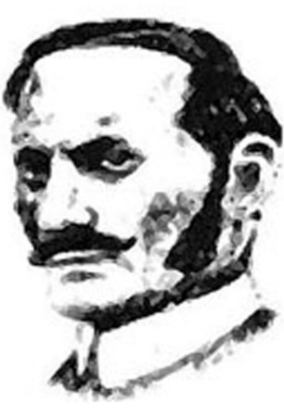
A DNA sample appears to identify Polish immigrant Aaron Kosminski as “Jack the Ripper”
Thanks to modern forensic science, a team of researchers believe they have identified “Jack the Ripper,” the serial killer responsible for at least five grisly murders in Whitechapel in East London during the autumn of 1888. DNA evidence appears to have confirmed which one of the six key suspects commonly cited in connection with the Ripper’s reign of terror was the actual killer. But does this evidence provide proof beyond a reasonable doubt?
A shawl found by the body of Catherine Eddowes, one of the Ripper’s victims, has been analyzed and found to contain DNA from her blood as well as DNA from a key suspect. The DNA evidence appears to confirm the identity of the suspect most favored as the ‘killer’ following the exhaustive study.
The landmark discovery was made after businessman Russell Edwards bought the shawl at an auction and enlisted the help of Dr. Jari Louhelaine—a world-renowned expert in analyzing genetic evidence from historical crime scenes—in identifying the man with the most-favored suspect credentials following the discovery.
Using cutting-edge techniques, Dr. Louhelainen was able to extract 126-year-old DNA from the material and compare it to DNA from descendants of Eddowes and the suspect, with both proving to be a perfect match.
The revelation has for some ended speculation over the Ripper’s identity which has lasted since his murderous rampage in the most impoverished and dangerous streets of London.
Over the course of the last century, a “Jack the Ripper” industry has proliferated, prompting an endless array of more than 100 suspects, including Queen Victoria’s grandson—Prince Albert Victor, the Duke of Clarence—the post-Impressionist painter Walter Sickert, and the former Liberal Prime Minister William Gladstone.
It was March 2007, in an auction house in Bury St Edmunds, that Ripperologist neophant Russel Edwards first saw the blood-soaked shawl ostensibly found near Catherine Eddowes’ corpse the night of her murder. The blood stains were in two surprisingly large sections—the first measuring 73.5in by 25.5in, the second 24in by 19in—and, despite its stains, much prettier than one would expect any artefact connected to “Jack the Ripper” to be. It was mostly blue and dark brown, with a delicate pattern of red, ochre, and gold Michaelmas daisies at both ends.
It was said to have been found next to the body of one of the Ripper’s victims, Catherine Eddowes, and soaked in her blood. After the auction, Edwards obtained a letter from its previous owner who claimed his ancestor had been a police officer present at the murder scene and had taken it from there, thus accounting for its provenance.
Edwards was determined to bid for the shawl and was prepared to pay a handsome sum for it. He hoped somehow to prove that it was genuine. However, he could never have anticipated that this flimsy, badly stained, and incomplete piece of material would lead to what he and many others believe is the smoking-gun evidence in the most famous murder mystery of all time— culminating in what some believe represents the definitive identification of “Jack the Ripper.”
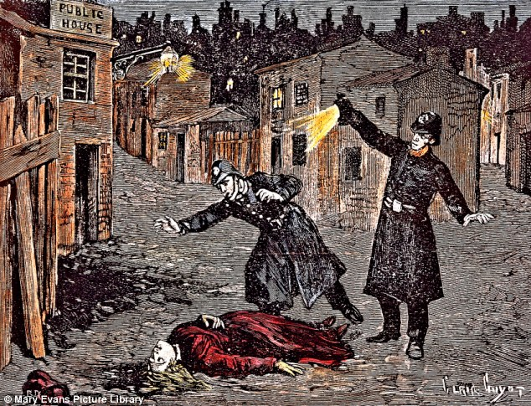
A contemporary engraving of a “Jack the Ripper” crime scene in London’s Whitechapel
Edwards is just a businessman who claims he became an armchair detective and was prompted to do his own research on the case after watching the Johnny Depp film “From Hell” in 2001, which had piqued his curiosity about the 1888 killings when five—possibly more—prostitutes were slaughtered in London’s East End.
Edwards claims that after becoming a Ripperology as a hobby, he visited the National Archives in Kew to view as much of the original paperwork as still exists, noting how many of the authors of books speculating about the Ripper had not bothered to do this. He became convinced that there must be something, somewhere that had been missed.
By 2007, he felt he had exhausted all avenues of research until he read a news article about the sale of a shawl connected to the Ripper case. Edwards informs us that its owner, David Melville-Hayes, believed it had been in his family’s possession since the murder of Catherine Eddowes, when his ancestor, Acting Sergeant Amos Simpson, asked his superiors if he could take it home to give to his wife, a dressmaker. Incredibly, it was stowed without ever being washed, and was handed down from generation to generation as a keepsake. In 1991, David gave it to Scotland Yard’s Crime Museum, where it was placed in storage rather than on display because of the lack of proof of its provenance. In 2001, David reclaimed it, and it was exhibited at the annual “Jack the Ripper” conference. One forensic test was carried out on it for a Channel 5 documentary in 2006, using a simple cotton swab from a randomly chosen part of the shawl, but the test proved inconclusive.
Most Ripper experts dismissed it when it came up for auction, but Edwards believed he had hit upon something no one else had noticed which linked it to the Ripper. The shawl is patterned with Michaelmas daisies. Today the Christian feast of Michaelmas is archaic, but in Victorian times it was familiar as a quarter day, when rents and debts were due.
Edwards discovered there were two dates for Michaelmas: one, September 29, in the Western Christian church and the other, November 8, in the Eastern Orthodox church. Startled, it suddenly dawned on him that the two dates coincided precisely with the nights of the last two murder dates. September 29 was the night on which Elizabeth Stride and Catherine Eddowes were killed, and November 8 was the night of the final, most horrific of the murders, that of Mary Jane Kelly. While it is true that the shawl, apparently made in honor of the Michaelmas feast, was found near “Ripper” victim Catherine Eddowes’ corpse, would Kosminski, an Eastern European, be aware of the Western calendar date for celebrating Michaelmas? Could it not just be an odd coincidence that a Michaelmas commemorative shawl was found at the Sept. 29 crime scene? Furthermore, Kosminski is known to have been Jewish, so it is doubtful he celebrated Michaelmas. Therefore, the shawl’s only value to him would be purely decorative.
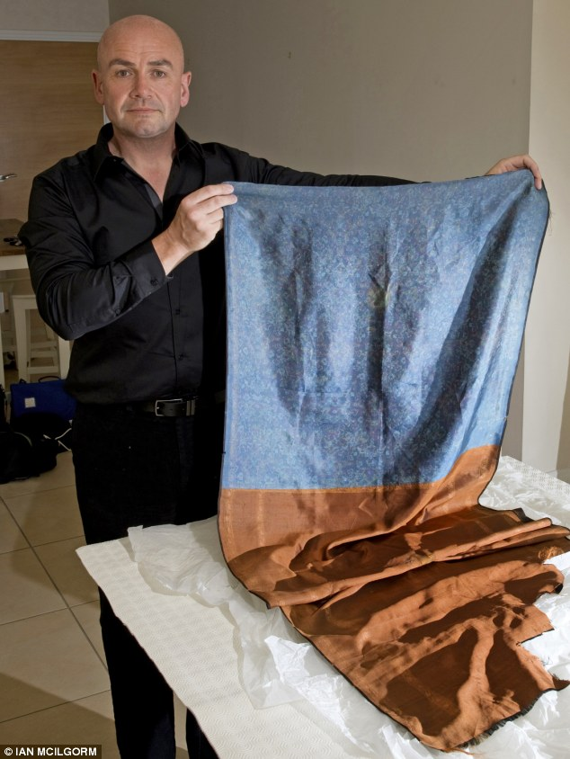
+7
Found at the scene: Russel Edwards holds the shawl he bought in 2007, allegedly handed down from a policeman who took it from the scene, which had the incriminating DNA on it
Edwards has made another misguided presupposition about the shawl, reasoning that it made no sense for Eddowes to have owned the expensive shawl herself, pointing out that this was a woman so poor she had pawned her shoes the day before her murder. “But could the Ripper have brought the shawl with him and left it as an obscure clue about when he was planning to strike next?” Edwards asks, while failing to consider that the Michaelmas feast date for the Eastern Orthodox church of November 8 would be lost on Londoners. Nevertheless, acting on a hunch, it was the shawl that motivated him to see where such evidence would lead.
Before buying it, Edwards had a word with Alan McCormack, the officer in charge of the Crime Museum, also known as the Black Museum. He told me the police had always believed they knew the identity of the Ripper. Chief Inspector Donald Swanson, the officer in charge of the investigation, had named him in his notes: Aaron Kosminski, a Polish Jew who had fled to London with his family, escaping the Russian pogroms, in the early 1880s. Edwards has just committed another logical fallacy called a “slippery slope argument.” One officer mentions Kosminski as a suspect in his notes in the 1880s and suddenly the Polish immigrant is implicated in five murders. Then, Edwards finds one piece of apparently corroborating evidence linking Kosminski to one of the murder victims through trace DNA evidence, and suddenly he’s convinced he’s nailed “Jack the Ripper.” The degree of presupposition involved in his conjectures shows how Edwards is truly an untrained amateur detective who jumps to conclusions like an excitable upstart adolescent.
“Kosminski has always been one of the three most credible suspects,” amateur sleuth Edwards informs us. He then informs us that Kosminski is often described as having been a hairdresser in Whitechapel, the occupation written on his admission papers to the workhouse in 1890. What is certain is “he was seriously mentally ill,” Edwards argues, “probably a paranoid schizophrenic who suffered auditory hallucinations and described as a misogynist prone to ‘self-abuse’, a euphemism for masturbation.” Edwards commits the logical fallacy of a slippery slope argument once again. He claims that Kosminski is “seriously mentally ill.” How can he deduce this? From reading one article or report about the man? He then makes the conjecture that Kominski is “probably a paranoid schizophrenic who suffered auditory hallucinations.” Perhaps Kosminski was a schizophrenic, but Edwards, not being a qualified expert in the psychiatric field, does not have the expertise to make this assumption. As for the claim Kosminski was a “misogynist,” what’s Edwards’ source for this information? As for the claim Kosminski was prone to masturbation, one can almost hear Kosminki’s defence attorney raising the objection, ‘Objection your Honor, relevance.’ It is truly irrelevant. Many men have fantasies about women whom they masturbate to. It does not make them sexual deviants, misogynistic, or men prone to displaying violence toward women. Edwards is making a lot of presuppositions here and appears to be inventing a psychological profile for Kosminski to fit his presupposition that Kosminski is the “Ripper.”
Police museum curator McCormack said police did not have enough evidence to convict Kosminski, despite identification by a witness, but kept him under 24-hour surveillance until he was committed to mental asylums for the rest of his life. “I became convinced Kosminski was our man, and I was excited at the prospect of proving it,” states our amateur detective, displaying adolescent excitement once again. “I felt sure that modern science would be able to produce real evidence from the stains on the shawl,” Edwards writes.
Edwards received some scientific help from Dr. Jari Louhelainen, who is a senior lecturer in molecular biology at Liverpool John Moores University and an expert in historic cold-case forensic research. Dr. Jari Louhelainen is a leading expert in genetic evidence from historical crime scenes, combining his day job as senior lecturer in molecular biology at Liverpool John Moores University with working on cold cases for Interpol and other projects. Edwards informs us that Louhelainen agreed to conduct tests on the shawl, beginning in 2011, using special photographic analysis to establish what the stains were. Using an infrared camera, Louhelainen determined the dark stains were not just blood, but consistent with arterial blood spatter caused by slashing, matching exactly the grim death Catherine Eddowes had met with.
“But the next revelation was the most heart-stopping,” Edwards writes. Under UV photography, a set of fluorescent stains showed up which Louhelainen said displayed the characteristics of semen. Edwards claims he never expected to find evidence of the “Ripper” himself, and found it thrilling, despite the forensic geneticist cautioning him that more testing was required before any conclusions could be arrived at.
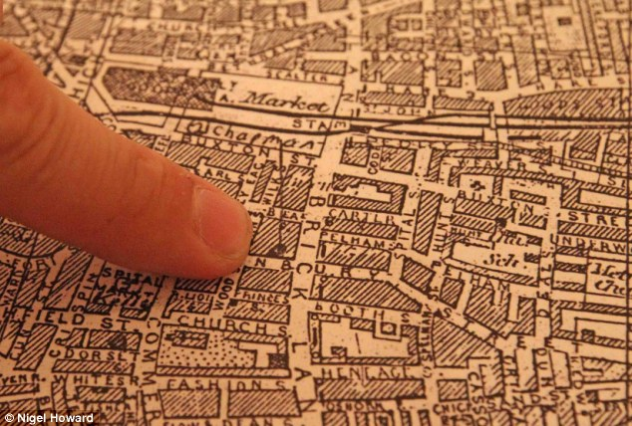
Obsession: Russell Edwards points to Hambury Street where one of the murders took place
Louhelainen also found evidence of split body parts during the frenzied attack. One of Eddowes’ kidneys was removed by her murderer, and later in his research the scientist managed to identify the presence of what he believed to be a kidney cell.
It was impossible to extract DNA from the stains on the shawl using the method employed in current cases, in which swabs are taken. The samples were just too old. Instead, Louhelainen used a method he called ‘vacuuming’, using a pipette filled with a special ‘buffering’ liquid that removed the genetic material in the cloth without damaging it.
Louhelainen warned Edwards that it would also prove impossible to use genomic DNA, which is used in fresh cases and contains a human’s entire genetic data, because over time it would have become fragmented. However, he explained it would be possible to use mitochondrial DNA instead. It is passed down exclusively through the female line, is much more abundant than genomic DNA, and survives far better.
This meant that in order to give us something to test against, I had to trace a direct descendant through the female line of Catherine Eddowes. Luckily, a woman named Karen Miller, the three-times great-granddaughter of Eddowes, had featured in a documentary about the Ripper’s victims, and agreed to provide a sample of her DNA.
Jari managed to get six complete DNA profiles from the shawl, and when he tested them against Karen’s they were a perfect match.
It was an amazing breakthrough. We now knew that the shawl was authentic, and was at the scene of the crime in September 1888, and had the victim’s blood on it. On its own, this made it the single most important artefact in Ripper history: nothing else has ever been linked scientifically to the scene of any of the crimes.
Months of research on the shawl, including analyzing the dyes used, had proved that it was made in Eastern Europe in the early 19th century. Given that Kosminski was from Easter Europe, Poland in particular, this did seem to already point to the shawl originally being his. “Now it was time to attempt to prove that it contained the killer’s DNA,” writes Edwards, once again relying on presupposition. Just because the shawl was found at the crime scene, and that the shawl had at some point belonged to Kosminski, does not prove the Pole had brought the shawl to the crime scene or that he had even been at the Eddowes’ crime scene. Below six of the prime “Ripper” suspects are shown.
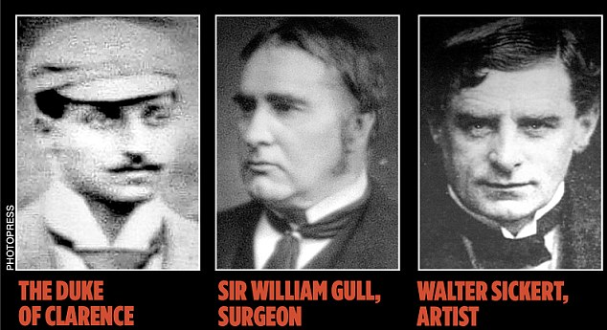
+7
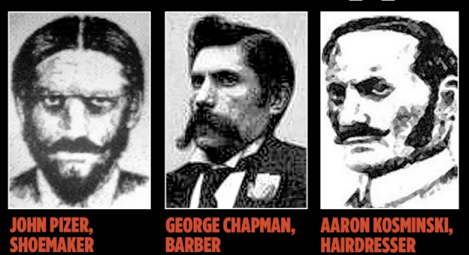
The suspects: The long line of men believed to be Jack the Ripper include, from top left to right, Prince Albert Victor, Edward VII’s son, allegedly driven by syphilis-induced madness, Sir William Gull, Queen Victoria’s doctor, painter Walter Sickert, a Jewish shoemaker, a Polish barber who later poisoned three women, and Kosminski
Louhelainen used the same extraction method on the semen traces on the shawl, warning that the likelihood of sperm lasting all that time was very slight. He enlisted the help of Dr. David Miller, a world expert on the subject, and in 2012, they made another remarkable breakthrough when they found surviving cells. They were from the epithelium, a type of tissue which coats organs. In this case, it was likely to have come from the urethra during ejaculation. This evidence would suggest that Eddowes had also ejaculated during sex, her fluid ending up on the shawl. However, this in no way proves that she had achieved coitus with Kosminski, or that coitus was achieved by the pair before her murder. It hardly seems likely that Kosminski would take the time to have sex with the victim before killing her. Murders are committed with great haste so that the killer can avoid capture. In all probability, he was Eddowes’ customer and the pair had achieved coitus together on some occasion at her residence, the evidence for which can still be found on the shawl 126 years later.
Kosminski was 23 when the murders took place, and living with his two brothers and a sister in Greenfield Street, just 200 yards from where the third victim, Elizabeth Stride, was killed. As a key suspect, his life story has long been known, but Edwards also researched his family. Eventually, we tracked down a young woman whose identity he is now protecting—a British descendant of Kosminski’s sister, Matilda, who would share his mitochondrial DNA. She provided Edwards with swabs from the inside of her mouth.
Amplifying and sequencing the DNA from the cells found on the shawl took months of painstaking, innovative work. By that point, Edwards’ excitement had reached fever-pitch. And when the email finally arrived informing him that Jari had found a perfect match, he was overwhelmed. Seven years after he had purchased the shawl, he believed he had pinned down the right suspect—Aaron Kosminski.
As a scientist, Jari is naturally cautious, unwilling to let his imagination run away without testing every minute element, but even he declared the finding “one hell of a masterpiece.” Edwards claims he celebrated “by visiting the East End, wandering the streets where Kosminski lived, worked, and committed his despicable crimes, feeling a sense of euphoria but also disbelief that we had unmasked the Ripper.” Yes again, Edwards is jumping to a foregone conclusion. What would be Kosminski’s motive? We have already established motive. The murder victims knew each other and knew the royal secret for which they were planning to blackmail the royal family. What motive would Kosminksi have for killing these particular women? After all, it has been established that there is a unifying motive for which the killer(s) sought to eliminate these women, with the exceptions of Eddowes who appears to have been murdered due to being misidentified as Mary Kelly.
Kosminski was not a member of the royal family, or an eminent surgeon or politician. Serial killers rarely are. Instead, he was a pathetic creature, a lunatic who achieved sexual satisfaction from slashing women to death in the most brutal manner. He died in Leavesden Asylum from gangrene at the age of 53, weighing just 7 stone—about 98 pounds.
Edwards makes a lot of wrongful claims here. For instance, he states that, “Kosminki is not a member of the royal, or an eminent surgeon or politician, stating that “serial killers rarely are.” Where does he get that wrongful assumption from? Serial killers come from all walks of life. However, by identifying the alleged lunatic Kosminski as the “Ripper,” Edwards somewhat discredits the high society link made by the most recent Ripperologists of the last half century and reiterates the “lone nut” killer theory promoted by the very high society that sought to hide its crimes. Was Edwards, the amateur detective put up to this, and handsomely paid for the favor in order to reduce suspicion that British high society was behind the effort to implicate Kosminski as a lone nut candidate?
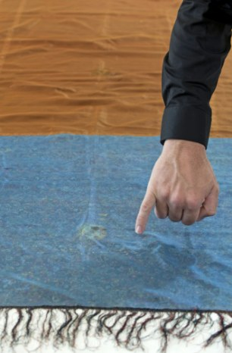
Evidence: Edwards points to the part of the shawl where DNA was found
Louhelainen claims that, when Russell Edwards first approached him in 2011, he was oblivious to the massive public interest in the Ripper case, as he was a scientist originally from Finland, but later realized the team was on the verge of making a big discovery, causing him to work on the shawl obsessively from early in the morning until late at night. He also claims it had required great skill, employing cutting-edge scientific techniques that would not have been available five years before the breakthrough discovery.
To extract DNA samples from the stains on the shawl, he used a technique he developed himself, which he calls ‘vacuuming’—to pull the original genetic material from the depths of the cloth.
He filled a sterile pipette with a liquid ‘buffer’, a solution known to stabilize the cells and DNA, and injected it into the cloth to dissolve the material trapped in the weave of the fabric without damaging the cells, then sucked it out.
He needed to sequence the DNA found in the stains on the shawl, which requires mapping the DNA by determining the exact order of the bases in a strand. He used polymerase chain reaction, a technique which allows millions of exact copies of the DNA to be made, enough for sequencing. When he tested the resulting DNA profiles against the DNA taken from swabs from Catherine Eddowes’s descendant, a match was established. He used the same extraction method on the stains which had characteristics of seminal fluid. Dr. David Miller found epithelial cells—which line cavities and organs—much to two scientists’ surprise, as they were not expecting to find anything usable after 126 years. Then I used a new process called whole genome amplification to copy the DNA 500 million-fold and allow it to be profiled.
Once he had the profile, he was able to compare it to that of the female descendant of Kosminski’s sister, who had given the team a sample of her DNA swabbed from inside her mouth. The first strand of DNA showed a 99.2 per cent match, as the analysis instrument could not determine the sequence of the missing 0.8 per cent fragment of DNA. On testing the second strand, a perfect 100 percent match was established.
Because of the genome amplification technique, he was also able to ascertain the ethnic and geographical background of the DNA he extracted. It was of a type known as the haplogroup T1a1, common in people of Russian Jewish ethnicity. He was even able to establish that the suspect had dark hair.
But the good doctor ends his analysis with a massive presupposition that, because the semen stain identified as Kosminski’s through DNA analysis was extracted from the shawl found at the scene of Eddowes’ murder, this implicates Kosminski in the Eddowes’ murder and every other slaying committed by the “Ripper” beyond a reasonable doubt. “Now that it’s over, I’m excited and proud of what we’ve achieved, and satisfied that we have established, as far as we possibly can, that Aaron Kosminski is the culprit,” Louhelainen states. That bold final claim of the doctor is indefensible. The blood, the semen, and the DNA extracted from both the blood sample and the semen stains, not to mention Eddowes’ ejaculartory fluid, all found on the shawl discovered near her corpse at the crime scene is trace evidence. Trace evidence is circumstantial material evidence. However, el flagrante delicto meaning “finds committing” is one of the principles of common law. And until someone can prove that Kosminski was at the scene of Eddowes murder, along with the other four women’s, there is no proof he is the killer. The trace evidence of seminal and urethra fluid found on the shawl could have been on the shawl for weeks. There is no evidence—and it seems contextually highly unlikely—that Kosminski would have left his ejaculate at the crime scene or that he and the victim Eddowes would have achieved coitus together before he murdered her. The thought of such a possibility seems laughable it is so improbable. This was a crime of violence with the sole motive being the murder of the victim. If Kosminski was involved, it is highly unlikely that sex would have been on his mind, sex-crazed lunatic or not.
“Freemasons applaud violence, terror and crime, provided it is carried out in a crafty manner,” writes Knight. “Humor is all important and the most appalling crimes may be committed under its cloak.”
In fact, one of the key Masonic insights into human nature, says Knight, is the reaction of people to terrorism and serial ritual murders executed with great skill. In other words, people will marvel and say, “What a dirty trick, but how skillfully executed. What a swindle, but how well and with what courage it has been done.” In the case of the CoViD-19 psy-op, for instance, many people marveled at how seamless and well planned it was. ‘You have to give the Devil his due,’ many people marveled, ‘the plandemic was very well-orchestrated and planned.’
This macabre sense of humor (or base insanity) is the trademark of Masonic Magick—to cause an effect, by an act so devilish yet cunning, that the entire world pays attention—while it’s virtually terrorized and traumatized in the same collective gasp of horror. “Ghoulish murders with a Puckish sense of fun” characterizes these atrocities. For example, how could the murders be committed in such open locations with police on the beat nearby and then the murderer suddenly disappears without a trace?
“All Jack the Ripper victims were dispatched according to age-old Masonic ritual,” Knight continues. The mutilations of the unfortunate victims were done according to Masonic tradition, the standard way of dealing with “treachery.” In fact, the oath recited by initiates promises a ghastly death and mutilation—in the case of “betrayal.”
“From Hell” actually shows the Masonic ritual initiation for the First Degree, and the candidate’s recited vow of promised retribution in the case of his “betrayal” sounds like a dictation from the devil himself.
It is, after all, the standard Illuminati Two Fer (Two, Two, Two for the Price of One). In this case, Number One is to eliminate the blackmailers and witnesses, the prostitutes who knew about Eddy’s indiscretions. And Number Two is to instill terror in the general populace by horrific murders (and “unsolved murder mysteries”), which traumatize the people into deeper submission and subconscious programming. The “deliberately engineered panic” to which Knight refers has been used historically to shift the paradigm from a scam which is about to be uncovered to a matter of “public concern.”
The movie “Wag the Dog,” of course, illustrates this concept with unrivalled brilliance. Divert attention from a potential scandal (the President’s sexual indiscretions) to a greater potential problem (a “manufactured” war) and the entire population is once again under a “hoodwink.”
As Dr. Albert Mackey, a 33rd Degree Freemason writes in “The Encyclopedia of Freemasonry,” a hoodwink is “a symbol of the secrecy, silence and darkness in which the mysteries of the art should be preserved from the unhallowed gaze of the profane.” In other words, when attention is diverted even for a nanosecond, the con artist (shell game practitioner, or magician) once again confuses his mark. The street-wise expression is simply “The House Always Wins.”
Knight maintains that Inspector Abberline was historically part of the cover-up himself, and that the real “hero” was actually Ernest Parke, a thirty-year-old editor of the North London Press, “who pinpointed in his newspaper the deliberate mishandling of the brothel investigation and trial. He attacked the police not only for allowing one of the conspirators to escape to the Continent, but also for giving him so much time in which to do so that he managed to take his furniture with him. He attacked the court for passing a sentence of four months for Veck, who had been one of the worst offenders in an unsavory case. Then Parke himself was charged with criminal libel in an unrelated case and sentenced to a year’s imprisonment, effectively silencing him for probing much too deeply into the cover-up.
Though finding out that the “Jack the Ripper” murders, masterminded by Freemasons and perpetrated according to Masonic ritual, is an astonishing revelation to many people, the Whitechapel Murders are not the first to be attributed to Masonic skullduggery.
Freemason Wolfgang Amadeus Mozart, who left the brotherhood in his later years, was allegedly poisoned for his “betrayal,” as well as for revealing their esoteric secrets in “The Magic Flute.” Vincent van Gogh was allegedly punished for his refusal to join the Brotherhood. William Morgan, author of a major 19th century expose of the Brotherhood called Freemasonry Exposed, was murdered. Film director Stanley Kubrick mysteriously died after his ritual-obsessed movie Eyes Wide Shut was completed. And yes, Stephen Knight, author of Jack the Ripper: The Final Solution mysteriously died after his best-selling expose The Brotherhood: The Secret World of the Freemasons was published in 1984.
An example of Masonic audacity would be the 9/11 spectacle, whose decidedly “unMuslim”, Hollywoodesque spectacle was foreshadowed in films such as Die Hard II and Fight Club. The fact that the Twin Towers were caught on film by the Noday Brothers who just happened to have their cameras all set up and at an optimal angle so as to catch this historical event for posterity is as convenient as the Titanic being photographed so assiduously and adroitly before she set sail from Southampton or 32° degree Freemason Abraham Zapruder just happening to be on hand with his home movie camera to capture the presidential motorcade slowing down to ten miles an hour to navigate the turn at Dealey Plaza on that fateful day in 1963. The fact that the assassination of the president and the attack on New York were both spectacle events witnessed by millions around the world is a form of trauma-based mind control on the mass media level. Audiences worldwide are so horrified by the shock and awe associated with the worldwide telecast of Freemason ritual murder that they fall into such a profound state of psychological denial that the arguments for and against conspiracy become a mute point. The collective public mind has formed a collective amnesiac barrier around the trauma event and it will take far more than the “100 monkey syndrome” to wake them up from their collective amnesia.

“If Masonic supremacy appears in jeopardy, it is reestablished by a show of strength, by crimes of violence, perpetrated to demonstrate the continuing power of Freemasons for the benefit of Brothers abroad,” writes Knight. “Crimes of violence would have been committed to reestablishing Masonic authority in the eyes of Masons everywhere.” The fact that 32° degree Freemason James Cameron should receive his Oscar before adoring fans at the Shrine Auditorium in L.A. is an example of such audacity. Upon receiving his Oscar, he declares, “I am king of the world,” which a newly initiated 33° Freemason might imagine himself to be having wended his way up the Masonic 33° degree ladder to the top. The entire film enterprise was designed to further distort the already badly distorted historical account known as the Titanic disaster. As the author showed in the chapter on Titanic in Shakespeare’s Codex (Vol. 1), the Titanic was a mass murder orchestrated by the military wing of the Jesuit Order, in collusion with Scottish Rite Freemasonry, which orchestrated the entire scheme from the Freemason-owned shipyard in Belfast to the sister ship Olympic’s watery grave.

It so happened that there was another police constable on his beat in the area the night of the Eddowes’ murder. PC Long reported finding both the message and an apron cloth at the crime scene. At 2.55 am, he purportedly made his way along Goulston Street, where he stopped at the entrance to the dwellings and made two finds; the writing on the wall and the dirty, blood-stained rag. He apparently found both articles interesting and noteworthy enough to record the chalked message in his notebook. Why would anyone find such articles interesting or worthy of note at all when they denied having any knowledge of the murder at the time of their discovery? After all, finding discarded rubbish on his beat would have been a common enough sight. And graffiti of obscure and senseless reference could be found on many buildings throughout the East End. Yet, curiously, he copied the writing down in his notebook and reported back to Commercial Street Police Station. At the Eddowes inquest, Long stated that he did not know of Eddowes’ murder when he made his find. If this is true, why did he seize on that apron rag in the first place? For at that time, it could have held no meaning for him whatsoever, since he denies having any knowledge of the crime at this time. When the body of Catherine Eddowes was found, none of the crime investigators appeared to know then that part of her apron was missing.

Goulston Street was part of Long’s beat. It was a street he had already patrolled earlier at 2.20 a.m. But at that time, there was no sign of any writing or rag in the entrance to Wentworth Dwellings, a fact also recorded by PC Halse, who had checked the entrance himself at 2.20 a.m. when he passed along the very same street. Since both officers were known to have been at the crime scene location at roughly the same time, they must have crossed paths at Goulston Street. We have two sources—two policemen recording in their respective notebooks—their presence on the same street at the same time. And Halse would naturally have informed his fellow officer of the murder that had so recently taken place in Mitre Square. Thus, Long was made aware of two facts: a woman had been murdered and her killer was on the loose. There had been no mention of a missing piece of apron, because at that time no one knew of its existence.

Clearly, then, Long would not have reported his finds unless he had some reason to believe one or both were connected to the Mitre Square murder. Yet how did he arrive at that conclusion? For later, at the inquest, we find Long denying all knowledge of Eddowes’ murder when he picked up that portion of her apron in Goulston Street. Stung by a juror’s rebuke for not conducting a search of the block of the Wentworth Dwellings, Long became noticeably flustered. But at that moment, a quick-thinking Henry Crawford, a solicitor acting for the police, jumped to the constable’s defense, suggesting that Long, upon discovering the cloth, might have thought the victim of a rape, not a murderer, might be inside on the staircase or landings. Grateful to have been thrown a rescue line, Long immediately seized on this as the true motive for his actions. However, the nimble-minded solicitor never considered the implications of his suggestion.

PC Long’s conduct and denials are mysterious and illogical from a crime investigation standpoint. Why did he record the chalked message if he was not aware of any crime being committed? The message itself is incomprehensible and of no significance whatsoever unless tied into a crime or a crime scene. And why should a piece of discarded cloth be any more noteworthy without evidence of an associated crime or crime scene? PC Long must have known far more than he was letting on. His behavior is irregular and points to obstruction of justice and concealment pf evidence. It is in any event highly irregular and inexcusable.

Both the message and the apron have Masonic significance. Masons are known to wear aprons and it is considered part of their regalia. To remove Catherine Eddowes’ apron is symbolic of a Masonic defrocking. Eddowes was being punished for revealing or threatening to reveal secrets compromising or damaging to a member of the Masonic Order. She was consequently punished according to the punishment reserved for offenders of the order who betray a member of the brotherhood. Her apron was cut away and removed as a symbol of one who had been defrocked and disgraced for betraying the Masonic Order. While some will argue that such a ritual is illogical since she is not a Mason, such rituals are still carried out symbolically for those who attack or endanger the order. To enforce the ritual deaths on Masons and non-Masons alike serves the dual purpose of instilling terror in non-Masons, while at the same time reminding members of the order of the consequences of their actions.

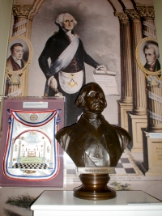
George Washington’s Masonic Apron (MasonicDictionary.com)

Warren's Report to the Home Secretary
6 November 1888
4 Whitehall Place, S.W.
6th November 1888
Confidential
The Under Secretary of State
The Home Office
Sir,
In reply to your letter of the 5th instant, I enclose a report of the circumstances of the Mitre Square Murder so far as they have come under the notice of the Metropolitan Police, and I now give an account regarding the erasing of the writing on the wall in Goulston Street which I have already partially explained to Mr. Matthews verbally.
On the 30th September on hearing of the Berner Street murder, after visiting Commercial Street Station I arrived at Leman Street Station shortly before 5 A.M. and ascertained from the Superintendant Arnold all that was known there relative to the two murders.
The most pressing question at that moment was some writing on the wall in Goulston Street evidently written with the intention of inflaming the public mind against the Jews, and which Mr. Arnold with a view to prevent serious disorder proposed to obliterate, and had sent down an Inspector with a sponge for that purpose, telling him to await his arrival.
I considered it desirable that I should decide the matter myself, as it was one involving so great a responsibility whether any action was taken or not.
I accordingly went down to Goulston Street at once before going to the scene of the murder: it was just getting light, the public would be in the streets in a few minutes, in a neighbourhood very much crowded on Sunday mornings by Jewish vendors and Christian purchasers from all parts of London.
There were several Police around the spot when I arrived, both Metropolitan and City.
The writing was on the jamb of the open archway or doorway visible in the street and could not be covered up without danger of the covering being torn off at once.
A discussion took place whether the writing could be left covered up or otherwise or whether any portion of it could be left for an hour until it could be photographed; but after taking into consideration the excited state of the population in London generally at the time, the strong feeling which had been excited against the Jews, and the fact that in a short time there would be a large concourse of the people in the streets, and having before me the Report that if it was left there the house was likely to be wrecked (in which from my own observation I entirely concurred) I considered it desirable to obliterate the writing at once, having taken a copy of which I enclose a duplicate.
After having been to the scene of the murder, I went on to the City Police Office and informed the Chief Superintendant of the reason why the writing had been obliterated.
I may mention that so great was the feeling with regard to the Jews that on the 13th ulto. the Acting Chief Rabbi wrote to me on the subject of the spelling of the word “Jewes” on account of a newspaper asserting that this was Jewish spelling in the Yiddish dialect. He added “in the present state of excitement it is dangerous to the safety of the poor Jews in the East [End] to allow such an assertion to remain uncontradicted. My community keenly appreciates your humane and vigilant action during this critical time.”
It may be realized therefore if the safety of the Jews in Whitechapel could be considered to be jeopardized 13 days after the murder by the question of the spelling of the word Jews, what might have happened to the Jews in that quarter had that writing been left intact.
I do not hesitate myself to say that if that writing had been left there would have been an onslaught upon the Jews, property would have been wrecked, and lives would probably have been lost; and I was much gratified with the promptitude with which Superintendent Arnold was prepared to act in the matter if I had not been there.
I have no doubt myself whatever that one of the principal objects of the Reward offered by Mr. Montagu was to shew to the world that the Jews were desirous of having the Hanbury Street Murder cleared up, and thus to divert from them the very strong feeling which was then growing up.
I am, Sir,
Your most obedient Servant,
(signed) C. Warren

Two identical copies of the "Juwes" message were enclosed with this correspondence, which read as follows:
The Jewes are
The men that
Will not
be Blamed
for nothing

Warren’s excuse of wishing to avoid an anti-Jewish backlash if this message came to be the subject of gossip or published in the paper is plausible, but why did he not allow police photographers to snap a picture of the evidence before he erased the chalk message from the wall? What was Warren trying to hide? What possible motive could he have for destroying evidence at the crime scene of a murder? It becomes apparent that there is only one reason why a senior police officer would go to such lengths to defeat the ends of justice. It is when the officer owes allegiance to a master higher than justice itself. It has been shown that Warren was one of the world’s most advanced and powerful Freemasons. He had long since taken the Masonic oath in which he swore to assist a fellow Mason in murder or treason by concealing evidence. This is exactly what Warren was doing on Goulston Street. But what exactly was it in that scrawled message that pointed the finger of accusation at a Mason or Masons? “The Juwes are/The men That/Will not/be Blamed/For nothing” was not, as Warren had tried to persuade critics, an anti-Semetic slur against Jews. The “Juwes” was rather a reference to the three unworthy apprentices who killed Hiram Abif, who form the basis of Masonic ritual.

Until the discovery of the writing on the wall, Commissioner Warren had never set foot in the East End. News of the message brought him racing from Whitehall as fast as a carriage could convey him. He ordered the photographers sent by Major Smith of the City Police not to take any pictures and proceeded with a course of action that has never been properly explained. Why were the photographers forbidden to take pictures of the chalked message before Warren proceeded to erase it? After all, this was the only real clue ever left by “Jack the Ripper.”

Is there any doubt left that the Ripper murders, the subsequent cover-up, and also the cover-up surrounding the Cleveland Street brothel were carried out by a cabal of extremist Freemasons? Even Lord Euston, the prime minister in the last brutal part of the Cleveland Street cover-up, was a prominent Freemason. And despite the fact he was known to frequent the gay brothel on Cleveland Street, his Masonic career still managed to prosper following the scandal. The moral virtue Masons profess to hold sacred was of small importance when Lord Euston was made G/rand Master of the Mark Masons. Then again, he was being “raised” not in recognition of his sound morals, but as his reward for the service he provided in silencing Ernest Parks, the journalist who had been exposing the Cleveland Street goings-on.

Chris Everard’s Enigma Channel reveals that the mainstream media and British police authorities have been concealing the fact that “Jack the Ripper” was not a single person - but a gang of killers who worked in concert to kill women in order to cover up a royal scandal.
One of the Ripper gang members was JK Stephen, an aristocratic socialite who confessed to Scotland Yard great detail about who the other gang members were and how they drugged female victims with grapes injected with Laudanum opiate tincture. It turns out that JK Stephen was an art tutor for the Royal Family! Might he have known Walter Sickert and might he have visited Sickert’s studio on Cleveland Street?

The leader of the Ripper Gang was Lord Randolph Spencer-Churchill, the father of Winston Churchill. How do the Enigma Channel researchers reach that conclusion? Because Scotland Yard sealed JK Stevens’ confession in wax for an entire century! Eye witness sketches by London Police officers show Jack the Ripper leaving a crime scene—the sketch shows Jack wearing the exact same fur collared long coat worn by Lord Randolph Spencer-Churchill.

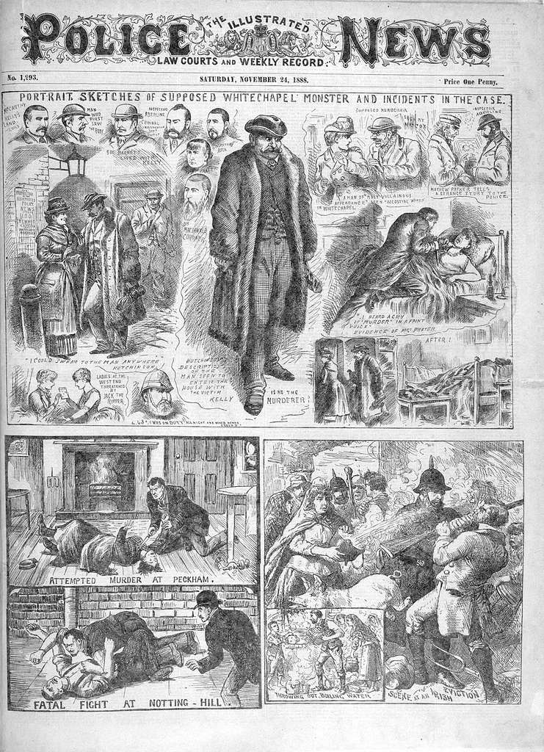

The most important thing to understand about the eight Witchcraft Sabbats is that they are not man-made. What is meant by this is that they are not holidays in the same way that Independence Day is a holiday, i.e. a calendar anniversary of some date that has a special importance in history. Indeed, the Sabbats of Witchcraft do not commemorate any historical event and are, as we shall see, almost antithetical to the concept of history. Nor are they randomly chosen holidays to observe some social institution, such as Mother’s Day. No, the eight Sabbats of Witchcraft were not man-made because they existed long before our holy and unholy holidays. Sabbats differ from other sacred days in that they are based on the Earth’s natural annual cycles. Practitioners of witchcraft and Satanic rites consider these sabbats to be days of good disposition and perform ceremonial observances on those days. The adherents of the Craft or Freemasonry, as the word “craft” implies, practice witchcraft. The three individuals who carried out the slayings attributed to “Jack the Ripper” performed these murders in adherence to Masonic witchcraft rites.
Yule Dec 22
Imbolc Feb 2
Ostara Mar 21
Beltaine May 1
Midsummer Jun 21
Lughnasadh Aug 1
Mabon Sep 21
Samhain Oct 31

Generally Accepted (Canonical) Victim
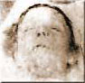
Mary Ann Nichols
31 August 1888

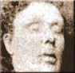
Annie Chapman
8 Sept. 1888

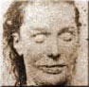
Elizabeth Stride
30 Sept. 1888

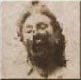
Catherine Eddowes
30 Sept. 1888

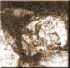
Mary Jane Kelly
9 November 1888

Other Alleged Ripper Victims

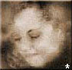
"Fairy Fay"
26 December 1887

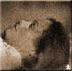
Annie Millwood
25 February 1888

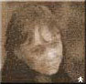
Ada Wilson
28 March 1888

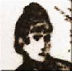
Emma Smith
3 April 1888

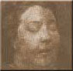
Martha Tabram
7 August 1888

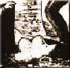
Whitehall Mystery
3 October 1888

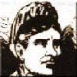
Annie Farmer
20 November 1888

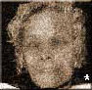
Rose Mylett
20 December 1888

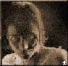
Elizabeth Jackson
June 1889

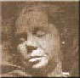
Alice Mackenzie
17 July 1889

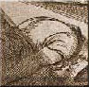
Pinchin St. Murder
10 Sept. 1889

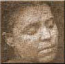
Frances Coles
13 February 1891


Carrie Brown
24 April 1891

There are Satanic calendar date correspondences with the Ripper slayings. Is there anything conclusive to be derived from this? Let’s not forget “Jack” said: “I gave birth to the 20th Century.”

Mary Ann Nichols
August 31, 1888
(Aug 28, Feast of Nepthys)

Annie Chapman
Sept. 8, 1888
(Feast of the Beast,
Bride of Satan,
Sept. 7)

Elizabeth Stride
Sept. 30, 1888
(Mysteries of Eleusis)

Fairy Fay
Dec. 26, 1887
(Day after Feast Day
of Our Lord)

Annie Millwood
Feb. 25, 1888
(Satanic, St. Walpurgis Day)

Ada Wilson
March 28, 1888
(March 24, Feast of Beast)

Emma Smith
April 3, 1888
(Easter Eve Day?)

Martha Tebran
August 7, 1888
(Nothing to Note)

Whitehall Mystery
October 3, 1888
(Mysteries of Eleusis,
Strong Satanic signature
since Mystery associated
with Mysteries and "Whitehall"
and White House must have
something to do with Temple
architecture)

Annie Farme
Nov. 20, 1888
(Nothing of Note)

Rose Mylett
Dec. 20, 1888
(Great Sabbat)

Elizabeth Jackson
June 1889
(Summer Solstice)

Alice Mackenzie
July 17, 1888
(Nothing of Note)

Pinchin St. Murder
Sept. 10, 1888
(Sept. 7, Feast of Beast,
Bride of Satan)

Francis Coles
Feb. 13, 1891
(Feb. 14, Valentine’s Day)

Carrie Brown
April 24, 1891
(Occult, St. Mark’s Eve)

These correspondences are based on the following charts showing major Satanic calendar dates:
This is based on a 1987 Calendar year.
Reprinted from PASSPORT Magazine Article: America's Best Kept Secret, 1987.

Date |  | Celebration | Type |  | Activity |  | Age
Jan. 7 | St.Winebald |  |  | Blood |  | Animal and/or Human Sacrifice & Dismemberment |  | 15-13 (Male if human)
Jan 17 | Satanic Revels |  |  | Sexual |  | Oral, Anal, Viginal |  | 7-17 female
Jan 20-27 | Abduction,Ceremonial Preparation and Holding, of Victim for Grand Climax |  |  | Sexual Blood |  | Oral, Anal, viginal Human Sacrifice |  | Female or Child
Feb 2 | Candlemas (sabbat Festival)Satanic Revels |  |  | Blood and Sexual |  | Animal or Human Oral, Anal, Vaginal |  | 7-17 female
Feb. 25 | St. Walpurgis Day |  |  | Blood |  | Communion of blood and dismemberment |  | Animal
March 1 | St. Eichatadt |  |  | Blood |  | Drinking of human blood for strength and homage to demons |  | Any age  Male of Female
March 21  day varies anually | Spring Equinox  (Sabbat Festival)  (Major fertility Sabbath) |  |  | Orgies |  | Oral, Anal, Vaginal |  | Any age  Male Female  human or animal
April 17 | Good Friday  Day of Passion  Death of Christ |  |  | Blood |  | Human Sacrifice |  | Male
April | Easter Eve Day |  |  | Blood |  | Human Sacrfice |  | Male of Female
April 21-25 | Sacrificial preparation  Abduction, holding, and ceremonial preparation of individual for sacrifice |  |  | N/A |  | N/A |  | N/A
April 26 | Grand Climax |  |  | Da Meur |  | Oral, Anal, Vaginal |  | Female  1-25
April 30 | Walpurgisnacht  Roodmas Day |  |  | Blood |  | Animal and/or Human Sacrifice |  | Any Age
May 1 | Beltane  Walpurgis Day  May Day |  |  | Druid Fire Festival  Coven Initiations |  | N/A |  | N/A
June 21  date varies annually | Summer Solstice  Feast Day |  |  | Orgies |  | Oral, Anal, Vaginal  Animal and or Human sacrifice |  | Any age  Male or Female  Human or Animal
July 1 | Demon Revels |  |  | Blood |  | Druids Sexual association with demons |  | Any age  Female
July 20-26 | Sacrificial preparation  Abduction, holding, and ceremonial preparation of individual for sacrifice |  |  | N/A |  | N/A |  | N/A
July 27 | Grand Climax  (5 weeks 1 day after the Summer Solstice) |  |  | Da Meur |  | Oral, Anal, Vaginal  Human Sacrifice |  | Female  child or adult
August 1 | Lammas Day  (Sabbat Festival) |  |  | Blood |  | Animal and/or Human Sacrifice |  | N/A
August 3 | Satanic Revels |  |  | Sexual |  | Oral, Anal, Vaginal |  | Female  7-17
Sept. 7 | Marriage to Satan |  |  | Sexual |  | Sacrifice  Dismemberment |  | Female  Infant -21
Sept 30 | Midnight Host |  |  | Blood |  | Dismemberment  Hands Removed  Hand of Glory |  | Female  Infant-21
Sept 23 | Fall Ezuinox  Feast Day |  |  | Orgies |  | Oral, Anal, Vaginal |  | Any Age
Preparation for all Hallows Eve, Samhain (Halloween) | Abduction, holding, and ceremonial preparation of individual for sacrifice |  |  | N/A |  | N/A |  | N/A
Oct 28 | Satanist High Holy Day  (Related to Halloween) |  |  | Blood |  | Human Sacrifice |  | N/A
Oct 29 | Satanist High Holy Day  (Related to Halloween) |  |  | Blood |  | Human Sacrifice |  | N/A
Oct 30 | Satanist High Holy Day  (Related to Halloween) |  |  | Blood |  | Human Sacrifices |  | N/A
Oct 31 | All Hallows Eve |  |  | Blood and Sexual |  | Sexual Climax  Association with demons  Animal and/or Human Sacrifice |  | Any Age  Male or Female
Nov. 1 | Satanist High Holy Day  (Related to Halloween) |  |  | Blood |  | Human Sacrificed |  | N/A
Nov. 4 | Satanic Revels |  |  | Sexual |  | Oral, Anal, Vaginal |  | Female  7-17
Dec 22 | Winter Solstice  (Sabbat Festival) |  |  | Orgies |  | Oral, Anal, Vaginal |  | Any age  Male or Female  Human or Animal
Dec 24 | Demon Revels |  |  | Da Meur |  | High Grand Climax  Animal and/or Human Sacrifice |  | Any Age  Male or Female
http://www.heart7.net/date/srac2.html

Pagan Book of Days Pagan Calendar COMMON “ANNIVERSARY” DATES
(Many of these holidays are practiced with positive meaning, however, abusers commonly distort cultural or religious celebrations to suit their own purposes.)
Family birthdays, weddings, baptisms, full moons, etc.
Date | Occult/Satanic | Celebration | Type | Usage
Jan. 1 | Occult  (Druid Feast) | New Years' Day | Blood | Animal or Human Sacrifice
Jan. 5 | N/A | Feast of Fools  Shivaratri | Night of Shiva  Creator/Destroyer | N/A
Jan. 6 | N/A | Epiphany  Twelfth Night | Kore give birth/manifestation of divinty | N/A
Jan. 7 | Satanic | St. Winebald | Blood  animal or human sacrifice, Dismemberment | Sexual violation
Jan. 17 | Satanic | Satanic Revels | Sexual | Sexual violation
Jan. 17 | N/A | Feast of Fools  Old Twelfth Night | N/A | N/A
Jan. 18 | N/A | Old Epiphany  Dream Festival  Pleiades | 3 days | N/A
Jan. 20 | Occult | St. Agnes Eve | N/A | N/A
Feb. 1-3 | N/A | Mysteries of Persephone  Imbolic | N/A | Druid Earth Mother
Feb. 2 | Satanic | Santanic Revels | Sexual | Sexual violation
Feb. 2 | Occult | Candlemas  Witches Sabbats | N/A | N/A
Feb. 14 | N/A | St. Valentine Day | Blood | Infant Sacrifice
Feb. 15 | N/A | Lupercalia | N/A | she-wolf mother of  Romulus & Remus  honoring Pan
Feb. 21-22 | N/A | Feralia Terminilia  Roman all Souls day | N/A | Boundary day candles & rocks
Feb. 25 | Occult/Satanic | St Walpurgis Day | Blood | N/A
3 days Preceding Ash Wednesday | Witches Sabbat | Shrovetide | Shove Sun.  Shove Tues.  Shove Wed. | N/A
Ash Wed. | Some Christans receive a mark of ashes on forehead | 7th Wed before Easter  1st day of Lent | N/A | as a token of Penitence and Mortality
March 1 | Santanic | St. Eichatadt | Blood | Drinking of human blood  for strength & homage to demons
March 9 | N/A | Festival of Ishtar  Astarte, Aphrodite, Venus | N/A | Love, Fertility
March 15 | Occult | Ides of March  Rites of Cybele & Attis | N/A | 12 day death & resurrection ritual
March 18 | Occult | Sheila-na-gig  Sheelah's Day Creatress  Jacques De Molay Day (Knights Templar | N/A | N/A
March 20 | Santanic | Feast Day  Spring Equinox | Orgies | Sexual violation
March 20-22 | Satanic | Spring Equinox  Pelusia | Invocation of Hindi Holi  Tubulustrum | Roman purificaton  Shab-i-barat Night of Forgiveness Islam
March 24 | Satanic | Feast of the Beast  Feast of Priapus  Festival of Isis | Mock Wedding | Bride of Satan
April 1 | N/A | All Fools Day | N/A | N/A
April 8 | Satanic | Day of the Masters | N/A | N/A
April 21-26 | Satanic | Preparation for Sacrifice | N/A | N/A
April 24 | Occult | St. Marks Eve | N/A | N/A
April 21-36 | Satanic | Preparation for sacrifice | N/A | N/A
April 26-May 1 | Satanic | Grand Climax  Da Meur  Corpus de Baahl | N/A | N/A
April 30 | Occult | Walpurgis Night | one of the greates Witches Sabbats | N/A
May 1 | Occult | Beltane  May Day | Fire Festival | N/A
April 03-May 5 | Occult | Walpurgisnacht  Beltane | N/A | (8) days
May 9,11,13 | N/A | Lumeria | N/A | 3 days  Roman All Souls
June 21 | Satanic | Feast Day  Summer Soltice | Orgies | Sexual violation
June 23 | Occult | Midsummer’s Eve  St. John Eve | Fire Festival | important time for practice of magic
July 1 | Satanic | Demon Revels | Blood | Druids sexual Association w/demons
July 25 | Occult | St James Day | N/A | N/A
August 1 | Occult | Lammas | Great Sabbat  (harvest) | N/A
August 3 | Satanic | Satanic Revels | Sexual | Sexual violation
Aug. 24 | Occult | St. Bartholomews Day | Fire | Great Sabbat
Aug. 24 | Satanic | Mania | N/A | N/A
Aug. 28 | Satanic | Feast of Nephthys  (wife of Set  Goddess of Death) | N/A | N/A
Sept 6 | Satanic | Marriage to Satan | Sexual | Sacrifice  Dismemberment
Sept 7 | Satanic | Feast of the Beast | N/A | N/A
Sept. 20 | Satanic | Midnight Host | Blood | Dismemberment
Sept. 21-21 | N/A | Fall Equinox | N/A | N/A
Sept. 22 | Satanic | Feast Day | Orgies | Sexual violation
Sept. 23- Oct. 2 | N/A | Mysterise of Eleusis | 28th entering of  Gate of Mysteries | N/A
Oct. 2 | N/A | Durga Puja  (Kali) | N/A | N/A
Oct. 5 | N/A | Opening of Mundus Cereis | N/A | N/A
Oct. 10 | N/A | Dashara  Kali's victory over Mahishasura | N/A | N/A
Oct. 29 | Satanic | All Hallow Eve | Blood | Sexual Climax
Oct. 31 | Occult | Halloween | Fire | Great Sabbat  this night dead return to earth
Oct. 31 | Occult | Preparation for Isia | ring of 6  Resurrection of Osiris | Isis,Hathor,  Nepthys, Horus,  Thoth, Anubis
Nov. 1 | Satanic | Halloween | Sexual | With Demons
Nov. 1-6 | Satanic/Occult | All Souls Day  The Isia  Samhain/Hallowman  Feast of Nether World | Isis 6 days  Ritual Drama search for pieces of Osiris  parting of the astral Veil  Resurrection of Osiris | N/A
Nov. 4 | Satanic | Satanic Revels | Sexual | Sexual violation
Nov. 7 | N/A | Hilaris/Mania | opening of Mimdis Cereris | Rebirth of Osiris
Dec. 21 | Occult | St. Thomas Day | Fire | Great Sabbat
Dec. 21 | Occult | Winter Solstice | N/A | N/A
Dec. 22 | Satanic | Feast Day | Orgies | Sexual violation
Dec. 24 | Satanic | Demon Revels | Da Meur | High Grand Climax
http://www.heart7.net/date/srac3.html
Below on the next page is one of the famous “Jack the Ripper” letters sent to Scotland Yard. As with the Shakespeare plays, where can detect different writing styles being employed in different plays, suggesting different authors, so with the “Jack the Ripper” letters, we can detect three different styles or hands at work, hence three “Jacks.”

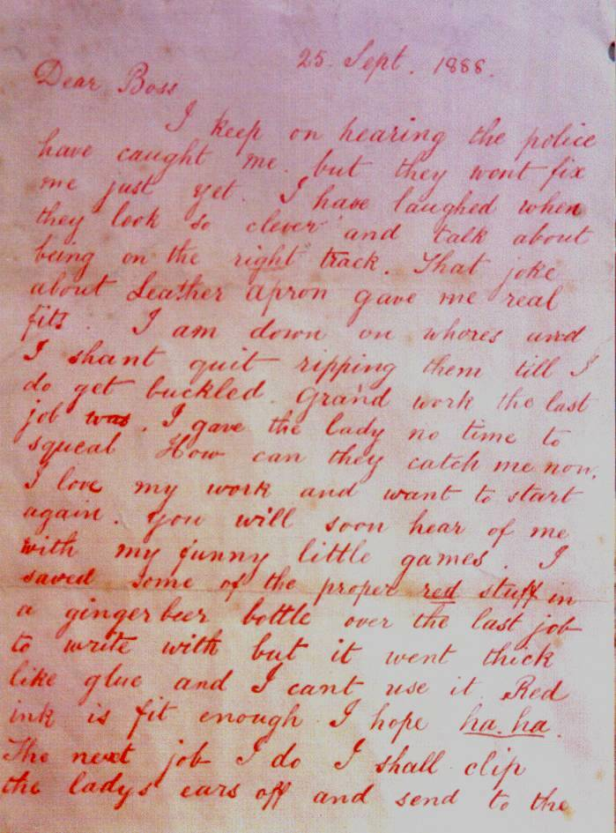
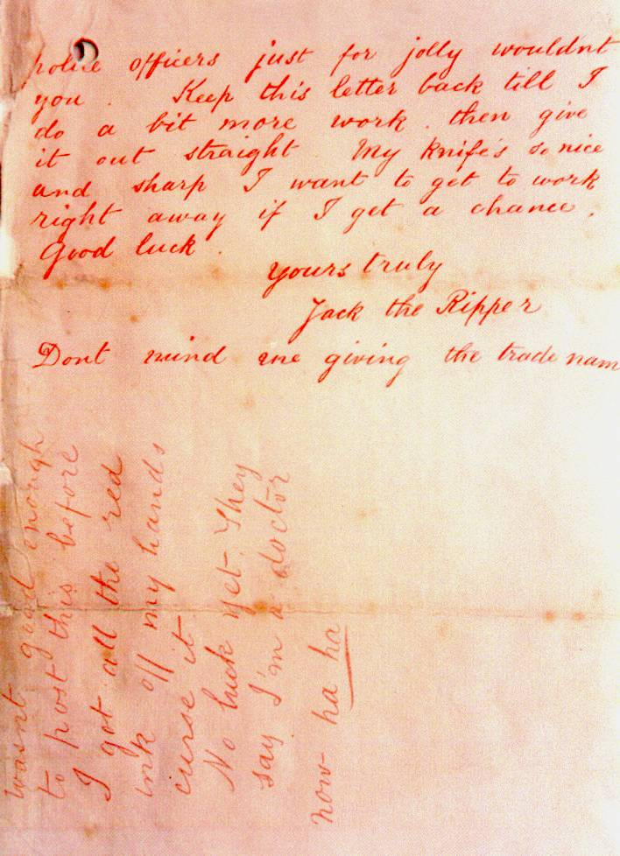

Note the unmistakable East End Cockney slang of the “Dear Boss” Letter. This is just one of the “Jacks” featured in the various letters considered authentic by Scotland Yard. There are three distinct hands, voices and styles at work in the letters epitomized by high English or the Queen’s English, middling English and commoner’s English of the East End Cockney variety. The “Dear Boss” letters are of the Cockney variety and carry the unique signature of that dialect. The grammar and punctuation also display a distinct lack of schooling, probably deliberately adopted as a psychopath’s mask. There is for example a notable absence of apostrophes for abbreviations, a characteristic of modern e-mail communications but considered of exceedingly poor taste in the Victorian era.
(Transcription of “Dear Boss” letter to police below)
Dear Boss,
I keep on hearing the police have caught me but they wont fix me just yet. I have laughed when they look so clever and talk about being on the right track. That joke about Leather Apron gave me real fits. I am down on whores and I shant quit ripping them till I do get buckled. Grand work the last job was. I gave the lady no time to squeal. How can they catch me now. I love my work and want to start again. You will soon hear of me with my funny little games. I saved some of the proper red stuff in a ginger beer bottle over the last job to write with but it went thick like glue and I cant use it. Red ink is fit enough I hope ha. ha. The next job I do I shall clip the lady’s ears off and send to the police officers just for jolly wouldn’t you. Keep this letter back till I do a bit more work, then give it out straight. My knife’s so nice and sharp I want to get to work right away if I get a chance. Good Luck.
Yours truly
Jack the Ripper
Dont mind me giving the trade name
PS Wasnt good enough to post this before I got all the red ink off my hands curse it No luck yet. They say I’m a doctor now. ha ha
  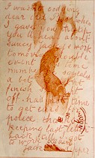
  The "Saucy Jacky" postcard.
  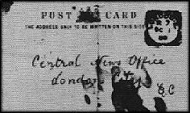
  Front-side of postcard.
(Transcription)
I was not codding dear old Boss when I gave you the tip, you'll hear about Saucy Jacky's work tomorrow double event this time number one squealed a bit couldn't finish straight off. ha not the time to get ears for police. thanks for keeping last letter back till I got to work again.
Jack the Ripper
‘From Hell’ Letter
On October 16, 1888 George Lusk, the president of the Whitechapel Vigilance Committee, received a three-inch-square cardboard box in his mail. Inside was half a human kidney preserved in wine, along with the following letter. Medical reports carried out by Dr. Openshaw found the kidney to be very similar to the one removed from Catherine Eddowes, though his findings were inconclusive either way. While the “From Hell” letter still displays the Cockey dialect and the poor spelling of a semi-literate fool, the handwriting style is distinctly different from the earlier “Dear Boss” letter. While the English continues to display the dialect of the London East End, there is a sophistication to the handwriting that suggests the actual writing was penned by a man of superior education and a more practiced hand than the author of the “Dear Boss” letter.
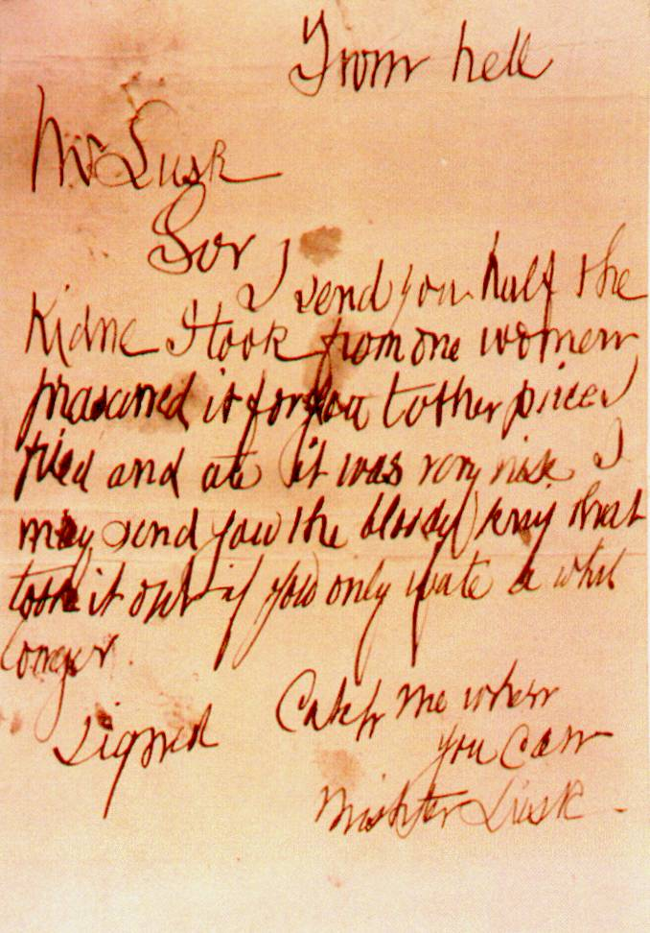
(Transcription of “From Hell” letter below)
From hell.
Mr Lusk,
Sir
I send you half the Kidne I took from one woman and prasarved it for you tother piece I fried and ate it was very nise. I may send you the bloody knif that took it out if you only wate a whil longer
signed
Catch me when you can Mishter Lusk
It is interesting that the one letter claimed to be genuine is not even signed “Jack the Ripper.” This letter did more to foster panic in the East End than any other. Though it comes across as a letter composed by an illiterate at first glance, it is more likely the writer took pains to make it appear that way. For instance, an illiterate is more likely to write ‘nife’ than ‘knif’, or ‘wile’ as opposed to ‘whil’. And someone who thinks ‘wait’ is rendered as ‘wate’ is unlikely to know that ‘bludie’ is rendered properly as ‘bloody’.
The authenticity of the Lusk letter seems to be confirmed by the findings of Canadian handwriting expert Miss C.M. Macleod, who wrote in The Criminologist in 1968, “If there was only one real Jack the Ripper, I should cast my vote for the writer of sample 1 (the Lusk letter).”
But if this is true, who wrote the letter? More than one killer made up the identity of “Jack the Ripper.” A case has already been made for three suspects working together—two killers and an accomplice. The identity of this particular “Ripper” suspect is to be found in the same analysis of the writing, as Miss Macleod postulates:
I would have looked for this killer among such men as cab drivers, who had a legitimate excuse to be anywhere at any time. I should have sought a hail-fellow-well-met who liked to eat and drink; who might attract women of the class he preyed on by an overwhelming animal charm. I would say in fact he was a latent homosexual (suggested by lower-zone strokes returning on the wrong side of the letter) and passed as a “man’s man”; the roistering blade who made himself the life and soul of the pub and sneered at women as objects to be used and discarded.
In adding that, “this writer was capable of conceiving any atrocity and of carrying it out in an organized way,” Macleod might be accused of deducing this from already known facts. However, her character sketch of the suspect based on his handwriting alone is nothing short of remarkable and leaves little doubt about the identity of the author of the “From Hell” letter. She has offered us a perfect description of Netley.
A skeptic might argue that using a person’s handwriting to form a character profile is like using palmistry to define a person’s fate, but this author can attest to the value of such tools. I once knew a Chinese painter who was skilled at phronology (the study of the conformation of the skull as indicative of mental faculties and traits of character). He took a good close look at my face and said boldly, “You will leave your family.” I have in fact spent much of my life away from Canada living in the Far East. Another useful tool is to pay attention to speech patterns. Psychopaths, which Netley most assuredly was, tend to hesitate and stutter when speaking as they are pathological liars and need to give themselves time to invent the next lie. The fact that Netley liked to indulge in food and drink and was an inveterate womanizer also points to his being a psychopath, as they tend to have difficulty accessing the “pleasure principle” due to low galanin production in the amygdala. Netley seemed to crave the pleasures of life and to be strongly Id dominant.

October 6, 1888 – This letter was received by a local paper and is believed to have been intended for either Israel Schwartz or Joseph Lawende, both of whom are believed to have witnessed the Ripper and gave descriptions of the man they saw to the police. Few researchers believe this letter to be real.
{Transcription)
You thought your-self very clever I reckon when you informed the police. But you made a mistake if you thought I dident see you. Now I known you know me and I see your little game, and I mean to finish you and send your ears to your wife if you show this to the police or help them if you do I will finish you. It no use your trying to get out of my way. Because I have you when you dont expect it and I keep my word as you soon see and rip you up. Yours truly Jack the Ripper.
PS You see I know your address
No Date Available -- Catherine Eddowes was found murdered near the Minories on September 30, 1988. The ‘1st and 2nd inst.’ refers to the first and second of the month (October). Few researchers give this letter any credibility whatsoever. Why is that? Is it because the hand, voice, and style differ so dramatically from the other letters? Is it because the author of this letter appears to display greater education and familiarity with a pen? That, in the opinion of this researcher, is a serious error of judgment. The message scratched on the wall at the scene of the Catherine Eddowes’ murder said, “The Juwes are not the men who will be blamed for nothing.” That is an occult reference to the Third Degree of Freemasonry and is a distinct signature of Freemason-Satanic ritual murder. The “three Juwes” is a reference to the “Three Unworthy Craftsmen” who are depicted in the Freemason mythos as having participated in the murder of Masonic hero, Harim Abif, the man honored by Freemasonry as the architect of King Solomon’s Temple. Legend holds that Hiram Abif had just completed his prayers when he was confronted by three ruffians—Jubila, Jubilo and Jubulum— a.k.a. The Three Juwes. These were the three unworthy craftsmen who demanded that Hiram Abif reveal the secrets of the Third Degree otherwise known as the Master Mason Degree. When he refused, the unworthy craftsmen cordoned off the exits and delivered blows to the victim’s head with Mason builders’ tools, one to each temple and a final fatal blow to the forehead. These blows are symbolic of the Masonic-Satanic psychological warfare plan directed against humanity that targets the temporal lobe region of the brain as well as the third eye and its accompanying pineal gland in an operation aimed at shutting down the higher centers of consciousness within the human mind. The attack of the Three Unworthy Craftsmen is commemorated in the Masonic undertaking known as the Shakespeare plays in the murder of Banquo by three ruffians in Macbeth and in the assault on Prospero in The Tempest when he receives blows to the head that render him senseless while his three assailants make off with his much-coveted books of magic (the Craft). The assassination of Hiram Abif is also commemorated in the Masonic-Satanic ritual murders of Captain Morgon, who was sprung from his jail cell by three men the night of his Masonic assassination; by the “three railway hoboes” arrested at the scene of the JFK assassination; and the three paparazzi motorcyclists who were implicated as a factor in the death of Princess Diana in a Paris tunnel beneath Pont de l’Alma, which had been the traditional site for Diana worship in Gaul for centuries.

(Transcription)
Beware I shall be at work on the 1st and 2nd inst. in the Minories at 12 midnight and I give the authorities a good chance but there is never a policeman near when I am at work. Yours Jack the Ripper.
No Date Available -- Prince William Street was only yards from the main road between Aigburth and the office of the Cotton Exchange. Few researchers give this letter much credence. Again why? Is it also because the hand, voice, and style fail to match the English of the “Dear Boss” and “From Hell” letters? Why has no one ever considered that there was not one “Jack”, but in fact three, representing the Three Unworthy Craftsmen alluded to earlier? They were the Three Juwes after all. That the murderer should act with two accomplices would not be anomalous or inconsistent with the Masonic assassination M.O. employed in many assassination cases throughout history.
(Transcription)
What fools the police are. I even give them the name of the street where I am living. Prince William Street.
29 October 1888 -- this letter was sent to Dr. Openshaw, who performed the medical examination on the portion of kidney received by George Lusk in conjunction with the “From Hell” letter. Few researchers give this letter any credence.
(Transcription)
Old boss you was rite it was the left kidny i was goin to hoperate agin close to you ospitle just as i was going to dror mi nife along of er bloomin throte them cusses of coppers spoilt the game but i guess i wil be on the jobn soon and will send you another bit of innerds
Jack the Ripper
O have you seen the devle with his mikerscope and scalpul a-lookin at a kidney with a slide cocked up.
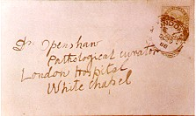
The original envelope of the Openshaw letter.

  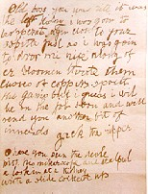
  The Openshaw letter.
  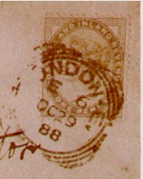
  Close-up of postmark, indicating "London.E".
Images courtesy Stewart P. Evans
Dated September 17th, 1888, this letter was only recently discovered by Peter McClelland in a sealed report envelope in the British Public Record Office in 1988. Its authenticity is hotly debated, many believing it to be a recent hoax placed surreptitiously in the records. It was first published in Paul Feldman’s Jack the Ripper: The Final Chapter.
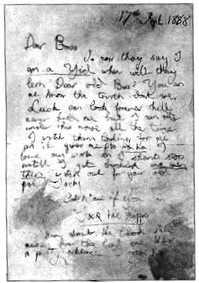
(Transcription)
17th Sept 1888
Dear Boss
So now they say I am a Yid when will they lern Dear old Boss! You an me know the truth dont we. Lusk can look forever hell never find me but I am rite under his nose all the time. I watch them looking for me an it gives me fits ha ha I love my work an I shant stop until I get buckled and even then watch out for your old pal Jacky.
Catch me if you Can
Jack the Ripper
Sorry about the blood still messy from the last one. What a pretty necklace I gave her.
Goulston Street Graffiti
On September 30, 1888, PC Alfred Long, 254A, found a blood-stained apron piece in an archway at Wentworth Model Dwellings, Goulston Street, (c.2:55am) and then a chalked message on the black brick fascia edging of the open doorway which led to the staircase and basement door of #108-119. DC Daniel Halse, City, arrived back at Goulston Street sometime after 3:00am. PC Long returned at c.5:00am. The writing was sponged out at c.5:30am.
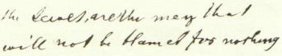
P.C. Long´s Version - "The Juwes are the men That Will not be Blamed for nothing"

PC Long’s original spelling, as seen in the above image, used "Jewes," which was corrected to "Juwes," on the scene by DC Halse. This correction was noted in PC Long's notebook and during the Eddowes Inquest.
DC Halse’s version
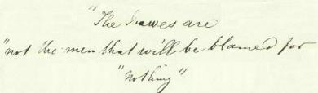
D.C. Halse´s Version - "The Juwes are not the men That Will be Blamed for nothing"

In the above images, the text of the transcriptions has been maintained, but the “layout” is not indicative to how it might have been actually written on the wall at Goulston Street.
Typically, the City Police accepted DC Halse’s version, while the Metropolitan Police accepted PC Long's version - each backing their own man. And, because of the numerous discussions concerning the word, “Juwes,” and what it is supposed to mean, it is interesting to note that there are actually many spellings of “Juwes” to be found within the official records (HO 144/221/A49301C f164, 195, 197; Eddowes Inquest Records):
Jewes, Jeuwes, Juwes, Jeuws, Juewes, Juews.
A lexicon search on the variations will invariably produce the same result – “Jews”. With all the Freemasons that serve on the British police force, particularly in the upper ranks, it is impossible to believe that the occult reference to the Third Degree could have gone unnoticed. The fact that the police superintendent, who appeared on the scene of the Endowes’ murder, was the one who erased the message, points to a cover up and whitewash of any Freemason involvement in the case. Denials will be forthcoming from the Freemason-controlled academic world, but this book is not written for the deeply academic world and the author is unconcerned what they think or how bad their reviews and reception of this book might be. They and their opinion are redundant as the bulk of humanity have woken up to the truth of the monopoly control they have exercised over learning and have opted for true learning as opposed to their counterfeit version of it, which explains why many of us who have earned higher degrees through blood, sweat and tears, have dispensed with the title “doctor”, since there are many a pretend “teacher”, teacher being the original meaning of “doctor” in the Latin.
Masonic Ritual Murders Perpetrated by “Jack the Ripper” Team
Jack the Ripper is a misnomer," writes Stephen Knight beginning his landmark book Jack the Ripper: The Final Solution. “The name conjures up visions of a lone assassin, stalking his victims under the foggy gaslight of Whitechapel. It is just this mistaken notion, inspired almost solely by that terrifying nickname, which rendered the murders of five East End London prostitutes in 1888 insoluble. For Jack the Ripper was not one man, but three, two killers and an accomplice. The facts surrounding their exploits have never before been teased from the confused skeins of truths, half-truths and lies which have been woven around this case.” Likewise, the film From Hell, partially based on Knight’s book, is a horror movie and occult thriller-murder mystery.
Based on the graphic novel of the same name by Alan Moore and Eddie Campbell, From Hell is a well-crafted, fictionalized version of the suppressed history of England—how a cabal of Freemasons orchestrated the so-called “Jack the Ripper” murders.
In the movie, Inspector Fred Abberline (Johnny Depp) tries to make sense of the serial murders in a lower-class London ghetto plagued by poverty and violence. When he’s not on the job, Abberline tries to deal with the death of his wife by soaking his sorrows in absinthe and opium. Chasing the dragon, he’s stoned again, when he sees the grisly murders through his astral vision—a drug-induced psychic journey through the seedy London East End underworld. Tracking him down to an opium den, his obese sidekick Peter Godley (Robbie Coltrane) brings him back to consensus reality with a well-placed bitch slap.
Meanwhile, Mary Kelly (Heather Graham) and her hooker friends are being extorted by a gang of thugs.
Abberline follows the clues, leading him to a conspiracy at the highest levels of government and Freemasonry—Sir William Gull (Ian Holm), the Queen’s physician, and Sir Charles Warren (Ian Richardson), Commissioner of Police and member of the Ars Quator Coronatorum Masonic Lodge—confidants to Queen Victoria herself. A gripping, well-styled movie, “From Hell” is a bold revision of history based on Stephen Knight’s ground-breaking research.
Historically, this cabal of high-level Masons was determined to “protect” the monarchy—and safeguard their own control of the government. After all, conspiracies involving nation states are always informative because of the depths of depravity that show what men will do to preserve the status quo of the ruling class and power elite. In this case, the movie deftly illustrates that xenophobia and unvarnished hypocrisy are the hallmarks of the outwardly prim and proper Victorian Age. The flood of immigrants; the rising tide of socialism; the perceived threat of catholicism to the crown; the possibility of an uprising by the proletariat. These were all political factors in an age when the decadence of the ruling class was a fact of life, as was the ruthlessness and corruption of the crown.
The “Jack the Ripper” saga had its origins on Cleveland Street, which at the time was the artistic center of London, where the local artist Walter Richard Sickert had his studio. At No. 22 Cleveland St., there was a confectioner’s and tobacconist’s shop, where Annie Elizabeth Crook worked. Mary (Marie) Kelly had been her co-worker in the shop, the same girl who was the Ripper’s last tragic victim. It was here that Prince Eddy, Duke of Clarence, had met Annie on one of her secretive visits to the area. A wedding has taken place at St. Saviour’s Chapel, but there was only one relevant witness, Marie Kelly. In 1888, there had been a police raid on certain premises on Cleveland St. and two people were taken away, the Duke of Clarence and Annie E. Crook, the latter being confined to various institutions until her death in 1920, completely insane. Marie Kelly had seen what had happened and also took charge of a child, Annie Margaret. Marie fled to the East End and hid in a convent, and the next time she was heard from was November 9, 1888.
An important point needs to be made here. The Freemasons founded all of our social institutions including the medical profession. We can see their influence even in the anatomical terms for parts of the body. The “temples” found on either side of the skull in the frontal region, housing the frontal cerebral cortex, gets its name from the 3rd° of Freemasonry, where Hiram Abif was attacked in the Temple. The first two ruffians then delivered blows to his “temples,” which gets their name from the Temple where the attack took place. When a mental patient is given a frontal lobotomy operation, the operation targets the two temples, as a medical reenactment of the 3rd°. When a person is lobotomized, they are rendered a senseless idiot, and are therefore “silenced,” because no one will listen to the blithering idiot talking nonsense ever again. If such a fate befell Annie Elizabeth Crook, as the film “From Hell” shows, then this is how the British establishment effectively silenced the Catholic wife of Prince Eddy. The lobotomy operation is often used to silence a black sheep member of an establishment family or someone who imprudently whistle-blows about a subject the establishment wishes to keep quiet. Medically, it is a lobotomy, but Masonically, it is a 3rd° ritual punishment, after which the “invalid” is permanently silenced, as it is the operation itself that has made them an invalid.
Author Stephen Knight, in his out-of-print masterpiece, Jack the Ripper: The Final Solution, explains how Britain’s entire political system at the end of the 19th century was threatened by the hidden facts—Prince Albert Victor (“Eddy”) was not only bisexual, but had married a Roman Catholic girl and fathered a child with her. Such “debaucheries” were so scandalous that the ruling class could not abide even the slightest hint of this revelation. And the reason for this is that the British establishment had created the illusion of such an ultra-conservative and respectable upper class that its very survival depended on maintaining the false façade of respectability.
When a group of working girls (Annie Chapman, Mary (Marie) Kelly, Elizabeth Stride and Mary Nichols) decided to blackmail the royals, the Marquess of Salisbury, then Prime Minister, had to take care of the problem. He entrusted Sir William Gull, physician and abortionist to the Royal Family, to undertake the mission. One of the country’s most prominent Freemasons, Gull understood that “Freemasonry was the power behind the government and it was the unseen influence of the Masonic elders which dictated major policies, not the pleasing façade of house of commons debate.”
The deliberately engineered panic, i.e., the murder of five prostitutes, was done according to Masonic ritual. The ritual murder and disembowelment “met with such ghastly success because of the audacity with which they were executed,” said Walter Sickert, Knight’s informant whose painter-father had intimate knowledge of the Cleveland Street murders. This so-called “audacity” is a trademark of Masonic “mischief-making.”
“Freemasons applaud violence, terror and crime, provided it is carried out in a crafty manner,” writes Knight. “Humor is all important and the most appalling crimes may be committed under its cloak.”
In fact, one of the key Masonic insights into human nature, says Knight, is the reaction of people to terrorism and serial ritual murders executed with great skill. In other words, people will marvel and say, “What a dirty trick, but how skillfully executed. What a swindle, but how well and with what courage it has been done.”
This macabre sense of humor (or base insanity) is the trademark of Masonic Magick—to cause an effect, by an act so devilish yet cunning, that the entire world pays attention—while it’s virtually terrorized and traumatized in the same collective gasp of horror. “Ghoulish murders with a Puckish sense of fun” characterizes these atrocities. For example, how could the murders be committed in such open locations with police on the beat nearby and then the murderer suddenly disappears without a trace?
“All Jack the Ripper victims were dispatched according to age-old Masonic ritual,” Knight continues. The mutilations of the unfortunate victims were done according to Masonic tradition, the standard way of dealing with “treachery.” In fact, the oath recited by initiates promises a ghastly death and mutilation—in the case of “betrayal.”
“From Hell” actually shows the Masonic ritual of initiation for the 1st°, and the candidate’s recited vow of promised retribution in the case of his “betrayal” is ominous enough to keep most brethren fiercely faithful to the Order.
It is, after all, the standard Illuminati Two Fer (Two, Two, Two for the Price of One). In this case, Number One is to eliminate the blackmailers and witnesses, the prostitutes who knew about Eddie’s indiscretions. And Number Two is to instill terror in the general populace by horrific murders (and “unsolved murder mysteries”), which traumatize the people into deeper submission and subconscious programming.
The “deliberately engineered panic” to which Knight refers has been used historically to shift the paradigm from a scam which is about to be uncovered to a matter of “public concern.”
The movie “Wag the Dog,” of course, illustrates this concept with unsurpassed brilliance. Divert attention from a potential scandal (the President’s sexual indiscretions) to a greater potential problem (a “manufactured” war) and the entire population is once again under a “hoodwink.”
As Dr. Albert Mackey, a 33° Degree Freemason writes in “The Encyclopedia of Freemasonry,” a hoodwink is “a symbol of the secrecy, silence and darkness in which the mysteries of the art should be preserved from the unhallowed gaze of the profane.”
In other words, when attention is diverted even for a nanosecond, the con artist (shell game practitioner, or magician) once again confuses his mark. The street-wise expression is simply “The House Always Wins.”
Knight maintains that Inspector Abberline was historically part of the cover-up himself, and that the real “hero” was actually Ernest Parke, a thirty-year-old editor of the North London Press, “who pinpointed in his newspaper the deliberate mishandling of the brothel investigation and trial. He attacked the police not only for allowing one of the conspirators to escape to the Continent, but also for giving him so much time in which to do so that he managed to take his furniture with him. He attacked the court for passing a sentence of four months for Veck, who has been one of the worst offenders in an unsavory case.”
Then Parke himself was charged with criminal libel in an unrelated case and sentenced to a year’s imprisonment, effectively silencing him for probing much too deeply.
Though finding out that the “Jack the Ripper” murders, masterminded by Freemasons and perpetrated according to Masonic ritual, is an astonishing revelation to many people, the Whitechapel Murders are not the first to be attributed to Masonic skullduggery.
Freemason Wolfgang Amadeus Mozart, who left the brotherhood in his later years, was allegedly poisoned for his “betrayal,” as well as for revealing their esoteric secrets in “The Magic Flute.” William Morgan, author of a major 19th century expose of the Brotherhood called Freemasonry Exposed, was murdered. Film director Stanley Kubrick mysteriously died after his ritual-obsessed movie Eyes Wide Shut was completed. And yes, Stephen Knight, author of Jack the Ripper: The Final Solution mysteriously died after his best-selling expose The Brotherhood: The Secret World of the Freemasons was published in 1984.
As a fictionalized account of the Ripper killings, From Hell gets closer to true history than any other work of fiction—or even so-called "history" itself. It even shows the genesis of today’s voodoo science and its bizarre obsession with psycho-surgery or lobotomies as well as cut-and-burn AMA-sanctioned “medicine.”
Most importantly, “From Hell” shows, in gruesome detail, the deep long-standing connection between the world’s most mysterious society and the world’s most mysterious murders. Conspiracy, after all, is not just “business-as-usual,” but also “government-as-usual.”

A Freemason Speaks
Author Stephen Knight wrote one of the seminal books on Freemasonry called The Brotherhood in 1983. During the course of his research for this book he was introduced to a man known as ‘Christopher’, a mason of the highest 33rd degree ranking. In the Cafe Royal, London, Christopher showed him the papers demonstrating the authenticity of his Masonic rank and told Knight that he was keen to “stop the rot” in Freemasonry. Stephen Knight asked him what a person might have to fear from a group of influential Freemasons if circumstances made him, for instance, a threat to them in the business world; or if he discovered they were using Masonry for corrupt purposes; or had fallen a victim of their misuse of Freemasonry and would not heed warnings not to oppose them.
‘Christopher’, 33° Freemason: “It is not difficult to ruin a man and I will tell you how it is done time and again. There are more than half a million brethren under the jurisdiction of the Grand Lodge. Standards have been falling for twenty or thirty years. It is too easy to enter the Craft, so many men of dubious morals have joined. The secrecy and power attract such people, and when they come the decent leave. The numbers of people who would never have been considered for membership in the fifties are getting larger all the time. If only five per cent of Freemasons use (abuse) the Craft for selfish or corrupt ends it means there are 25,000 of them. The figure is much closer to twelve or thirteen percent now.”
Stephen Knight: “Christopher explained that Masonry’s nationwide organization of men from most walks of life provided one of the most efficient private intelligence networks imaginable. Private information on anybody in the country could normally be accessed very rapidly through endless permutations of Masonic contacts—police, magistrates, solicitors, bank managers, post office staff, doctors, government employees, bosses of firms. A dossier of personal data could be built up on anybody very quickly. When the major facts of an individual’s life were known, areas of vulnerability would become apparent. Perhaps he is in financial difficulties; perhaps he has some social vice—if married he might ‘retain a mistress’ or have a proclivity for visiting prostitutes; perhaps there is something in his past he wishes kept buried, some guilty secret, a criminal offence (easily obtainable through Freemason police of doubtful virtue), or other blemish on his character: all these and more could be discovered via the wide-ranging Masonic network of 600,000 contacts, a great many of whom were indisposed to do favours for one another because that had been their prime motive for joining. Even decent Masons could often be ‘conned’ into providing information on the basis that ‘Brother Smith needs this to help the person involved.’ The adversary would even sometimes be described as a fellow Mason to the Brother from whom information was sought—perhaps someone with access to his bank manager. The ‘good’ mason would not go to the lengths of checking with Freemason’s Hall whether or not this was so. If the ‘target’ was presented as a Brother in distress by a fellow Mason, especially a fellow lodge member, which would be enough for any upright member of the craft. Sometimes this information gathering process—often involving a long chain of Masonic contacts all over the country and possibly abroad—would be necessary. Enough would be known in advance about the adversary to initiate any desired action against him.
‘Christopher’, the 33rd degree Mason: “Solicitors are very good at it. Get your man involved in something legal—it need not be serious—and you have him.”
Stephen Knight: “Masons can bring about the situation where credit companies and banks withdraw credit facilities from individual clients and tradesmen, said my informant. Banks can foreclose. People who rely on the telephone for their work can be cut off for long periods. Masonic employees of local authorities can arrange for a person’s drains to be inspected and extensive damage to be reported, thus burdening the person with huge repair bills; workmen carrying out the job can ‘find’—in reality cause—further damage. Again with regard to legal matters, a fair hearing is hard to get when a man in ordinary circumstances is in financial difficulties. If he is trying to fight a group of unprincipled Freemasons skilled in using the ‘network’ it will be impossible because Masonic DHSS and Law Society officials can delay applications for Legal Aid endlessly.”
‘Christopher’, 33° Mason: “Employers, if they are freemasons or not, can be given private information about a man who has made himself an enemy of Masonry. At worst he will be dismissed (if the information is true) or consistently passed over for promotion. Masonic doctors can also be used. But for some reason doctors seem to be the least corruptible men. There are only two occurrences of false medical certificates issued by company doctors to ruin the chances of an individual getting a particular job which I know about. It’s not a problem that need greatly worry us like the rest.
“Only the fighters have any hope of beating the system once it’s at work against them. Most people, fighters or not, are beaten in the end, though. It’s.... you see, I... you finish up not knowing who you can trust. You can get no help because your story sounds so paranoid that you are thought a crank, one of those nuts who think the whole world is a conspiracy against them. It is a strange phenomenon. By setting up a situation that most people will think of as fantasy, these people can poison every part of person’s life. If they give in they go under. If they don’t give in it's only putting off the day because if they fight, so much unhappiness will be brought to the people around them that there will likely come a time when even their families turn against them out of desperation. When that happens and they are without friends wherever they look, they become easy meat. The newspapers will not touch them. “There is no defense against an evil which only the victims and perpetrators know exists.”
http://www.conspiracyarchive.com/NWO/Masonic_Ritual_Murders.htm

Stephen Knight, Jack the Ripper: The Final Solution, Hammersmith, London: Harper Collins publisher, 1976, p. 15.
Ibid., pp.15,16.
Ibid., p.16.
https://freemasonrywatch.org/jacktheripper.html
Ibid., p.21.
Ibid., p.22.
Ibid., p.27.
Ibid., p.30.
Ibid., p.97.
Ibid., p.96.
Uri Dowbenko, “Masonic Ritual Murders AKA Jack the Ripper,” http://www.conspiracyarchive.com/NWO/Masonic_Ritual_Murders.htm
Ibid.
Masonic Conspircies, “No.10 Jack the Ripper,” http://masonicbrothers.com/blog/2016/05/15/masonic-conspiracies/
Malcolm C. Duncan, “Duncan’s Masonic Ritual and Monitor,” https://sacred-texts.com/mas/dun/
Patricia Cornwel, Portrsit of a Killer: Jack the Ripper Case Closed, New York: Berkley Books, 2002, p.3.
Ibid.,p.53.
Ibid, pp.13,14.
Ibid., pp.11,12.
Ibid., p.12.
Ibid., pp.13,14
Stephen Knight, Kack the Ripper: The Final Solution, pp.161,162.
Ibid., p.36.
Ibid., p.30.
Ibid. pp.30,31.
Ibid., p.31.
Ibid., pp.36,37.
Ibid., pp.152,153.
Ibid., p.263.
The Chicago Times-Herald, “Capture of Jack the Ripper,” April 28,1895, quoted in Jack the Ripper: The Final Solution by Stephen Knight, pp.189,190.
Ibid.
Ibid.
Stephen Knight, Jack the Ripper: Case Closed, p.190.
William Stewart, Jack the Ripper: A New Theory, quoted in Jack the Ripper: The Final Solution by Stephen Knight, pp.192,193.
Ibid., p.193.
Ibid., p.201.
Ibid.,pp.201,202.
Ibid., p.174.
Ibid., p.175.
Ibid.,pp.175,176.
Ibid., p.168.
Ibid., pp.168,169.
Ibid., pp.pp.169,170.
Ibid., p.171.
Ibid., p.172.
Ibid.
Ibid.p.166.
Ibid., p.47.
Ibid., p.121.
Ibid., pp.138-140.
“Montague John Druitt” in Jack the Ripper 1888, https://www.jack-the-ripper.org/druitt.htm
Ibid.,p.107.
Ibid. pp.155,156.
David Barrett, “Scotland Yard fights to keep Jack the Ripper files secret,” May 15, 2011, http://www.telegraph.co.uk/news/uknews/crime/8514000/Scotland-Yard-fights-to-keep-Jack-the-Ripper-files-secret.html
Russel Edwards, “WORLD EXCLUSIVE: Jack the Ripper unmasked: How amateur sleuth used DNA breakthrough to identify Britain’s most notorious criminal 126 years after string of terrible murders,” Sept. 6, 2014, http://www.dailymail.co.uk/news/article-2746321/Jack-Ripper-unmasked-How-amateur-sleuth-used-DNA-breakthrough-identify-Britains-notorious-criminal-126-years-string-terrible-murders.html#ixzz3Cd3ijSZZ
Ibid.
Ibid.
Ibid.
Ibid.
Dr. Juri Louhelainen, “Shawl that nailed Polish lunatic Aaron Kosminski and the forensic expert that made the critical match,” Sept.6, 2014, http://www.dailymail.co.uk/news/article-2746321/Jack-Ripper-unmasked-How-amateur-sleuth-used-DNA-breakthrough-identify-Britains-notorious-criminal-126-years-string-terrible-murders.html#ixzz3Cd3ijSZZ
Ibid.
Ibid.,p.178.
Ibid.
Ibid.,p.179.
Chris Everard, “The Real Jack the Ripper,” The Enigmas Channel, https://EnigmaChannel.com
Ibid., pp.222,223.
Ibid.,pp.223,224.
Ibid.,p.224.
Stephen Knight, Jack the Ripper: The Final Solution, p.21.
Ibid., p.22.
Uri Dowbenko, “Masonic Ritual Murders AKA Jack the Ripper,”, 2001 http://www.whale.to/b/jack.html

