Chart for Time of Accident
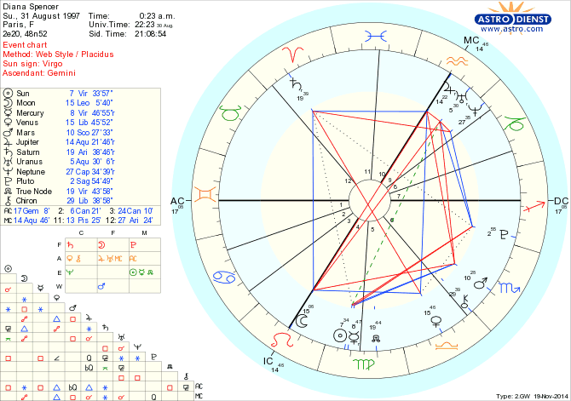

Estimated Time of Death Chart
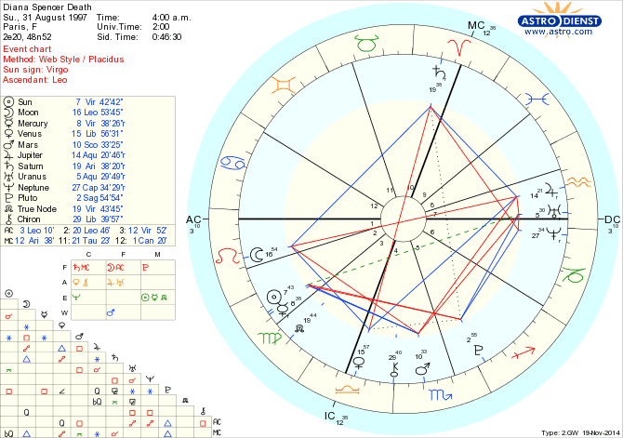

Diana: Moon Goddess Sacrifice
By Timothy Spearman
At the time of her death at 0023 Hours, the chart cast for the time of Diana’s car accident shows her AC (Ascendant) in Gemini at 17°. This suggests that the seeding motivating factor behind the event was communications under the rulership of the communicator Gemini. The fact that this media event was broadcast worldwide was one thing, but then there is the fact that the Paparazzi were represented as the precipitating factor behind the accident.The three Paparazzi motorcyclists were merely agent provocateurs placed at the scene by design. In part, the event was meant to cast aspersions on the media’s penchant for harassing to the point of driving them around a perilous bend toward their demise and ruination. This combined with Masonic-Illuminati ritual, in which the incarnation of the moon goddess was meant to die at Pont de L’Alma, the traditional site of Diana worship over the course of the centuries. At the same time, the three Paparazzi motorcyclists played their part in a Masonic passion play based on the Third Degree of Freemasonry as the Three Unworthy Craftsman.
This is a common signature in Masonic assassinations. The killing of John F. Kennedy, for example, also staged the appearance of the Three Unworthy Craftsman in the form of the three so-called Railway Hoboes, who were subject to a mock arrest never recorded in the Dallas police records, designed to convey them safely from the scene of the crime. All this had the effect of reigning in the power of the media to pry where it was not wanted, i.e. into the private lives of the elite.
In addition, the AC at 17° of Gemini represents the Sabian symbol of “The head of a robust youth changes into that of a mature thinker”. One is tempted here to think of Prince William, who at the time of his loss would have had many sobering realizations to confront, which would have doubtless made him come of age prematurely. The experience of suffering the loss of his beloved mother at so early an age would have had the effect of giving him “an old head on young shoulders” so to speak as the Sabian symbol suggests.
The chart cast for the time of her death shows that Diana’s (AC) Ascendant is at 3°of Capricorn, representing the Sabian symbol, “The human soul in its eagerness for new experiences seeks embodiment”. This is fascinating in its implications as it implies that Diana’s purpose in this incarnation had been accomplished and that her soul was in process of migrating to a new body that might possibly have invited new hopes and a happier existence. What the position of the AC does confirm is that her soul was in migration at the moment the chart was cast for the time of her death, which is startling in terms of confirmation.
The DC (Descendant) at 17° of Sagittarius shows that under the rulership of Sagittarius the traveler, there is the presence of the malefic scorpionic planet Pluto, which often brings change through death and destruction. The fact that Diana’s fatal accident occurred by means of travel is reflected in the outcome in the Seventh House under the rulership of the sign of travel. The Sabian symbol for 17° of Sagittarius is “An Easter sunrise service”. This is an obvious allusion to the fact that the accident is a fatal one and that a solemn funeral service will be the outcome. The DC then transforms to 3° of Aquarius, which is the Sabian symbol for “A deserter from the Navy”. Could it be that one of the covert ops was a former Navy man or an intelligence operative recruited from the Navy? Military intelligence involvement is well known. MI6 intelligence agent Tomlinson was the first to make the public disclosure that there were plans to murder Diana by using the same M.O. that had formerly been planned to take out Serbian leader Slobodan Milošević, in which a bright beam of laser-guided light would be used to blind the driver.
The position of the MC (Midheaven) at the time of the accident was 14° of Aquarius, which symbolizes “A Train entering a tunnel”. The import of this Sabian symbol is complimented by the fact that Jupiter is also at 14° of Aquarius, lending it a double aspect also representing “A train entering a tunnel”. It is also worth mentioning that the migration of the soul after death is also depicted as the soul entering a long tunnel, not of darkness usually but of light. Jupiter also rules rulers and kings and since the princess was a royal princess, it speaks of someone of royal lineage being the one to enter the tunnel however one might view the tunnel, whether literal or figurative.
Certainly it was a speeding juggernaut entering a tunnel, not a train perhaps but a vehicle resembling one in its relentlessness and dauntlessness. The position of the MC (Midheaven) at the time of Diana’s death was in Aries, the god of war, under the rulership of Saturn, the malefic planet oft associated with death. Since the Midheaven represents effects on public and social life, it seems evident that a large portion of the public would quickly realize that this was a malefic and aggressive action homicidal in its implications. With the MC at 12° of Aquarius in the chart cast for her time of death, under the rulership of the malefic planet Saturn, there is the implication that the Aquarian influence of freedom was dealt a blow in the public domain. This was of course true, since Diana was perceived as a vibrant free spirit who embodied the very principle of freedom. With her gone, there was the feeling and genuine reality that freedom had left the world with her. In addition, the agents provocateurs disguised as Paparazzi photojournalists dealt freedom of speech a blow as well, for it called into question the powers of the media, and led to curbs being placed on them in terms of how far they would be allowed to go in the coverage of the lives of celebrities and people occupying positions of real power in society.
The MC at 12° of Aries also represents the Sabian symbol of “A bomb which failed to explode is now safely concealed”. There are two possible implications here. Either it represents the fact that a bomb was also deployed in the apparent assassination attempt and was found to be unnecessary and therefore disposed of or Diana herself represented a “bomb” that was figuratively set to detonate with a public disclosure that would have been explosive in its ramifications. However, since she failed to explode as a result of her death, the “bomb”, in this case Diana’s disclosure, “is now safely concealed” from public view. The latter possibility seems the more likely alternative, since revelations have come out that Diana planned to go public with information damaging to the Royal Family of Britain, but in the event of her death that mission was derailed.

Chiron at 29° of Libra reveals the Sabian symbol, “Mankind’s vast effort to reach for knowledge transferable from generation to generation, knowledge”. Chiron represents weakness and debility, a condition where an Achilles’ heel exists, leading to injury or death. Perhaps the weakness lies in humanity’s inability to learn from its mistakes, causing it to have to relive these experiences in one form or another karmically from generation to generation. The fact that Chiron is in Libra is significant because Libra rules justice and the principle of achieving balance in terms of law and order. With Chiron here, our collective weakness is revealed. We as a people have a great deal of trouble achieving law and order and the principle of justice tends to allude us generationally, so that we are destined to relive the same experiences and exhibit the same patterns of behaviour until we finally learn to transcend and overcome.
Hegel expressed the condition by claiming, “We learn from history that we learn absolutely nothing from history.” But perhaps eventually we do. When the truth of our machinations and wicked ways finally comes out, there is perhaps a time when we do learn. It is a desperate struggle, in which some of us express a “vast effort to reach knowledge from generation to generation”. These represent the initiated few who endeavour to discover the truth and convey it to others, but the weakness lies in our collective psychological denial, our fear of the truth, our inability to face our dark side, our shadow personality, the unpopular part of our psyche. So instead we tend to subvert the truth, suppress it, push it into the subconscious and refuse to allow it to come to the surface. Lord and Lady Macbeth express this tendency perfectly.
Macbeth even received an advanced warning from the subconscious part of his psyche before he even commits the heinous act of murder and high treason, but fails to listen, plunging headlong into the action that would lead to his demise. It is not until he is haunted by the ghosts of his own action as in the scene where he asks, “Is this a dagger I see before me?” that the truth of his actions and the suppressed guilt he experiences is forced to the surface. In the meantime, he and Lady Macbeth put up a false front in public, playing out the hypocritical role necessary to feign innocence. But it is in the night, in the somnambulant sleepwalking of Lady Macbeth that the truth comes out. It is in her sleep that admissions of guilt are made.
The truth cannot be suppressed. Even the psychopathic personality must eventually give itself away, and so it is with Lady Macbeth, whose subconscious confesses in her sleep, broadcasting forth the truth of her dark machinations and evil designs. So it is with humanity collectively. We are forced to confront the ghosts of our past, our crimes, our insane and bloody actions, forced to relive them collectively as the patterns of history reveal, confronting the same bloody conditions over and over until we finally learn the karmic lesson we are assigned to learn and from which we transcend.
Venus is at 15° of Libra revealing the Sabian symbol of “Circular paths”. The fact that this occurs in Libra once again points to the fact that a principle of justice is at work, in which we are destined to relive in “circular paths” our karma until the truth is revealed and the dark past comes to the surface.
The truth must come out so that humanity is able to collectively confront its ghosts, its shadows, the dark side of itself that must be revealed so that humanity is able to overcome and transcend. As Nietzsche suggested, “Man must overcome the disease called ‘man’.” There is a higher man destined emerge on the evolutionary scale and when it does, then the love of the Divine as expressed through Venus, will lead us down the path to confronting the “circular paths” of our astrology, the stars forming the same patterns and configurations, until the lesson is learned and the chalkboard of the heavens is erased once and for all, so that a new lesson can be written on the board. In the Bible, we learn that Abraham was taught to number the stars by Yahwey.
This means that God revealed the occult secrets of astrology to Abraham, teaching him about the zodiac and how to interpret the lessons that are written in the stars. Occult initiates like Abraham were able to divine these lessons, predict worldly events and anticipate the hard lessons that would come as they were played out on the world stage. As for the rest of humanity, the uninitiated, what the Freemasons call “the profane”, they are destined to relive the same dark chapters of history over and over until the lessons are learned and the classroom instruction is complete.
Mars at 10° of Scorpio reveals the Sabian symbol of “A fellowship supper reunites old comrades”. The fact that Mars is the ruling planet in Scorpio suggests that the planet governing the war drive is behind this little gathering and that their deeds are scorpionic in design. Scorpio is a vengeful sign and the implication is that a conspiracy has been hatched with revenge as the motivating factor.
Diana had a reputation for getting her own back on the Royal Family, who had treated her so abominably. She had publicly embarrassed the Royals, most particularly her ex-husband Charles, on numerous occasions. She had cuckolded Charles by having a love affair with Mark Philips. The coup de grâce was her planned betrothal to Dodi Fayed.
Rumors that she was carrying his child would have made the public embarrassment for the British Royals intolerable, since it would have led to the entry of an unwanted foreign and Muslim line into the British upper caste.
Whether or not Diana was actually pregnant may never be proven, since the embalming fluid she was given with unseemly haste would have prevented a conclusive pregnancy test from being performed. The collective embarrassments she had created for the Royals and the British establishment had reached such a crescendo that the drive to silence her and curtail her activities had reached a fevered pitch.
Since MI6 is charged with protecting the Royal Family, it is probable that this was the agency in charge of orchestrating her execution. Perhaps this was the “fellowship supper” which reunited “old comrades”. It is disturbing to think that the conspiracy might have been hatched over dinner, but then there is also the allusion to the possibility of a symbolic “Last Supper” for the victim in question. Ironically, she had been dining at the Ritz the night of her death and of course it was to be her last supper.
Pluto at 2° of Sagittarius reveals the Sabian symbol “The ocean covered with white caps”. Pluto, the malefic scorpionic planet under the rulership of Sagittarius, suggests that an accident or a destructive event might result from travel.
Death did occur by a vehicle of travel. The Sabian symbol indicates that the event involved a storm and an associated tempest of activity. In fact, the media frenzy that erupted in the aftermath of the event was oceanic in scope. The world’s citizenry was caught up in the furor for weeks, immersed in gossip about the Royal Family, many blaming them for her death, and others criticizing them for their withdrawal from the public eye and caginess during this period.
Saturn at 19° of Aries reveals the Sabian symbol of “The magic carpet of oriental imagery”. Many researchers have referred to the seduction of Diana by Mohamed Al-Fayed, who seduced her with his glamorous charms. It is probable that he was hoping to wend his way into the British establishment by courting a relationship with Diana in order to introduce his son as a suitor. It is probable that Diana was seduced by “The magic carpet of oriental imagery” in both father and son.
The fact that Al-Fayed went to such links to wine and dine her and lavish her with gifts whenever she came to Harrod’s Department Store indicates that he was doing his level best to impress her.
And there is every indication that it worked, since Diana appeared to be taken with the oriental charms of father and son. In short, she was seduced. The fact that the malefic planet Saturn is aspected here suggests that she was lured to her death by a seducer’s lair. While the intention may not have been malevolent on either of their parts, the outcome was and that is the point.
Seduction seems to have led in this instance to death. The simple and horrible fact is that there was no way a racist British aristocracy was going to accept a Middle Eastern bloodline into their genetic pool anymore than an aristocracy allied to the Church of England were going to let a Muslim line into their midst.
The seduction of a British princess by an Arabic Muslim foreigner was tantamount to her death knell. In fact, the knell was ringing from the moment they exchanged love vows. If it were discovered she was carrying his child, it would spell her end.

